**August 2020 Challenge**

Week 1: August 1st - August 7th

~~+35~~

 Logger Rate Limiter

~~+10~~

**Detect Capital**

~~+10~~

 Design HashSet

~~+10~~

 Valid Palindrome

~~+10~~

**Power of Four**

~~+10~~

 Add and Search Word - Data structure design

~~+10~~

**Find All Duplicates in an Array**

~~+10~~

**Vertical Order Traversal of a Binary Tree**

Week 2: August 8th - August 14th

~~+35~~

**Closest Binary Search Tree Value**

~~+10~~

**Path Sum III**

~~+10~~

**Rotting Oranges**

~~+10~~

 Excel Sheet Column Number

~~+10~~

**H-Index**

~~+10~~

 Pascal's Triangle II

~~+10~~

**Iterator for Combination**

~~+10~~

**Longest Palindrome**

Week 3: August 15th - August 21st

~~+35~~

**Find Permutation**

~~+10~~

**Non-overlapping Intervals**

~~+10~~

 Best Time to Buy and Sell Stock III

~~+10~~

**Distribute Candies to People**

~~+10~~

**Numbers With Same Consecutive Differences**

~~+10~~

**Goat Latin**

~~+10~~

 Reorder List

~~+10~~

 Sort Array By Parity

Week 4: August 22nd - August 28th

~~+35~~

**The Maze**

~~+10~~

**Random Point in Non-overlapping Rectangles**

~~+10~~

**Stream of Characters**

~~+10~~

 Sum of Left Leaves

~~+10~~

**Minimum Cost For Tickets**

~~+10~~

 Fizz Buzz

~~+10~~

**Find Right Interval**

~~+10~~

**Implement Rand10() Using Rand7()**

Week 5: August 29th - August 31st

~~+35~~

 Robot Room Cleaner

~~+10~~

**Pancake Sorting**

~~+10~~

**Largest Component Size by Common Factor**

~~+10~~

 Delete Node in a BST

**Detect Capital**

Given a word, you need to judge whether the usage of capitals in it is right or not.

We define the usage of capitals in a word to be right when one of the following cases holds:

1. All letters in this word are capitals, like "USA".
2. All letters in this word are not capitals, like "leetcode".
3. Only the first letter in this word is capital, like "Google".

Otherwise, we define that this word doesn't use capitals in a right way.

**Example 1:**

**Input:** "USA"

**Output:** True

**Example 2:**

**Input:** "FlaG"

**Output:** False

**Note:** The input will be a non-empty word consisting of uppercase and lowercase latin letters.

Solution

Overview

It's a fairly easy problem because it does not require you to use any special trick, and all you need to do is to implement the solution step by step.

However, it would take some time if you want to make your code easily readable, beautiful, and short. Below two approaches are introduced, they are *"Character by Character"* method and *"Regex"* method.

Approach 1: Character by Character

**Intuition**

Recall (part of) the description of the problem:

We define the usage of capitals in a word to be right when one of the following cases holds:

1. All letters in this word are capitals, like "USA".
2. All letters in this word are not capitals, like "leetcode".
3. Only the first letter in this word is capital, like "Google".

The problem gives us three patterns, and ask if the given word matches any of them. It would be easy to think of checking the cases one by one. In each case, we can just use the most simple method to check if word matches the pattern -- **check the char one by one**.

**Algorithm**

We need three bool variables to store if the pattern matches or not. We set the variables to be true at the beginning, and when the pattern doesn't match, we turn the variables into false. You can also do it otherwise, but the code would be a little longer.

The code is a little long... **Don't be afraid!** It's fairly easy to understand, and we will shorten it later.

|  |
| --- |
| class Solution {  public boolean detectCapitalUse(String word) {  int n = word.length();  boolean match1 = true, match2 = true, match3 = true;  // case 1: All capital  for (int i = 0; i < n; i++) {  if (!Character.isUpperCase(word.charAt(i))) {  match1 = false;  break;  }  }  if (match1) {  return true;  }  // case 2: All not capital  for (int i = 0; i < n; i++) {  if (!Character.isLowerCase(word.charAt(i))) {  match2 = false;  break;  }  }  if (match2) {  return true;  }  // case 3: All not capital except first  if (!Character.isUpperCase(word.charAt(0))) {  match3 = false;  }  if (match3) {  for (int i = 1; i < n; i++) {  if (!Character.isLowerCase(word.charAt(i))) {  match3 = false;  break;  }  }  }  if (match3) {  return true;  }  // if not matching  return false;  }  } |

There are a few points you should notice from the code above:

1. We use the built-in function isUpperCase (in Java) and isupper (in Python) to check whether a char is upper case. You can also use the [ASCII](https://en.wikipedia.org/wiki/ASCII) to do that. Just use something like word.charAt(i) >= 'A' && word.charAt(i) <= 'Z'.
2. We use break after we find matching failed because there is no need to check whether the further char is valid.
3. You can combine the three match variables into one by reusing it after each case, but I prefer to separate it into three for better readability.

OK! Now we have solved this problem. The time complexity is O(n)*O*(*n*) (where n*n* is word length) because we need to check each char at most three times. This time complexity is great, and there is no too much we can do to improve it.

However, we can make the code looks better and shorter, without reducing the readability.

**Improvement**

Where to start? The biggest problem of the code above is that there are too many cases. What if we can combine them? Notice that the biggest difference between case 2 and case 3 is the condition of the first char.

By combining case 2 and case 3, we get a new pattern: No matter what first char is, the rest should be lowercase.

|  |
| --- |
| class Solution {  public boolean detectCapitalUse(String word) {  int n = word.length();  if (n == 1) {  return true;  }  // case 1: All capital  if (Character.isUpperCase(word.charAt(0)) && Character.isUpperCase(word.charAt(1))) {  for (int i = 2; i < n; i++) {  if (Character.isLowerCase(word.charAt(i))) {  return false;  }  }  // case 2 and case 3  } else {  for (int i = 1; i < n; i++) {  if (Character.isUpperCase(word.charAt(i))) {  return false;  }  }  }  // if pass one of the cases  return true;  }  } |

Still, there are a few points you should notice from the code above:

1. We check the length of the word firstly because we need to use the first two char to check if the word matches case1. Fortunately, a word with 1 length would always match either case2 or case3.
2. You can count the number of uppercase/lowercase letters in the word instead of checking it one by one and return immediately. That can also work.
3. Some programming languages have built-in methods to check if the word matches certain case, such as istitle() in Python and word.toUpperCase().equals(word) in Java. Those methods are doing the same things as our code above. It would be great if you can know both these APIs and how they implemented.

**Complexity Analysis**

* Time complexity: O(n)*O*(*n*), where n is the length of the word. We only need to check each char at most constant times.
* Space complexity : O(1)*O*(1). We only need constant spaces to store our variables.

#### Approach 2: Regex

**Intuition**

Hey, if we want to do pattern matching, why don't we use [Regular Expression](https://en.wikipedia.org/wiki/Regular_expression) (Regex)? Regex is a great way to match a given pattern to a string.

**Algorithm**

The pattern of case 1 in regex is [A-Z]*[*A*−*Z*]∗, where [A-Z][*A*−*Z*] matches one char from 'A' to 'Z', *∗ represents repeat the pattern before it at least 0 times. Therefore, this pattern represents "All capital".

The pattern of case 2 in regex is [a-z]*[*a*−*z*]∗, where similarly, [a-z][*a*−*z*] matches one char from 'a' to 'z'. Therefore, this pattern represents "All not capital".

Similarly, the pattern of case 3 in regex is [A-Z][a-z]*[*A*−*Z*][*a*−*z*]∗.

Take these three pattern together, we have [A-Z]*|[a-z]*|[A-Z][a-z]*[*A*−*Z*]∗∣[*a*−*z*]∗∣[*A*−*Z*][*a*−*z*]∗, where "|" represents "or".

Still, we can combine case 2 and case 3, and we get .[a-z]*.[*a*−*z*]∗, where "." can matches any char.

Therefore, the final pattern is [A-Z]*|.[a-z]*[*A*−*Z*]∗∣.[*a*−*z*]∗.

|  |
| --- |
| class Solution {  public boolean detectCapitalUse(String word) {  return word.matches("[A-Z]*|.[a-z]*");  }  } |

However, it is worth pointing out that the speed of regex is highly dependent on its pattern and its implementation, and the time complexity can vary from O(1)*O*(1) to O(2^n)*O*(2*n*). If you want to control the speed yourself, using Approach 1 would be better.

**Complexity Analysis**

* Time complexity: Basically O(n)*O*(*n*), but depends on implementation.
* Space complexity : O(1)*O*(1). We only need constant spaces to store our pattern.

**Power of Four**

Given an integer n, return *true* if it is a power of four. Otherwise, return *false*.

An integer n is a power of four, if there exists an integer x such that n == 4x.

**Example 1:**

**Input:** n = 16

**Output:** true

**Example 2:**

**Input:** n = 5

**Output:** false

**Example 3:**

**Input:** n = 1

**Output:** true

**Constraints:**

* -231 <= n <= 231 - 1

**Follow up:** Could you solve it without loops/recursion?

## Solution

#### Overview

**Prerequisites**

This bitwise trick will be used as something already known:

* How to check if the number is a power of two : x > 0 and x & (x - 1) == 0.

Please check the article [Power of Two](https://leetcode.com/articles/power-of-two/) for the detailed explanation.

**Intuition**

There is an obvious \mathcal{O}(\log N)O(log*N*) time solution and we're not going to discuss it here.

|  |
| --- |
| class Solution {  public boolean isPowerOfTwo(int n) {  if (n == 0) return false;  while (n % 4 == 0) n /= 4;  return n == 1;  }  } |

Let's discuss \mathcal{O}(1)O(1) time and \mathcal{O}(1)O(1) space solutions only.

#### Approach 1: Brute Force + Precomputations

Let's precompute all possible answers, as we once did for the problem [Nth Tribonacci Number](https://leetcode.com/articles/n-th-tribonacci-number/).

Input number is known to be [signed 32 bits integer](https://en.wikipedia.org/wiki/Integer_(computer_science)#Common_long_integer_sizes), i.e. x \le 2^{31} - 1*x*≤231−1. Hence the max power of four to be considered is [\log_4\left(2^{31} - 1\right)] = 15[log4​(231−1)]=15. Voila, here is all 16 possible answers: 4^040, 4^141, 4^242, ..., 4^{15}415. Let's precompute them all, and then during the runtime just check if input number is in the list of answers.

|  |
| --- |
| class Powers {  private int n = 15;  public List<Integer> nums = new ArrayList();  Powers() {  int lastNum = 1;  nums.add(lastNum);  for (int i = 1; i < n + 1; ++i) {  lastNum = lastNum * 4;  nums.add(lastNum);  }  }  }  class Solution {  public static Powers p = new Powers();  public boolean isPowerOfFour(int num) {  return p.nums.contains(num);  }  } |

**Complexity Analysis**

* Time complexity: \mathcal{O}(1)O(1).
* Space complexity: \mathcal{O}(1)O(1).

#### Approach 2: Math

If num is a power of four x = 4^a*x*=4*a*, then a = \log_4 x = \frac{1}{2}\log_2 x*a*=log4​*x*=21​log2​*x* is an integer. Hence let's simply check if \log_2 xlog2​*x* is an even number.

|  |
| --- |
| class Solution {  public boolean isPowerOfFour(int num) {  return (num > 0) && (Math.log(num) / Math.log(2) % 2 == 0);  }  } |

**Complexity Analysis**

* Time complexity : \mathcal{O}(1)O(1).
* Space complexity : \mathcal{O}(1)O(1).

#### Approach 3: Bit Manipulation

Let's first check if num is a power of two: x > 0 and x & (x - 1) == 0.

Now the problem is to distinguish between even powers of two (when x*x* is a power of four) and odd powers of two (when x*x* is not a power of four). In binary representation both cases are single 1-bit followed by zeros.

What is the difference? In the first case (power of four), 1-bit is at even position: bit 0, bit 2, bit 4, etc. In the second case, at odd position.

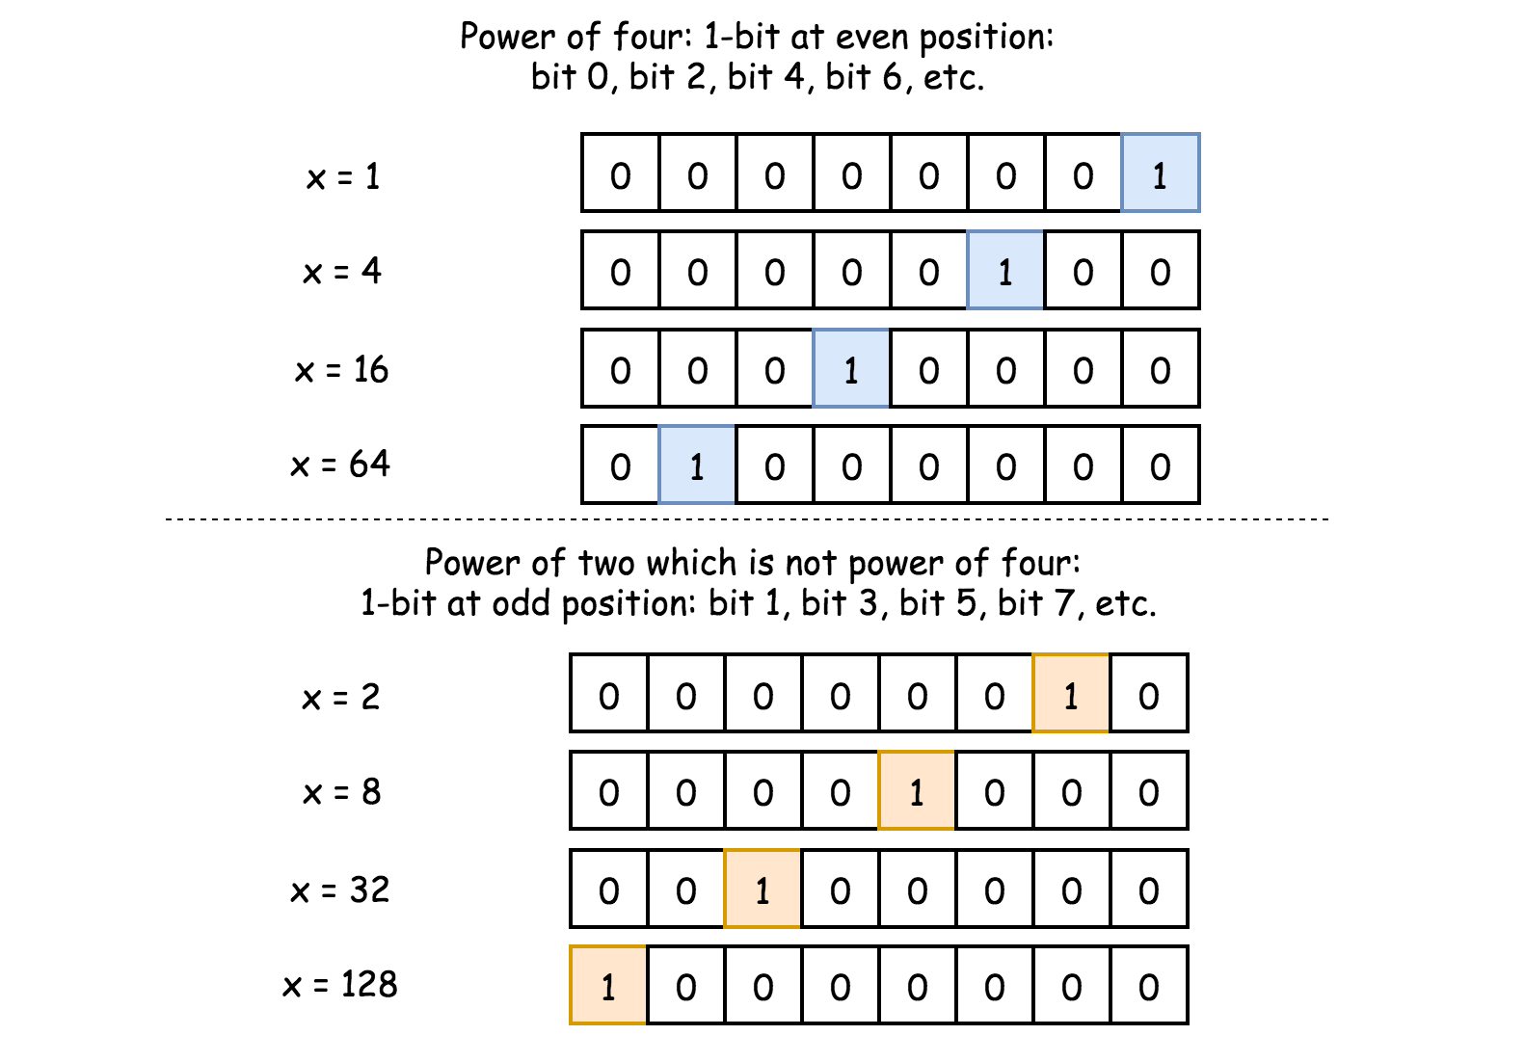

Hence power of four would make a zero in a bitwise AND with number (101010...10)_2(101010...10)2​:

4^a \land (101010...10)_2 == 04*a*∧(101010...10)2​==0

How long should be (101010...10)_2(101010...10)2​ if x*x* is a signed integer? 32 bits. To write shorter, in 8 charaters instead of 32, it's common to use [hexadecimal](https://en.wikipedia.org/wiki/Hexadecimal) representation: (101010...10)_2 = (aaaaaaaa)_{16}(101010...10)2​=(*aaaaaaaa*)16​.

x \land (aaaaaaaa)_{16} == 0*x*∧(*aaaaaaaa*)16​==0

|  |
| --- |
| class Solution {  public boolean isPowerOfFour(int num) {  return (num > 0) && ((num & (num - 1)) == 0) && ((num & 0xaaaaaaaa) == 0);  }  } |

**Complexity Analysis**

* Time complexity : \mathcal{O}(1)O(1).
* Space complexity : \mathcal{O}(1)O(1).

#### Approach 4: Bit Manipulation + Math

Let's first check if x*x* is a power of two: x > 0 and x & (x - 1) == 0. Now one could be sure that x = 2^a*x*=2*a*. Though x*x* is a power of four only if a*a* is even.

Next step is to consider both cases a = 2k*a*=2*k* and a = 2k + 1*a*=2*k*+1, and to compute x*x* modulo after division by three:

(2^{2k} \mod 3) = (4^k \mod 3) = ((3 + 1)^k \mod 3) = 1(22*k*mod3)=(4*k*mod3)=((3+1)*k*mod3)=1

((2^{2k + 1}) \mod 3) = ((2 \times 4^k) \mod 3) = ((2 \times(3 + 1)^k) \mod 3) = 2((22*k*+1)mod3)=((2×4*k*)mod3)=((2×(3+1)*k*)mod3)=2

If x*x* is a power of two and x % 3 == 1, then x*x* is a power of four.

|  |
| --- |
| class Solution {  public boolean isPowerOfFour(int num) {  return (num > 0) && ((num & (num - 1)) == 0) && (num % 3 == 1);  }  } |

**How this works: mod arithmetic**

To show the idea, let's compute x = 2^{2k} \mod 3*x*=22*k*mod3.

First, 2^{2k} = {2^2}^k = 4^k22*k*=22*k*=4*k*. Second, since 4 = 3 + 14=3+1, x*x* could be rewritten as

x = ((3 + 1)^k \mod 3)*x*=((3+1)*k*mod3)

Let's decompose

(3 + 1)^k = (3 + 1) \times (3 + 1)^{k - 1} = 3 \times (3 + 1)^{k - 1} + (3 + 1)^{k - 1}(3+1)*k*=(3+1)×(3+1)*k*−1=3×(3+1)*k*−1+(3+1)*k*−1.

The first term is divisible by 3, i.e. (3 \times (3 + 1)^{k - 1}) \mod 3 = 0(3×(3+1)*k*−1)mod3=0. Hence

x = ((3 + 1)^{k - 1} \mod 3)*x*=((3+1)*k*−1mod3)

One could continue like this k -> k - 1 -> k - 2 -> ... -> 1 and finally rewrite x*x* as

x = ((3 + 1)^1 \mod 3) = 1*x*=((3+1)1mod3)=1.

The job is done. Now y = 2^{2k + 1} \mod 3*y*=22*k*+1mod3 is simple, because if x \mod 3 = 1*x*mod3=1, then y \mod 3 = 2x \mod 3 = 2*y*mod3=2*x*mod3=2.

**Complexity Analysis**

* Time complexity : \mathcal{O}(1)O(1).
* Space complexity : \mathcal{O}(1)O(1).

**Find All Duplicates in an Array**

Given an array of integers, 1 ≤ a[i] ≤ *n* (*n* = size of array), some elements appear **twice** and others appear **once**.

Find all the elements that appear **twice** in this array.

Could you do it without extra space and in O(*n*) runtime?

**Example:**

**Input:**

[4,3,2,7,8,2,3,1]

**Output:**

[2,3]

## Solution

#### Approach 1: Brute Force

**Intuition**

Check for a second occurrence of every element in the rest of the array.

**Algorithm**

When we iterate over the elements of the input array, we can simply look for any other occurrence of the current element in the rest of the array.

Since an element can only occur once or twice, we don't have to worry about getting duplicates of elements that appear twice:

* **Case - I:** If an element occurs only once in the array, when you look for it in the rest of the array, you'll find nothing.
* **Case - II:** If an element occurs twice, you'll find the second occurrence of the element in the rest of the array. When you chance upon the second occurrence in a later iteration, it'd be the same as **Case - I** (since there are no more occurrences of this element in the rest of the array).

|  |
| --- |
| class Solution {  public List<Integer> findDuplicates(int[] nums) {  List<Integer> ans = new ArrayList<>();  for (int i = 0; i < nums.length; i++) {  for (int j = i + 1; j < nums.length; j++) {  if (nums[j] == nums[i]) {  ans.add(nums[i]);  break;  }  }  }  return ans;  }  } |

**Complexity Analysis**

* Time complexity : \mathcal{O}(n^2)O(*n*2).  
    
  For each element in the array, we search for another occurrence in the rest of the array. Hence, for the i^{{th}}*ith* element in the array, we might end up looking through all n - i*n*−*i* remaining elements in the worst case. So, we can end up going through about n^2*n*2 elements in the worst case.  
    
  n-1 + n-2 + n-3 + .... + 1 + 0 = \sum_{1}^{n}(n-i) \simeq n^2*n*−1+*n*−2+*n*−3+....+1+0=∑1*n*​(*n*−*i*)≃*n*2
* Space complexity : No extra space required, other than the space for the output list.

#### Approach 2: Sort and Compare Adjacent Elements

**Intuition**

After sorting a list of elements, all elements of equivalent value get placed together. Thus, when you sort an array, equivalent elements form contiguous blocks.

**Algorithm**

1. Sort the array.
2. Compare every element with it's neighbors. If an element occurs more than once, it'll be equal to at-least one of it's neighbors.

To simplify:

1. Compare every element with its predecessor.
   * Obviously the first element doesn't have a predecessor, so we can skip it.
2. Once we've found a match with a predecessor, we can skip the next element entirely!
   * **Why?** Well, if an element matches with its predecessor, it cannot possibly match with its successor as well. Thus, the next iteration (i.e. comparison between the next element and the current element) can be safely skipped.

|  |
| --- |
| class Solution {  public List<Integer> findDuplicates(int[] nums) {  List<Integer> ans = new ArrayList<>();  Arrays.sort(nums);  for (int i = 1; i < nums.length; i++) {  if (nums[i] == nums[i - 1]) {  ans.add(nums[i]);  i++; // skip over next element  }  }  return ans;  }  } |

**Complexity Analysis**

* Time complexity : \mathcal{O}(n \log{n}) + \mathcal{O}(n) \simeq \mathcal{O}(n \log{n})O(*n*log*n*)+O(*n*)≃O(*n*log*n*).
  + A performant comparison-based sorting algorithm will run in \mathcal{O}(n \log{n})O(*n*log*n*) time. Note that this can be reduced to \mathcal{O}(n)O(*n*) using a special sorting algorithm like [Radix Sort](https://en.wikipedia.org/wiki/Radix_sort).
  + Traversing the array after sorting takes linear time i.e. \mathcal{O}(n)O(*n*).
* Space complexity : No extra space required, other than the space for the output list. Sorting can be done in-place.

#### Approach 3: Store Seen Elements in a Set / Map

**Intuition**

In [Approach 1](https://leetcode.com/problems/find-all-duplicates-in-an-array/solution/#approach-1-brute-force) we used two loops (one nested within the other) to look for two occurrences of an element. In almost all similar situations, you can usually substitute one of the loops with a set / map. Often, it's a worthy trade-off: **for a bit of extra memory, you can reduce the order of your runtime complexity.**

**Algorithm**

We store all elements that we've seen till now in a map / set. When we visit an element, we query the map / set to figure out if we've seen this element before.

|  |
| --- |
| class Solution {  public List<Integer> findDuplicates(int[] nums) {  List<Integer> ans = new ArrayList<>();  Set<Integer> seen = new HashSet<>();  for (int num : nums) {  if (seen.contains(num)) {  ans.add(num);  } else {  seen.add(num);  }  }  return ans;  }  } |

**Complexity Analysis**

* Time complexity : \mathcal{O}(n)O(*n*) average case. \mathcal{O}(n^2)O(*n*2) worst case.
  + It takes a linear amount of time to iterate through the array.
  + Lookups in a hashset are constant time on average, however those can degrade to linear time in the worst case. Note that an alternative is to use tree-based sets, which give logarithmic time lookups always.
* Space complexity : Upto \mathcal{O}(n)O(*n*) extra space required for the set.
  + If you are tight on space, you can significantly reduce your physical space requirements by using bitsets [[1]](https://leetcode.com/problems/find-all-duplicates-in-an-array/solution/#fn1) instead of sets. This data-structure requires just one bit per element, so you can be done in just n*n* bits of data for elements that go up-to n*n*. Of course, this doesn't reduce your space complexity: bitsets still grow linearly with the range of values that the elements can take.

#### Approach 4: Mark Visited Elements in the Input Array itself

**Intuition**

All the above approaches have ignored a key piece of information in the problem statement:

The integers in the input array arr satisfy 1 ≤ arr[i] ≤ n, where n is the size of array. [[2]](https://leetcode.com/problems/find-all-duplicates-in-an-array/solution/#fn2)

This presents us with two key insights:

1. All the integers present in the array are positive. i.e. arr[i] > 0 for any valid index i. [[3]](https://leetcode.com/problems/find-all-duplicates-in-an-array/solution/#fn3)
2. The decrement of any integers present in the array must be an accessible index in the array.  
   i.e. for any integer x in the array, x-1 is a valid index, and thus, arr[x-1] is a valid reference to an element in the array. [[4]](https://leetcode.com/problems/find-all-duplicates-in-an-array/solution/#fn4)

**Algorithm**

1. Iterate over the array and for every element x in the array, negate the value at index abs(x)-1. [[5]](https://leetcode.com/problems/find-all-duplicates-in-an-array/solution/#fn5)
   * The negation operation effectively marks the value abs(x) as seen / visited.

**Pop Quiz:** Why do we need to use abs(x), instead of x?

1. Iterate over the array again, for every element x in the array:
   * If the value at index abs(x)-1 is positive, it must have been negated twice. Thus abs(x) must have appeared twice in the array. We add abs(x) to the result.
   * In the above case, when we reach the second occurrence of abs(x), we need to avoid fulfilling this condition again. So, we'll additionally negate the value at index abs(x)-1.

|  |
| --- |
| class Solution {  public List<Integer> findDuplicates(int[] nums) {  List<Integer> ans = new ArrayList<>();  for (int num : nums) {  nums[Math.abs(num) - 1] *= -1;  }  for (int num : nums) {  if (nums[Math.abs(num) - 1] > 0) {  ans.add(Math.abs(num));  nums[Math.abs(num) - 1] *= -1;  }  }  return ans;  }  } |

**Pop Quiz:** Can you do this in a single loop?

Definitely! Notice that if an element x occurs just once in the array, the value at index abs(x)-1 becomes negative and remains so for all of the iterations that follow.

1. Traverse through the array. When we see an element x for the first time, we'll negate the value at index abs(x)-1.
2. But, the next time we see an element x, we *don't* need to negate again! If the value at index abs(x)-1 is already negative, we know that we've seen element x before.

So, now we are relying on a single negation to mark the visited status of an element. This is similar to what we did in [Approach 3](https://leetcode.com/problems/find-all-duplicates-in-an-array/solution/#approach-3-store-seen-elements-in-a-set), except that we are re-using the array (with some smart negations) instead of a separate set.

|  |
| --- |
| class Solution {  public List<Integer> findDuplicates(int[] nums) {  List<Integer> ans = new ArrayList<>();  for (int num : nums) {  if (nums[Math.abs(num) - 1] < 0) { // seen before  ans.add(Math.abs(num));  }  nums[Math.abs(num) - 1] *= -1;  }  return ans;  }  } |

**Complexity Analysis**

* Time complexity : \mathcal{O}(n)O(*n*). We iterate over the array twice. Each negation operation occurs in constant time.
* Space complexity : No extra space required, other than the space for the output list. We re-use the input array to store visited status.

1. C++ provides an excellent std::bitset in the [standard library](https://en.cppreference.com/w/cpp/utility/bitset). [↩︎](https://leetcode.com/problems/find-all-duplicates-in-an-array/solution/#fnref1)
2. Some readers will notice a similarity with [the pigeonhole principle](https://en.wikipedia.org/wiki/Pigeonhole_principle). While this doesn't really come into play in [Approach 4](https://leetcode.com/problems/find-all-duplicates-in-an-array/solution/#approach-4-mark-visited-elements-in-the-input-array-itself), we utilized it indirectly in [Approach 3](https://leetcode.com/problems/find-all-duplicates-in-an-array/solution/#approach-3-store-seen-elements-in-a-set): since some elements appear twice, the number of unique elements is less than the size of the array. If every unique element gets a bucket in our map / set, some buckets are bound to have more than one element in them! [↩︎](https://leetcode.com/problems/find-all-duplicates-in-an-array/solution/#fnref2)
3. Because, arr[i] >= 1 for any valid index i of array arr. [↩︎](https://leetcode.com/problems/find-all-duplicates-in-an-array/solution/#fnref3)
4. Because, all elements in the array are integers that lie in the range [1, n][1,*n*] (where n*n* is length of the array). Thus, their decrements are integers that lie in the range [0, n-1][0,*n*−1] (which is precisely the set of valid indices for an array of length n*n*). [↩︎](https://leetcode.com/problems/find-all-duplicates-in-an-array/solution/#fnref4)
5. The abs() function provides the absolute value. [↩︎](https://leetcode.com/problems/find-all-duplicates-in-an-array/solution/#fnref5)

**Vertical Order Traversal of a Binary Tree**

Given the root of a binary tree, calculate the **vertical order traversal** of the binary tree.

For each node at position (row, col), its left and right children will be at positions (row + 1, col - 1) and (row + 1, col + 1) respectively. The root of the tree is at (0, 0).

The **vertical order traversal** of a binary tree is a list of top-to-bottom orderings for each column index starting from the leftmost column and ending on the rightmost column. There may be multiple nodes in the same row and same column. In such a case, sort these nodes by their values.

Return *the****vertical order traversal****of the binary tree*.

**Example 1:**

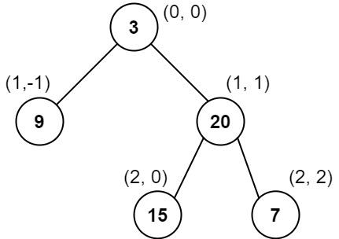

**Input:** root = [3,9,20,null,null,15,7]

**Output:** [[9],[3,15],[20],[7]]

**Explanation:**

Column -1: Only node 9 is in this column.

Column 0: Nodes 3 and 15 are in this column in that order from top to bottom.

Column 1: Only node 20 is in this column.

Column 2: Only node 7 is in this column.

**Example 2:**

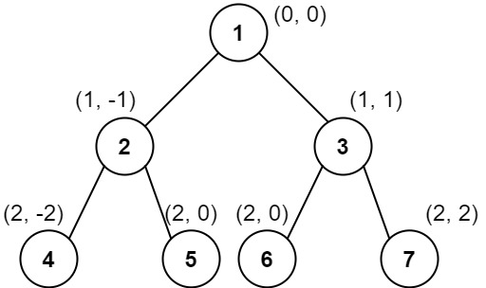

**Input:** root = [1,2,3,4,5,6,7]

**Output:** [[4],[2],[1,5,6],[3],[7]]

**Explanation:**

Column -2: Only node 4 is in this column.

Column -1: Only node 2 is in this column.

Column 0: Nodes 1, 5, and 6 are in this column.

1 is at the top, so it comes first.

5 and 6 are at the same position (2, 0), so we order them by their value, 5 before 6.

Column 1: Only node 3 is in this column.

Column 2: Only node 7 is in this column.

**Example 3:**

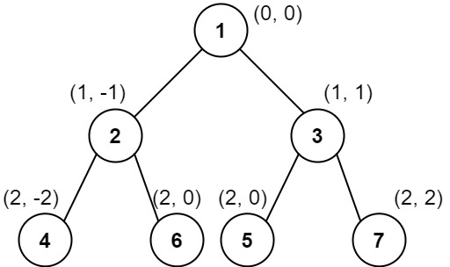

**Input:** root = [1,2,3,4,6,5,7]

**Output:** [[4],[2],[1,5,6],[3],[7]]

**Explanation:**

This case is the exact same as example 2, but with nodes 5 and 6 swapped.

Note that the solution remains the same since 5 and 6 are in the same location and should be ordered by their values.

**Constraints:**

* The number of nodes in the tree is in the range [1, 1000].
* 0 <= Node.val <= 1000

## Solution Article

#### Overview

This is yet another problem about Binary Tree traversals. As one would probably know, the common strategies to traverse a Tree data structure are **Breadth-First Search** (a.k.a. BFS) and **Depth-First Search** (a.k.a. DFS).

The DFS strategy can be further distinguished as preorder DFS, inorder DFS and postorder DFS, depending on the relative order of visit among the node itself and its child nodes.

If one is not familiar with the concepts of BFS and DFS, we have an Explore card called [Queue & Stack](https://leetcode.com/explore/learn/card/queue-stack/) where we cover the [BFS traversal](https://leetcode.com/explore/learn/card/queue-stack/231/practical-application-queue/) as well as the [DFS traversal](https://leetcode.com/explore/learn/card/queue-stack/232/practical-application-stack/). Hence, in this article, we won't repeat ourselves on these concepts.

In this problem, we are asked to return the **vertical** order of a binary tree, which implies three sub-orders (denoted as <column, row, value>) as follows:

* **column-wise order**

First, we look at a binary tree horizontally. Each node would be aligned to a specific column, based on its relative offset to the root node of the tree.

Let us assume that the root node has a column index of 0, then its left child node would have a column index of -1, and its right child node would have a column index of +1, and so on.

* **row-wise order**

Secondly, we look at the binary tree vertically. Each node would be assigned to a specific row, based on its level (i.e. the vertical distance to the root node).

Let us assume that the root node has a row index of 0, then both its child nodes would have the row index of 1. Note that the convention we adopt here is slightly different from the one in the problem description where the row index of a parent node is larger than the one of its child nodes. This, though, would not jeopardize our solution. On the contrary, it would help us to simplify the solution, as one will see later.

* **value-wise order**

Finally, given the definitions of the above two sub-orders, there could be a case where two different nodes have the same <column, row> index. As a result, to resolve the draw situation, as stated in the problem description, the node that has a smaller value should come first.

Given the above definitions, we can now formulate the problem as a task to **sort** the nodes based on the 3-dimensional coordinates (i.e. <column, row, value>) that we defined above.

The priority of each coordinate is determined by its order. For example, the coordinate column comes first, therefore it has the highest priority. A node with the lowest column index would come up first, regardless the other two coordinates.

Before proceeding to the solutions, we would like to mention that there is another almost identical problem called [314. Binary Tree Vertical Order Traversal](https://leetcode.com/problems/binary-tree-vertical-order-traversal/) in the LeetCode.

The only difference between these two problems lies in the third sub-order. When two nodes have the same <column, row> index, in this problem we would further order them based on their values, while in the problem of 314 we would order them based on the horizontal order from left to right. To illustrate the difference, we show an example in the following graph on how two nodes of the same <column, row> index should be ordered respectively in these two problems.

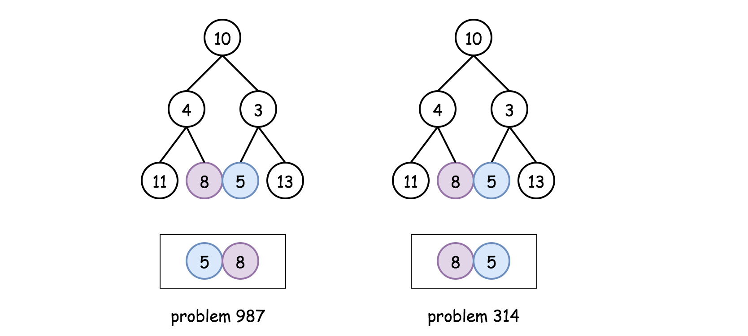

A subtle difference as it seems to be, yet it has a significant impact on the solutions. As a spoiler alert, one could solve the problem of 314 without resorting to the sorting operation, while for this problem the sorting is inevitable due to the third sub-order required in the problem.

#### Approach 1: BFS/DFS with Global Sorting

**Intuition**

In the overview section, we've reduced the problem into a sorting problem, based on the order of 3-dimensional coordinates <column, row, value> as we defined.

As a result, the idea to solve the problem would be as intuitive as **building** a list where each element in the list corresponds to the 3-dimensional coordinates of each node in the tree, and then **sorting** the list based on the coordinates.

To build such a list, we would need to traverse all the nodes in the tree, which we could do with either Breadth-First Search (**BFS**) or Depth-First Search (**DFS**). Most of the time, facing the problems of binary tree traversal, we need to make a choice between them. However, in this case, both of the approaches would work. Because both of them would lead to a list that contains the coordinates of all nodes. Though the order of elements in the list would differ depending on the approach, it does not matter, since we would sort the list anyway.

**Algorithm**

Based on the above intuition, we could implement the solution in 3 simple steps:

* **Step 1)**: we traverse the input tree either by BFS or DFS, in order to generate a list that contains the 3-dimensional coordinates (i.e. <column, row, value>) of each node.
  + Note that, we assign a higher row index value to a node's child node. This convention is at odds with the denotation given in the problem description. This is done intentionally, in order to keep the ordering of all coordinates consistent, i.e. a lower value in any specific coordinate represents a higher order. As a result, a sorting operation in ascending order would work for each coordinate consistently.
* **Step 2)**: Once we generate the desired list, we then sort the list.
* **Step 3)**: From the sorted list, we then extract the results, and group them by the column index.

In the following, we give some sample implementations with both the BFS traversal and the DFS traversal.

***BFS Traversal***

|  |
| --- |
| class Triplet<F, S, T> {  public final F first;  public final S second;  public final T third;  public Triplet(F first, S second, T third) {  this.first = first;  this.second = second;  this.third = third;  }  }  class Solution {  List<Triplet<Integer, Integer, Integer>> nodeList = new ArrayList<>();  private void BFS(TreeNode root) {  Queue<Triplet<TreeNode, Integer, Integer>> queue = new ArrayDeque();  int row = 0, column = 0;  queue.offer(new Triplet(root, row, column));  while (!queue.isEmpty()) {  Triplet<TreeNode, Integer, Integer> triplet = queue.poll();  root = triplet.first;  row = triplet.second;  column = triplet.third;  if (root != null) {  this.nodeList.add(new Triplet(column, row, root.val));  queue.offer(new Triplet(root.left, row + 1, column - 1));  queue.offer(new Triplet(root.right, row + 1, column + 1));  }  }  }  public List<List<Integer>> verticalTraversal(TreeNode root) {  List<List<Integer>> output = new ArrayList();  if (root == null) {  return output;  }  // step 1). BFS traversal  BFS(root);  // step 2). sort the global list by <column, row, value>  Collections.sort(this.nodeList, new Comparator<Triplet<Integer, Integer, Integer>>() {  @Override  public int compare(Triplet<Integer, Integer, Integer> t1,  Triplet<Integer, Integer, Integer> t2) {  if (t1.first.equals(t2.first))  if (t1.second.equals(t2.second))  return t1.third - t2.third;  else  return t1.second - t2.second;  else  return t1.first - t2.first;  }  });  // step 3). extract the values, partitioned by the column index.  List<Integer> currColumn = new ArrayList();  Integer currColumnIndex = this.nodeList.get(0).first;  for (Triplet<Integer, Integer, Integer> triplet : this.nodeList) {  Integer column = triplet.first, value = triplet.third;  if (column == currColumnIndex) {  currColumn.add(value);  } else {  output.add(currColumn);  currColumnIndex = column;  currColumn = new ArrayList();  currColumn.add(value);  }  }  output.add(currColumn);  return output;  }  } |

Note: when extracting the desired result from the sorted list, one would use the hashmap data structure, which could make the code more concise, as we did in the Python implementation.

Or, one could do so solely with the list data structure as we did in the Java implementation, which theoretically could be more efficient since we do not need to convert the results from hashmap to list.

***DFS Traversal***

|  |
| --- |
| class Triplet<F, S, T> {  public final F first;  public final S second;  public final T third;  public Triplet(F first, S second, T third) {  this.first = first;  this.second = second;  this.third = third;  }  }  class Solution {  List<Triplet<Integer, Integer, Integer>> nodeList = new ArrayList<>();  private void DFS(TreeNode node, Integer row, Integer column) {  if (node == null)  return;  nodeList.add(new Triplet(column, row, node.val));  // preorder DFS traversal  this.DFS(node.left, row + 1, column - 1);  this.DFS(node.right, row + 1, column + 1);  }  public List<List<Integer>> verticalTraversal(TreeNode root) {  List<List<Integer>> output = new ArrayList();  if (root == null) {  return output;  }  // step 1). DFS traversal  DFS(root, 0, 0);  // step 2). sort the list by <column, row, value>  Collections.sort(this.nodeList, new Comparator<Triplet<Integer, Integer, Integer>>() {  @Override  public int compare(Triplet<Integer, Integer, Integer> t1,  Triplet<Integer, Integer, Integer> t2) {  if (t1.first.equals(t2.first))  if (t1.second.equals(t2.second))  return t1.third - t2.third;  else  return t1.second - t2.second;  else  return t1.first - t2.first;  }  });  // step 3). extract the values, grouped by the column index.  List<Integer> currColumn = new ArrayList();  Integer currColumnIndex = this.nodeList.get(0).first;  for (Triplet<Integer, Integer, Integer> triplet : this.nodeList) {  Integer column = triplet.first, value = triplet.third;  if (column == currColumnIndex) {  currColumn.add(value);  } else {  output.add(currColumn);  currColumnIndex = column;  currColumn = new ArrayList();  currColumn.add(value);  }  }  output.add(currColumn);  return output;  }  } |

**Complexity Analysis**

Let N*N* be the number of nodes in the input tree.

* Time Complexity: \mathcal{O}(N \log N)O(*N*log*N*), which applies to both the BFS and DFS approaches.
  + In the first step of the algorithm, we traverse the input tree with either BFS or DFS, which would take \mathcal{O}(N)O(*N*) time.
  + Secondly, we sort the obtained list of coordinates which contains N*N* elements. The sorting operation would take \mathcal{O}(N \log N)O(*N*log*N*) time.
  + Finally, we extract the results from the sorted list, which would take another \mathcal{O}(N)O(*N*) time.
  + To summarize, the overall time complexity of the algorithm would be \mathcal{O}(N \log N)O(*N*log*N*), which is dominated by the sorting operation in the second step.
* Space Complexity: \mathcal{O}(N)O(*N*). Again this applies to both the BFS and DFS approaches.
  + In the first step of the algorithm, we build a list that contains the coordinates of all the nodes. Hence, we need \mathcal{O}(N)O(*N*) space for this list.
  + Additionally, for the BFS approach, we used a queue data structure to maintain the order of visits. At any given moment, the queue contains no more than **two levels** of nodes in the tree. The maximal number of nodes at one level is \frac{N}{2}2*N*​, which is the number of the leaf nodes in a balanced binary tree. As a result, the space needed for the queue would be \mathcal{O}(\frac{N}{2} \cdot 2) = \mathcal{O}(N)O(2*N*​⋅2)=O(*N*).
  + Although we don't need the queue data structure for the DFS approach, the recursion in the DFS approach incurs some additional memory consumption on the function call stack. In the worst case, the input tree might be completely imbalanced, e.g. each node has only the left child node. In this case, the recursion would occur up to N*N* times, which in turn would consume \mathcal{O}(N)O(*N*) space in the function call stack.
  + To summarize, the space complexity for the BFS approach would be \mathcal{O}(N) + \mathcal{O}(N) = \mathcal{O}(N)O(*N*)+O(*N*)=O(*N*). And the same applies to the DFS approach.

#### Approach 2: BFS/DFS with Partition Sorting

**Intuition**

As we can see in the above approaches, the overall time complexity is dominated by the sorting operation on the list of coordinates. In order to further optimize the solution, we can try to do something with the sorting.

It would be hard, if not impossible, to eliminate the sorting operation, since we still need a means to resolve the draw situation when two nodes share the same <column, row> index.

One might argue that we could use the **heap** data structure (also known as PriorityQueue in Java) to maintain the list of coordinates. The elements in the heap data structure are ordered automatically, and this does eliminate the sorting operation. However, to maintain the elements in order, each insertion operation in heap would take \mathcal{O}(\log N)O(log*N*) time complexity. In other words, one can consider the heap data structure as another form of sorting, which amortizes the cost of sorting operating over each insertion.

One could apply the head data structure to replace the sorting operation here, which could make the code more concise. But this is not the main point here.

That being said, one thing that we can do is to reduce the scope of sorting, by **partitioning** the list of coordinates into subgroups based on the column index.

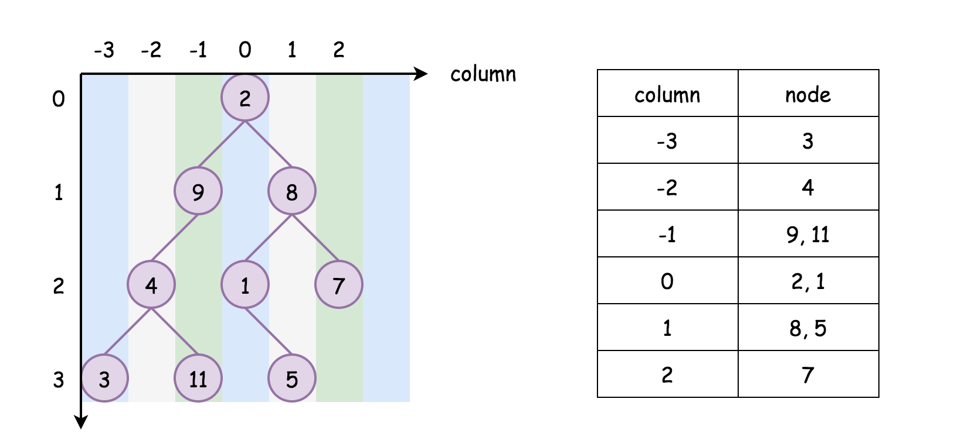

Although we would still need to sort the subgroups respectively, it would be **faster** to sort a series of subgroups than sorting them all together in a single group. Here is a not-so-rigid proof.

Suppose that we have a list of N*N* elements, it would then take \mathcal{O}(N \log N)O(*N*log*N*) time to sort this list.

Next, we divide the list into k*k* sublists equally. Each list would contain \frac{N}{k}*kN*​ elements. Similarly, it would take \mathcal{O}(\frac{N}{k} \log \frac{N}{k})O(*kN*​log*kN*​) time to sort each sublist.

In total, to sort all the k*k* sublists, it would take \mathcal{O}(k \cdot \frac{N}{k} \log \frac{N}{k}) = \mathcal{O}(N \log \frac{N}{k})O(*k*⋅*kN*​log*kN*​)=O(*N*log*kN*​), which is **less than** the time complexity of sorting the original list (i.e. \mathcal{O}(N \log N)O(*N*log*N*)).

More importantly, another rationale to partition the list into column based groups is that this is also the format of results that are asked in the problem.

Once we sort the column based groups, we can directly return the groups as results, without the need for extraction as we did in the previous approach.

This is also the reason why we would not recommend to further partition the list based on the combination of <column, row> index. Although theoretically, the more groups that we partition the list into, the faster the sorting operations would be.

If we partition the list into the groups lead by <column row> index, we would need some additional processing to extract the results. Hence, it would become an overkill.

**Algorithm**

We could implement the above intuition based on the previous approaches. Again, we could break it down into 3 steps:

* **Step 1)**: First of all, we create a hashmap called columnTable with the column index as key and the list of <row, value> tuples as value. This hashmap is used to hold the groups of coordinates.
  + We traverse the input tree by either BFS or DFS. During the traversal, we populate the hashmap that we created above.
  + Meanwhile, we also note down the minimal and maximal column index during the traversal. The minimal and maximal column index defines the range of column index. With this range, we could iterate through columns in order without the need for sorting, as one will see later.
* **Step 2)**: Once we populate the above hashmap, we then sort the value in each entry of the hashmap, i.e. we sort each group of coordinates led by the column index.
* **Step 3)**: From the sorted hashmap, we extract the results that are grouped by the column index.

In the following, we give some sample implementations with both the BFS traversal and the DFS traversal.

***BFS Traversal***

|  |
| --- |
| class Solution {  // key: column; value: <row, node_value>  Map<Integer, ArrayList<Pair<Integer, Integer>>> columnTable = new HashMap();  int minColumn = 0, maxColumn = 0;  private void BFS(TreeNode root) {  // tuples of <column, <row, value>>  Queue<Pair<TreeNode, Pair<Integer, Integer>>> queue = new ArrayDeque();  int row = 0, column = 0;  queue.offer(new Pair(root, new Pair(row, column)));  while (!queue.isEmpty()) {  Pair<TreeNode, Pair<Integer, Integer>> p = queue.poll();  root = p.getKey();  row = p.getValue().getKey();  column = p.getValue().getValue();  if (root != null) {  if (!columnTable.containsKey(column)) {  columnTable.put(column, new ArrayList<Pair<Integer, Integer>>());  }  columnTable.get(column).add(new Pair<>(row, root.val));  minColumn = Math.min(minColumn, column);  maxColumn = Math.max(maxColumn, column);  queue.offer(new Pair(root.left, new Pair(row + 1, column - 1)));  queue.offer(new Pair(root.right, new Pair(row + 1, column + 1)));  }  }  }  public List<List<Integer>> verticalTraversal(TreeNode root) {  List<List<Integer>> output = new ArrayList();  if (root == null) {  return output;  }  // step 1). BFS traversal  this.BFS(root);  // step 2). retrieve the value from the columnTable  for (int i = minColumn; i < maxColumn + 1; ++i) {  // order by both "row" and "value"  Collections.sort(columnTable.get(i), new Comparator<Pair<Integer, Integer>>() {  @Override  public int compare(Pair<Integer, Integer> p1, Pair<Integer, Integer> p2) {  if (p1.getKey().equals(p2.getKey()))  return p1.getValue() - p2.getValue();  else  return p1.getKey() - p2.getKey();  }  });  List<Integer> sortedColumn = new ArrayList();  for (Pair<Integer, Integer> p : columnTable.get(i)) {  sortedColumn.add(p.getValue());  }  output.add(sortedColumn);  }  return output;  }  } |

***DFS traversal***

|  |
| --- |
| class Solution {  Map<Integer, ArrayList<Pair<Integer, Integer>>> columnTable = new HashMap();  int minColumn = 0, maxColumn = 0;  private void DFS(TreeNode node, Integer row, Integer column) {  if (node == null)  return;  if (!columnTable.containsKey(column)) {  this.columnTable.put(column, new ArrayList<Pair<Integer, Integer>>());  }  this.columnTable.get(column).add(new Pair<Integer, Integer>(row, node.val));  this.minColumn = Math.min(minColumn, column);  this.maxColumn = Math.max(maxColumn, column);  // preorder DFS traversal  this.DFS(node.left, row + 1, column - 1);  this.DFS(node.right, row + 1, column + 1);  }  public List<List<Integer>> verticalTraversal(TreeNode root) {  List<List<Integer>> output = new ArrayList();  if (root == null) {  return output;  }  // step 1). DFS traversal  this.DFS(root, 0, 0);  // step 2). retrieve the value from the columnTable  for (int i = minColumn; i < maxColumn + 1; ++i) {  // order by both "row" and "value"  Collections.sort(columnTable.get(i), new Comparator<Pair<Integer, Integer>>() {  @Override  public int compare(Pair<Integer, Integer> p1, Pair<Integer, Integer> p2) {  if (p1.getKey().equals(p2.getKey()))  return p1.getValue() - p2.getValue();  else  return p1.getKey() - p2.getKey();  }  });  List<Integer> sortedColumn = new ArrayList();  for (Pair<Integer, Integer> p : columnTable.get(i)) {  sortedColumn.add(p.getValue());  }  output.add(sortedColumn);  }  return output;  }  } |

**Complexity Analysis**

Let N*N* be the number of nodes in the tree.

* Time Complexity: \mathcal{O}(N \log{\frac{N}{k}})O(*N*log*kN*​) where k*k* is the width of the tree, *i.e.* k*k* is also the number of columns in the result.
  + In the first step, it takes \mathcal{O}(N)O(*N*) time complexity for both the BFS and DFS traversal.
  + In the second step, we need to sort the hashmap entry by entry. As we shown in the intuition section, the time complexity of sorting k*k* equal-sized subgroups of with total N*N* elements would be \mathcal{O}(k \cdot \frac{N}{k} \log{\frac{N}{k}}) = \mathcal{O}(N \log{\frac{N}{k}})O(*k*⋅*kN*​log*kN*​)=O(*N*log*kN*​). If we assume that the nodes are evenly aligned in the columns, then this would be the time complexity of sorting the obtained hashmap.
  + Finally, it takes another \mathcal{O}(N)O(*N*) time complexity to extract the results from the hashmap.
  + As a result, the overall time complexity is \mathcal{O}(N \log{\frac{N}{k}})O(*N*log*kN*​).
  + Although the sorting operation in the second step still dominates, it is more optimized compared to the previous approach of sorting the entire coordinates. Let us look at one particular example. In the case where the tree is complete imbalanced (*e.g.* a node has only left node), the tree would be partitioned into exactly N*N* groups. Each group contains a single element. It would take no time to sort each group. As a result, the overall time complexity of this approach becomes N \cdot \mathcal{O}(1) = \mathcal{O}(N)*N*⋅O(1)=O(*N*). While for the previous approach, its overall time complexity remains \mathcal{O}(N \log N)O(*N*log*N*).
* Space Complexity: \mathcal{O}(N)O(*N*). Again this applies to both the BFS and DFS approaches. The analysis is the same as the previous approach.

**Closest Binary Search Tree Value**

Given a non-empty binary search tree and a target value, find the value in the BST that is closest to the target.

**Note:**

* Given target value is a floating point.
* You are guaranteed to have only one unique value in the BST that is closest to the target.

**Example:**

**Input:** root = [4,2,5,1,3], target = 3.714286

4

/ \

2 5

/ \

1 3

**Output:** 4

## Solution

#### Approach 1: Recursive Inorder + Linear search, O(N) time

**Intuition**

The simplest approach (3 lines in Python) is to build inorder traversal and then find the closest element in a sorted array with built-in function min.

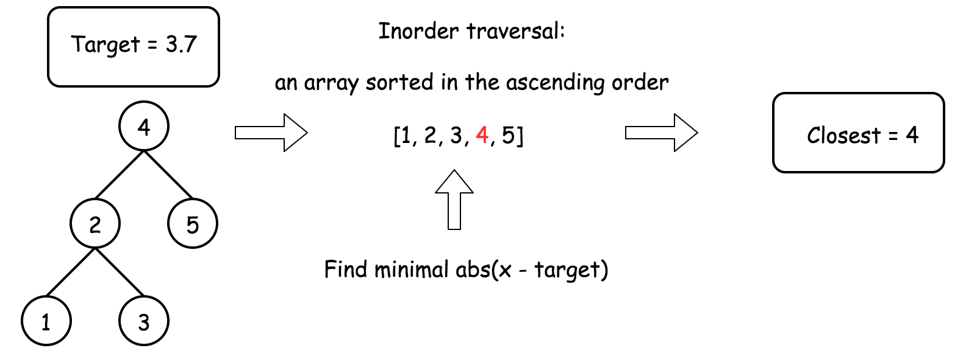

This approach is simple stupid, and serves to identify the subproblems.

**Algorithm**

* Build an inorder traversal array.
* Find the closest to target element in that array.

**Implementation**

|  |
| --- |
| class Solution {  public void inorder(TreeNode root, List<Integer> nums) {  if (root == null) return;  inorder(root.left, nums);  nums.add(root.val);  inorder(root.right, nums);  }  public int closestValue(TreeNode root, double target) {  List<Integer> nums = new ArrayList();  inorder(root, nums);  return Collections.min(nums, new Comparator<Integer>() {  @Override  public int compare(Integer o1, Integer o2) {  return Math.abs(o1 - target) < Math.abs(o2 - target) ? -1 : 1;  }  });  }  } |

**Complexity Analysis**

* Time complexity : \mathcal{O}(N)O(*N*) because to build inorder traversal and then to perform linear search takes linear time.
* Space complexity : \mathcal{O}(N)O(*N*) to keep inorder traversal.

#### Approach 2: Iterative Inorder, O(k) time

**Intuition**

Let's optimise Approach 1 in the case when index k of the closest element is much smaller than the tree heigh H.

First, one could merge both steps by traversing the tree and searching the closest value at the same time.

Second, one could stop just after identifying the closest value, there is no need to traverse the whole tree. The closest value is found if the target value is in-between of two inorder array elements nums[i] <= target < nums[i + 1]. Then the closest value is one of these elements.

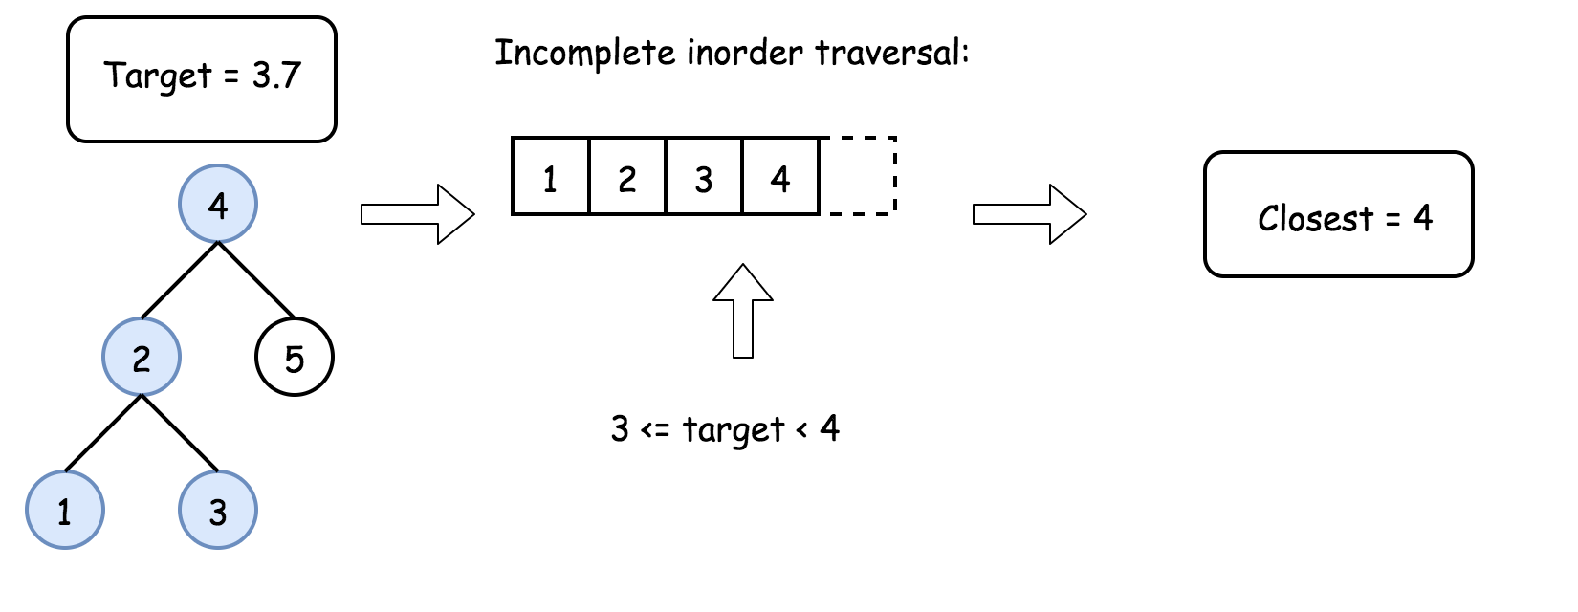

**Algorithm**

* Initiate stack as an empty array and predecessor value as a very small number.
* While root is not null:
  + To build an inorder traversal iteratively, go left as far as you can and add all nodes on the way into stack.
  + Pop the last element from stack root = stack.pop().
  + If target is in-between of pred and root.val, return the closest between these two elements.
  + Set predecessor value to be equal to root.val and go one step right: root = root.right.
* We're here because during the loop one couldn't identify the closest value. That means that the closest value is the last value in the inorder traversal, i.e. current predecessor value. Return it.

**Implementation**

|  |
| --- |
| class Solution {  public int closestValue(TreeNode root, double target) {  LinkedList<TreeNode> stack = new LinkedList();  long pred = Long.MIN_VALUE;  while (!stack.isEmpty() || root != null) {  while (root != null) {  stack.add(root);  root = root.left;  }  root = stack.removeLast();  if (pred <= target && target < root.val)  return Math.abs(pred - target) < Math.abs(root.val - target) ? (int)pred : root.val;  pred = root.val;  root = root.right;  }  return (int)pred;  }  } |

**Complexity Analysis**

* Time complexity : \mathcal{O}(k)O(*k*) in the average case and \mathcal{O}(H + k)O(*H*+*k*) in the worst case, where k is an index of closest element. It's known that [average case is a balanced tree](https://pages.cpsc.ucalgary.ca/~jacobs/Courses/cpsc331/F08/notes/lecture17.pdf), in that case stack always contains a few elements, and hence one does 2k2*k* operations to go to kth element in inorder traversal (k times to push into stack and then k times to pop out of stack). That results in \mathcal{O}(k)O(*k*) time complexity. The worst case is a completely unbalanced tree, then you first push H elements into stack and then pop out k elements, that results in \mathcal{O}(H + k)O(*H*+*k*) time complexity.

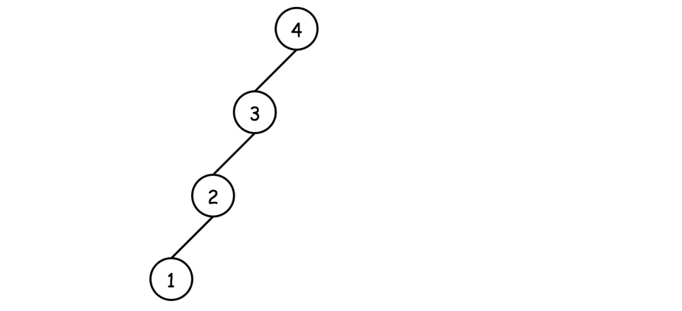

* Space complexity : up to \mathcal{O}(H)O(*H*) to keep the stack in the case of non-balanced tree.

#### Approach 3: Binary Search, O(H) time

**Intuition**

Approach 2 works fine when index k of closest element is much smaller than the tree height H.

Let's now consider another limit and optimise Approach 1 in the case of relatively large k, comparable with N.

Then it makes sense to use a binary search: go left if target is smaller than current root value, and go right otherwise. Choose the closest to target value at each step.

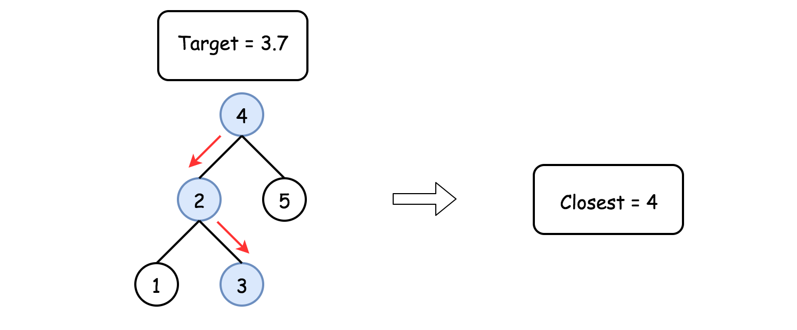

Kudos for this solution go to @[stefanpochmann](https://leetcode.com/stefanpochmann/).

**Implementation**

|  |
| --- |
| class Solution {  public int closestValue(TreeNode root, double target) {  int val, closest = root.val;  while (root != null) {  val = root.val;  closest = Math.abs(val - target) < Math.abs(closest - target) ? val : closest;  root = target < root.val ? root.left : root.right;  }  return closest;  }  } |

**Complexity Analysis**

* Time complexity : \mathcal{O}(H)O(*H*) since here one goes from root down to a leaf.
* Space complexity : \mathcal{O}(1)O(1).

**Path Sum III**

You are given a binary tree in which each node contains an integer value.

Find the number of paths that sum to a given value.

The path does not need to start or end at the root or a leaf, but it must go downwards (traveling only from parent nodes to child nodes).

The tree has no more than 1,000 nodes and the values are in the range -1,000,000 to 1,000,000.

**Example:**

root = [10,5,-3,3,2,null,11,3,-2,null,1], sum = 8

10

/ \

**5** **-3**

**/** **\** **\**

**3** **2** **11**

/ \ **\**

3 -2 **1**

Return 3. The paths that sum to 8 are:

1. 5 -> 3

2. 5 -> 2 -> 1

3. -3 -> 11

## Solution

#### Prefix Sum: What is it

In this article, we're going to discuss simple but powerful [prefix sum technique](https://en.wikipedia.org/wiki/Prefix_sum): one pass + linear time complexity.

Prefix sum is a sum of the current value with all previous elements starting from the beginning of the structure.

It could be defined for 1D arrays (sum the current value with all the previous integers),

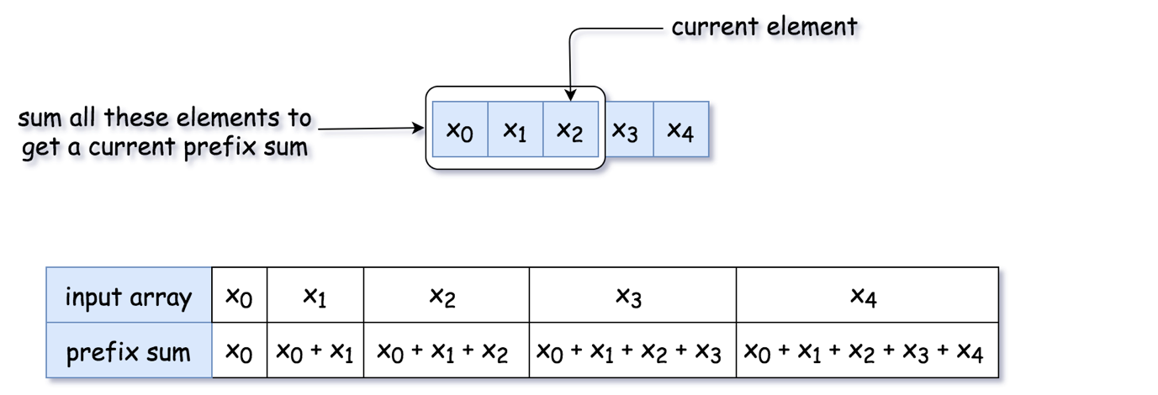 Figure 1. Prefix sum for 1D array.

for 2D arrays (sum of the current value with the integers above or on the left)

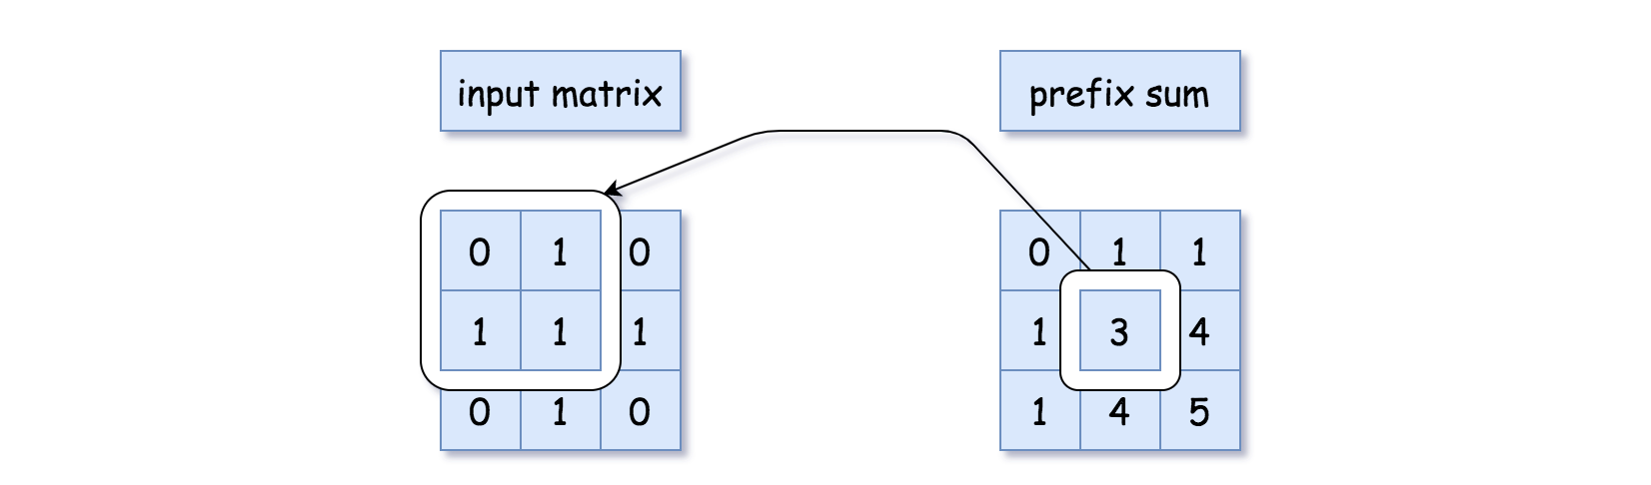 Figure 2. Prefix sum for 2D array.

or for the binary trees (sum the values of the current node  
and all parent nodes),

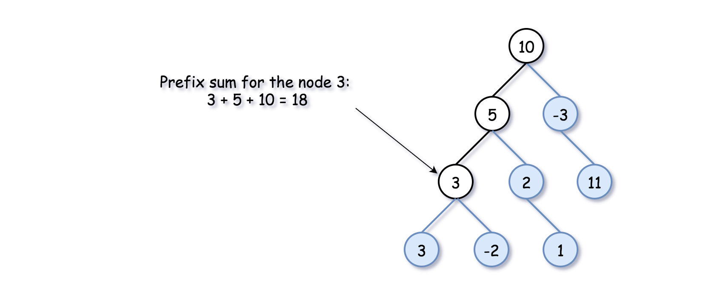 Figure 3. Prefix sum for the binary tree.

#### Prefix Sum: How to Use: Number of Continuous Subarrays that Sum to Target

You might want to use the prefix sum technique for the problems like "Find a number of continuous subarrays/submatrices/tree paths that sum to target".

Before going to the current problem with the tree, let's check the idea on a simpler example [Find a number of continuous subarrays that sum to target](https://leetcode.com/problems/subarray-sum-equals-k/).

* Use a variable to track the current prefix sum and a hashmap "prefix sum -> how many times was it seen so far".

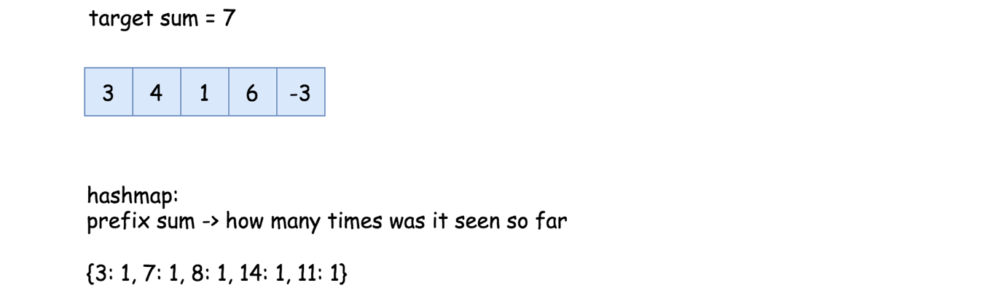 Figure 4. Find a number of continuous subarrays that sum to target.

* Parse the input structure and count the requested subarrays/submatrices/tree paths along the way with the help of that hashmap. How to count?

There could be two situations. In situation 1, the subarray with the target sum starts from the beginning of the array. That means that the current prefix sum is equal to the target sum, and we increase the counter by 1.

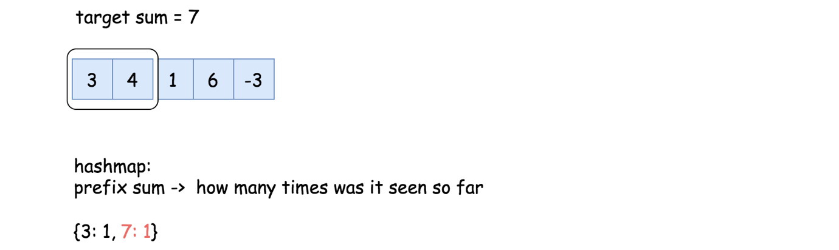 Figure 5. Situation 1: The subarray starts from the beginning of the array.

In situation 2, the subarray with the target sum starts somewhere in the middle. That means we should add to the counter the number of times we have seen the prefix sum curr_sum - target so far: count += h[curr_sum - target].

The logic is simple: the current prefix sum is curr_sum, and some elements before the prefix sum was curr_sum - target. All the elements in between sum up to curr_sum - (curr_sum - target) = target.

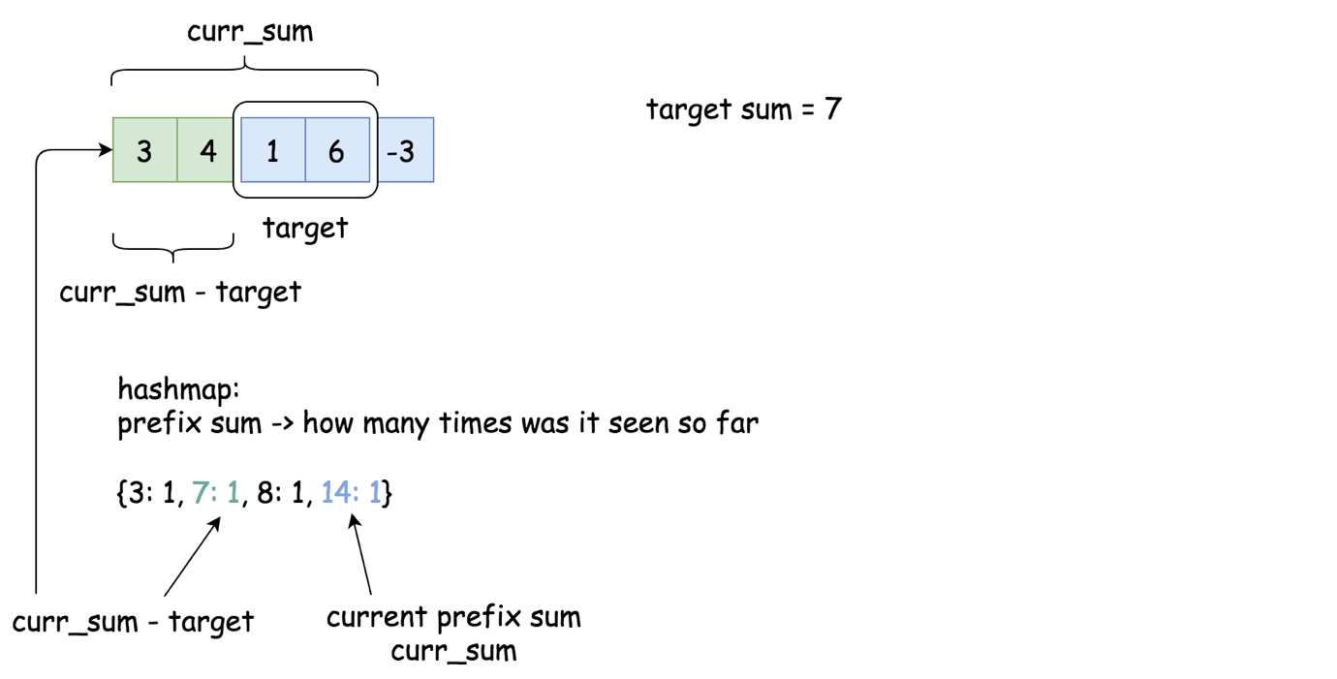 Figure 6. Situation 2: The subarray starts somewhere in the middle.

**Solution for Number of Continuous Subarrays that Sum to Target**

Here is an implementation of the solution for [Find a number of continuous subarrays that sum to target](https://leetcode.com/problems/subarray-sum-equals-k/).

|  |
| --- |
| public class Solution {  public int subarraySum(int[] nums, int k) {  int count = 0, currSum = 0;  HashMap<Integer, Integer> h = new HashMap();    for (int num : nums) {  // current prefix sum  currSum += num;    // situation 1:  // continuous subarray starts  // from the beginning of the array  if (currSum == k)  count++;    // situation 2:  // number of times the curr_sum − k has occured already,  // determines the number of times a subarray with sum k  // has occured upto the current index  count += h.getOrDefault(currSum - k, 0);    // add the current sum  h.put(currSum, h.getOrDefault(currSum, 0) + 1);  }    return count;  }  } |

#### Approach 1: Prefix Sum

Now let's reuse the same algorithm and the same code for the case of the binary tree.

There is just one thing that is particular for the binary tree. There are two ways to go forward - to the left and to the right. To keep parent->child direction, we shouldn't blend prefix sums from the left and right subtrees in one hashmap.

**Algorithm**

* Let's initialize tree paths counter count = 0, and the hashmap h "prefix sum -> how many times was it seen so far".
* One could parse the tree using [recursive preorder traversal](https://leetcode.com/articles/sum-root-to-leaf-numbers/): node -> left -> right: preorder(node: TreeNode, curr_sum: int) -> None. This function takes two arguments: a tree node and a prefix sum before that node. To start the recursion chain, one should call preorder(root, 0).
  + The first thing is to update the current prefix sum by adding the value of the current node: curr_sum += node.val.
  + Now one could update the counter. One should consider two situations.

In situation 1, the tree path with the target sum starts from the root. That means the current prefix sum is equal to the target sum curr_sum == k, so one should increase the counter by 1: count += 1.

In situation 2, the tree path with the target sum starts somewhere downwards. That means we should add to the counter the number of times we have seen the prefix sum curr_sum - target so far: count += h[curr_sum - target].

The logic is simple: the current prefix sum is curr_sum, and several elements before the prefix sum was curr_sum - target. All the elements in between sum up to curr_sum - (curr_sum - target) = target.

* + Now it's time to update the hashmap: h[curr_sum] += 1.
  + Let's parse left and right subtrees: preorder(node.left, curr_sum), preorder(node.right, curr_sum).
  + Now the current subtree is processed. It's time to remove the current prefix sum from the hashmap, in order not to blend the parallel subtrees: h[curr_sum] -= 1.
* Now the preorder traversal is done, and the counter is updated. Return it.

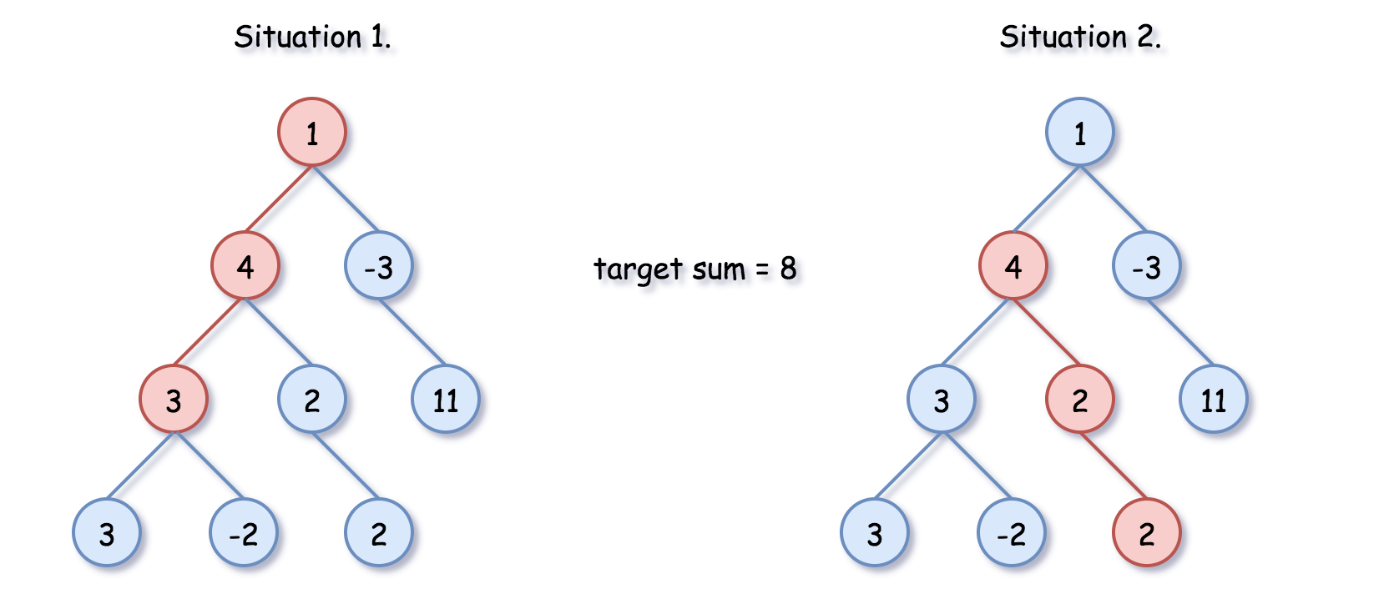 Figure 7. Situation 1 vs situation 2.

**Implementation**

On the following example the target sum is equal to 8.



|  |
| --- |
| class Solution {  int count = 0;  int k;  HashMap<Integer, Integer> h = new HashMap();    public void preorder(TreeNode node, int currSum) {  if (node == null)  return;    // current prefix sum  currSum += node.val;  // here is the sum we're looking for  if (currSum == k)  count++;    // number of times the curr_sum − k has occured already,  // determines the number of times a path with sum k  // has occured upto the current node  count += h.getOrDefault(currSum - k, 0);    // add the current sum into hashmap  // to use it during the child nodes processing  h.put(currSum, h.getOrDefault(currSum, 0) + 1);  // process left subtree  preorder(node.left, currSum);  // process right subtree  preorder(node.right, currSum);  // remove the current sum from the hashmap  // in order not to use it during  // the parallel subtree processing  h.put(currSum, h.get(currSum) - 1);  }    public int pathSum(TreeNode root, int sum) {  k = sum;  preorder(root, 0);  return count;  }  } |

**Complexity Analysis**

* Time complexity: \mathcal{O}(N)O(*N*), where N*N* is a number of nodes. During preorder traversal, each node is visited once.
* Space complexity: up to \mathcal{O}(N)O(*N*) to keep the hashmap of prefix sums, where N*N* is a number of nodes.

**Rotting Oranges**

You are given an m x n grid where each cell can have one of three values:

* 0 representing an empty cell,
* 1 representing a fresh orange, or
* 2 representing a rotten orange.

Every minute, any fresh orange that is **4-directionally adjacent** to a rotten orange becomes rotten.

Return *the minimum number of minutes that must elapse until no cell has a fresh orange*. If *this is impossible, return* -1.

**Example 1:**

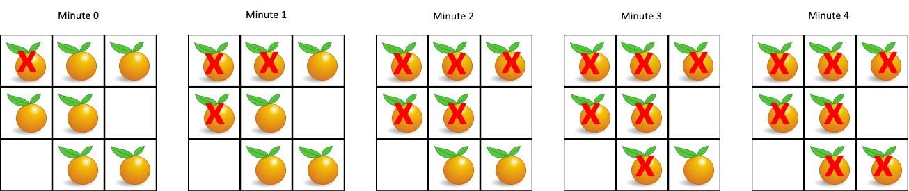

**Input:** grid = [[2,1,1],[1,1,0],[0,1,1]]

**Output:** 4

**Example 2:**

**Input:** grid = [[2,1,1],[0,1,1],[1,0,1]]

**Output:** -1

**Explanation:** The orange in the bottom left corner (row 2, column 0) is never rotten, because rotting only happens 4-directionally.

**Example 3:**

**Input:** grid = [[0,2]]

**Output:** 0

**Explanation:** Since there are already no fresh oranges at minute 0, the answer is just 0.

**Constraints:**

* m == grid.length
* n == grid[i].length
* 1 <= m, n <= 10
* grid[i][j] is 0, 1, or 2.

## Solution

#### Approach 1: Breadth-First Search (BFS)

**Intuition**

This is yet another 2D traversal problem. As we know, the common algorithmic strategies to deal with these problems would be **Breadth-First Search** (BFS) and **Depth-First Search** (DFS).

As suggested by its name, the BFS strategy prioritizes the **breadth** over depth, i.e. it goes wider before it goes deeper. On the other hand, the DFS strategy prioritizes the **depth** over breadth.

The choice of strategy depends on the nature of the problem. Though sometimes, they are both applicable for the same problem. In addition to 2D grids, these two algorithms are often applied to problems associated with tree or graph data structures as well.

In this problem, one can see that BFS would be a better fit.

Because the process of rotting could be explained perfectly with the BFS procedure, i.e. the rotten oranges will contaminate their neighbors first, before the contamination propagates to other fresh oranges that are farther away.

If one is not familiar with the algorithm of BFS, one can refer to our [Explore card of Queue & Stack](https://leetcode.com/explore/learn/card/queue-stack/231/practical-application-queue/) which covers this subject.

However, it would be more intuitive to visualize the rotting process with a graph data structure, where each node represents a cell and the edge between two nodes indicates that the given two cells are adjacent to each other.

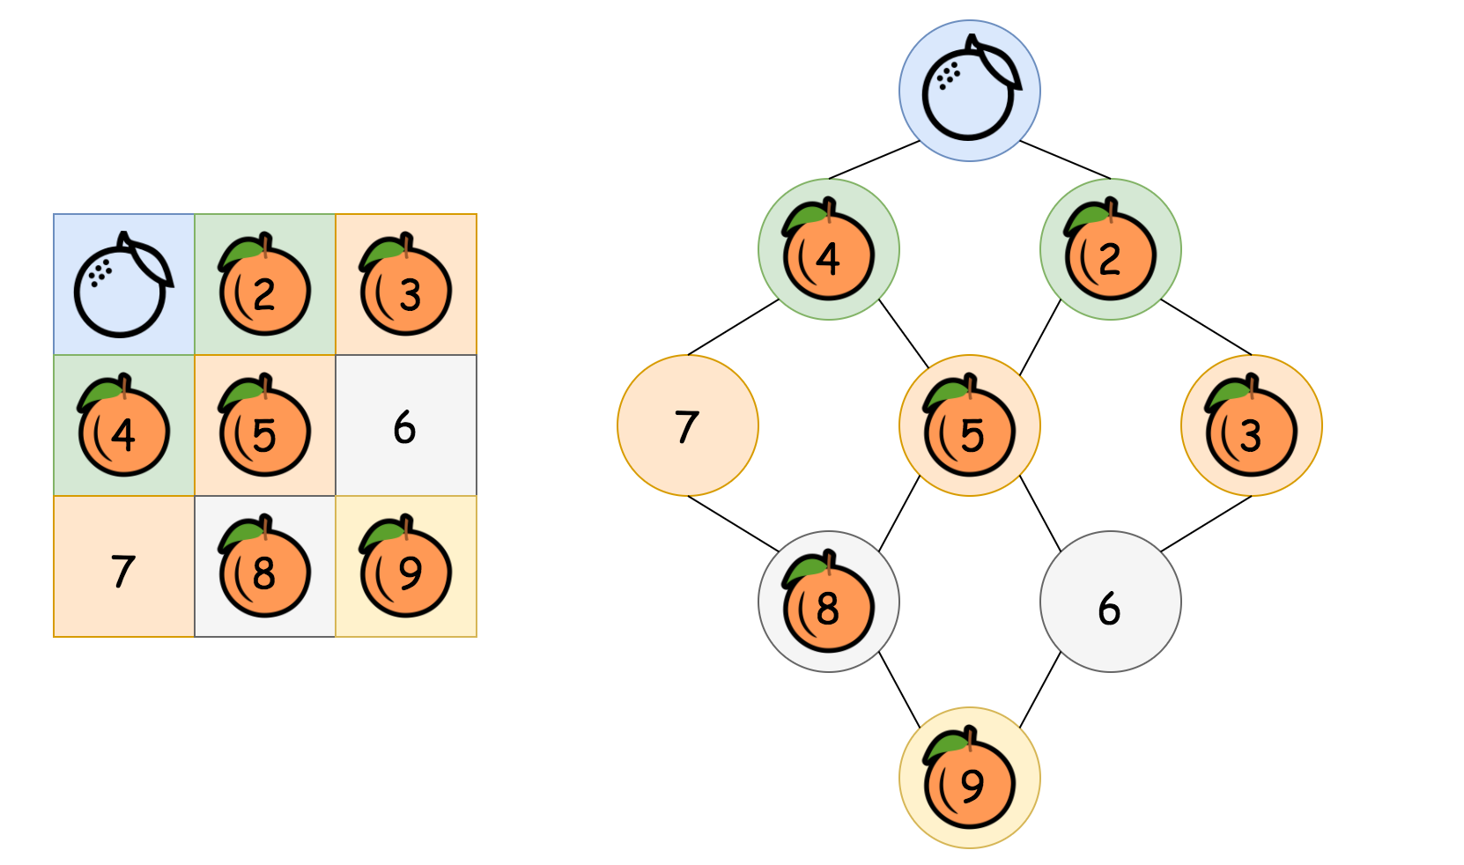

In the above graph (pun intended), as we can see, starting from the top rotten orange, the contamination would propagate ***layer by layer*** (or level by level), until it reaches the farthest fresh oranges. The number of minutes that are elapsed would be equivalent to the number of levels in the graph that we traverse during the propagation.



**Algorithm**

One of the most distinguished code patterns in BFS algorithms is that often we use a ***queue*** data structure to keep track of the candidates that we need to visit during the process.

The main algorithm is built around a loop iterating through the queue. At each iteration, we pop out an element from the head of the queue. Then we do some particular process with the popped element. More importantly, we then append neighbors of the popped element into the queue, to keep the BFS process running.

Here are some sample implementations.

|  |
| --- |
| class Solution {  public int orangesRotting(int[][] grid) {  Queue<Pair<Integer, Integer>> queue = new ArrayDeque();  // Step 1). build the initial set of rotten oranges  int freshOranges = 0;  int ROWS = grid.length, COLS = grid[0].length;  for (int r = 0; r < ROWS; ++r)  for (int c = 0; c < COLS; ++c)  if (grid[r][c] == 2)  queue.offer(new Pair(r, c));  else if (grid[r][c] == 1)  freshOranges++;  // Mark the round / level, _i.e_ the ticker of timestamp  queue.offer(new Pair(-1, -1));  // Step 2). start the rotting process via BFS  int minutesElapsed = -1;  int[][] directions = { {-1, 0}, {0, 1}, {1, 0}, {0, -1}};  while (!queue.isEmpty()) {  Pair<Integer, Integer> p = queue.poll();  int row = p.getKey();  int col = p.getValue();  if (row == -1) {  // We finish one round of processing  minutesElapsed++;  // to avoid the endless loop  if (!queue.isEmpty())  queue.offer(new Pair(-1, -1));  } else {  // this is a rotten orange  // then it would contaminate its neighbors  for (int[] d : directions) {  int neighborRow = row + d[0];  int neighborCol = col + d[1];  if (neighborRow >= 0 && neighborRow < ROWS &&  neighborCol >= 0 && neighborCol < COLS) {  if (grid[neighborRow][neighborCol] == 1) {  // this orange would be contaminated  grid[neighborRow][neighborCol] = 2;  freshOranges--;  // this orange would then contaminate other oranges  queue.offer(new Pair(neighborRow, neighborCol));  }  }  }  }  }  // return elapsed minutes if no fresh orange left  return freshOranges == 0 ? minutesElapsed : -1;  }  } |

In the above implementations, we applied some tricks to further optimize both the time and space complexities.

* Usually in BFS algorithms, we keep a visited table which records the visited candidates. The visited table helps us to avoid repetitive visits.
* But as one notices, rather than using the visited table, we reuse the input grid to keep track of our visits, i.e. we were altering the status of the input grid **in-place**.
* This in-place technique reduces the memory consumption of our algorithm. Also, it has a constant time complexity to check the current status (i.e. array access, grid[row][col]), rather than referring to the visited table which might be of constant time complexity as well (e.g. hash table) but in reality could be slower than array access.
* We use a ***delimiter*** (i.e. (row=-1, col=-1)) in the queue to separate cells on different levels. In this way, we only need one queue for the iteration. As an alternative, one can create a queue for each level and alternate between the queues, though technically the initialization and the assignment of each queue could consume some extra time.

**Complexity**

* Time Complexity: \mathcal{O}(N)O(*N*), where N*N* is the size of the grid.

First, we scan the grid to find the initial values for the queue, which would take \mathcal{O}(N)O(*N*) time.

Then we run the BFS process on the queue, which in the worst case would enumerate all the cells in the grid once and only once. Therefore, it takes \mathcal{O}(N)O(*N*) time.

Thus combining the above two steps, the overall time complexity would be \mathcal{O}(N) + \mathcal{O}(N) = \mathcal{O}(N)O(*N*)+O(*N*)=O(*N*)

* Space Complexity: \mathcal{O}(N)O(*N*), where N*N* is the size of the grid.

In the worst case, the grid is filled with rotten oranges. As a result, the queue would be initialized with all the cells in the grid.

By the way, normally for BFS, the main space complexity lies in the process rather than the initialization. For instance, for a BFS traversal in a tree, at any given moment, the queue would hold no more than 2 levels of tree nodes. Therefore, the space complexity of BFS traversal in a tree would depend on the ***width*** of the input tree.

#### Approach 2: In-place BFS

**Intuition**

Although there is no doubt that the best strategy for this problem is BFS, some users in the Discussion forum have proposed different implementations of BFS with constant space complexity \mathcal{O}(1)O(1). To name just a few, one can see the posts from [@manky](https://leetcode.com/problems/rotting-oranges/discuss/569248/Alternate-approach-BFS-O(N-*-Height)-but-constant-space-easy-to-understand-and-modular-code) and [@votrubac](https://leetcode.com/problems/rotting-oranges/discuss/238579/C%2B%2BJava-with-picture-BFS).

As one might recall from the previous BFS implementation, its space complexity is mainly due to the queue that we were using to keep the order for the visits of cells. In order to achieve \mathcal{O}(1)O(1) space complexity, we then need to eliminate the queue in the BFS.

The secret in doing BFS traversal without a queue lies in the technique called [in-place algorithm](https://en.wikipedia.org/wiki/In-place_algorithm), which transforms input to solve the problem without using auxiliary data structure.

Actually, we have already had a taste of in-place algorithm in the previous implementation of BFS, where we directly modified the input grid to mark the oranges that turn rotten, rather than using an additional visited table.

How about we apply the in-place algorithm again, but this time for the role of the queue variable in our previous BFS implementation?

The idea is that at each **round** of the BFS, we mark the cells to be visited in the input grid with a specific timestamp.

By round, we mean a snapshot in time where a group of oranges turns rotten.

**Algorithm**

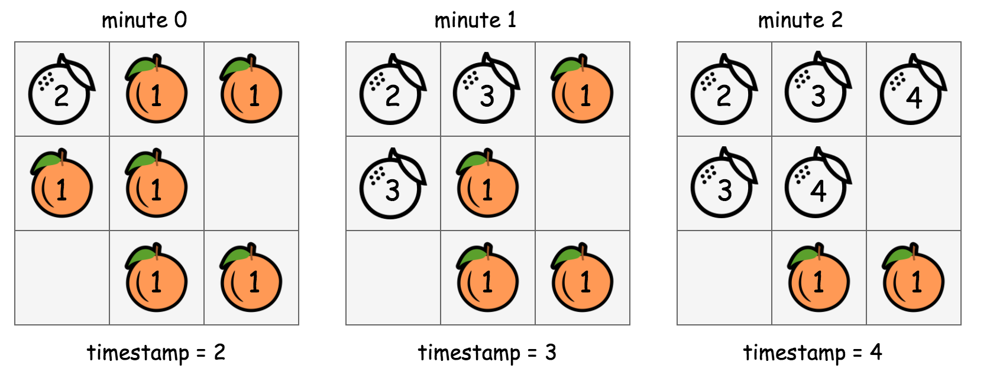

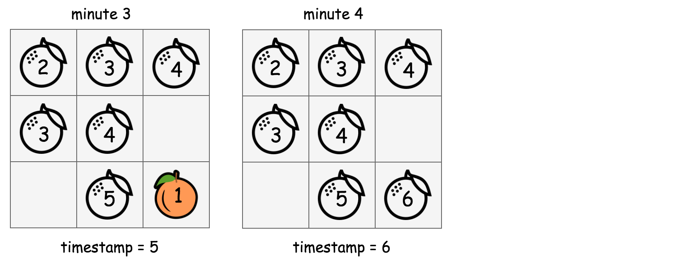

In the above graph, we show how we manipulate the values in the input grid in-place in order to run the BFS traversal.

* 1). Starting from the beginning (with timestamp=2), the cells that are marked with the value 2 contain rotten oranges. From this moment on, we adopt a **rule** stating as "the cells that have the value of the current timestamp (i.e. 2) should be visited at this round of BFS.".
* 2). For each of the cell that is marked with the current timestamp, we then go on to mark its neighbor cells that hold a fresh orange with the ***next*** timestamp (i.e. timestamp += 1). This ***in-place*** modification serves the same purpose as the queue variable in the previous BFS implementation, which is to select the candidates to visit for the next round.
* 3). At this moment, we should have timestamp=3, and meanwhile we also have the cells to be visited at this round marked out. We then repeat the above step **(2)** until there is no more new candidates generated in the step (2) (i.e. the end of BFS traversal).

To summarize, the above algorithm is still a BFS traversal in a 2D grid. But rather than using a queue data structure to keep track of the visiting order, we applied an in-place algorithm to serve the same purpose as a queue in a more classic BFS implementation.

|  |
| --- |
| class Solution {  // run the rotting process, by marking the rotten oranges with the timestamp  public boolean runRottingProcess(int timestamp, int[][] grid, int ROWS, int COLS) {  int[][] directions = { {-1, 0}, {0, 1}, {1, 0}, {0, -1}};  // flag to indicate if the rotting process should be continued  boolean toBeContinued = false;  for (int row = 0; row < ROWS; ++row)  for (int col = 0; col < COLS; ++col)  if (grid[row][col] == timestamp)  // current contaminated cell  for (int[] d : directions) {  int nRow = row + d[0], nCol = col + d[1];  if (nRow >= 0 && nRow < ROWS && nCol >= 0 && nCol < COLS)  if (grid[nRow][nCol] == 1) {  // this fresh orange would be contaminated next  grid[nRow][nCol] = timestamp + 1;  toBeContinued = true;  }  }  return toBeContinued;  }  public int orangesRotting(int[][] grid) {  int ROWS = grid.length, COLS = grid[0].length;  int timestamp = 2;  while (runRottingProcess(timestamp, grid, ROWS, COLS))  timestamp++;  // end of process, to check if there are still fresh oranges left  for (int[] row : grid)  for (int cell : row)  // still got a fresh orange left  if (cell == 1)  return -1;  // return elapsed minutes if no fresh orange left  return timestamp - 2;  }  } |

**Complexity Analysis**

* Time Complexity: \mathcal{O}(N^2)O(*N*2) where N*N* is the size of the input grid.

In the in-place BFS traversal, for each round of BFS, we would have to iterate through the entire grid.

The contamination propagates in 4 different directions. If the orange is well adjacent to each other, the chain of propagation would continue until all the oranges turn rotten.

In the worst case, the rotten and the fresh oranges might be arranged in a way that we would have to run the BFS loop over and over again, which could amount to \frac{N}{2}2*N*​ times which is the ***longest*** propagation chain that we might have, *i.e.* the zigzag walk in a 2D grid as shown in the following graph. 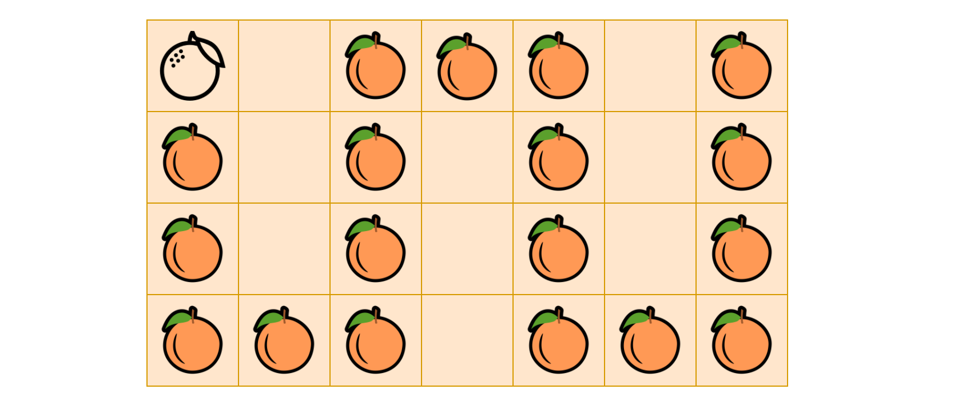

As a result, the overall time complexity of the in-place BFS algorithm is \mathcal{O}(N \cdot \frac{N}{2}) = \mathcal{O}(N^2)O(*N*⋅2*N*​)=O(*N*2).

* Space Complexity: \mathcal{O}(1)O(1), the memory usage is constant regardless the size of the input. This is the very point of applying in-place algorithm. Here we trade the time complexity with the space complexity, which is a common scenario in many algorithms.

**H-Index**

Given an array of citations (each citation is a non-negative integer) of a researcher, write a function to compute the researcher's h-index.

According to the [definition of h-index on Wikipedia](https://en.wikipedia.org/wiki/H-index): "A scientist has index *h* if *h* of his/her *N* papers have **at least** *h* citations each, and the other *N − h* papers have **no more than** *h* citations each."

**Example:**

**Input:** citations = [3,0,6,1,5]

**Output:** 3

**Explanation:** [3,0,6,1,5] means the researcher has 5 papers in total and each of them had

received 3, 0, 6, 1, 5 citations respectively.

  Since the researcher has 3 papers with **at least** 3 citations each and the remaining

  two with **no more than** 3 citations each, her h-index is 3.

**Note:**If there are several possible values for h, the maximum one is taken as the h-index.

   Hide Hint #1

An easy approach is to sort the array first.

   Hide Hint #2

What are the possible values of h-index?

   Hide Hint #3

A faster approach is to use extra space.

Summary

This article is for intermediate readers. It introduces the following ideas: Comparison Sort and Counting Sort.

Solution

Approach #1 (Sorting) [Accepted]

**Intuition**

Think geometrically. Imagine plotting a histogram where the y*y*-axis represents the number of citations for each paper. After sorting in *descending* order, h*h*-index is the length of the largest **square** in the histogram.

*Figure 1. hh-index from a plot of decreasing citations for papers*

**Algorithm**

To find such a square length, we first sort the citations array in *descending* order. After sorting, if \mathrm{citations}[i] \gt icitations[*i*]>*i*, then papers 00 to i*i* all have at least i + 1*i*+1 citations.

Thus, to find h*h*-index, we search for the largest i*i* (let's call it i'*i*′) such that

\mathrm{citations}[i] \gt icitations[*i*]>*i*

and therefore the h*h*-index is i' + 1*i*′+1.

For example:

| **i*i*** | **0** | **1** | **2** | **3** | **4** | **5** | **6** |
| --- | --- | --- | --- | --- | --- | --- | --- |
| sorted citations | 10 | 9 | 5 | 3 | 3 | 2 | 1 |
| \mathrm{citations}[i] \gt icitations[*i*]>*i*? | true | true | true | false | false | false | false |

In this example, we know that the largest i*i* with \mathrm{citations}[i] \gt icitations[*i*]>*i* is i'=2*i*′=2. Thus

h = i' + 1 = 3*h*=*i*′+1=3

Because \mathrm{citations}[i'] \gt i'citations[*i*′]>*i*′, i' + 1*i*′+1 papers (from paper 0 to paper i'*i*′) have citations at least i' + 1*i*′+1 and n - i' - 1*n*−*i*′−1 papers (from paper i' + 1*i*′+1 to paper n - 1*n*−1) have citations no more than i' + 1*i*′+1. By the definition of h*h*-index, h = i' + 1*h*=*i*′+1.

It is also possible to find i'*i*′ through binary search after sorting. However, since comparison sorting has a time complexity of O(n \log n)*O*(*n*log*n*) which dominates the performance of entire algorithm (linear search is O(n)*O*(*n*)). Using a binary search (O(\log n)*O*(log*n*)) instead of linear search won't change the asymptotic time complexity.

Also note that, we deduced the algorithm in descending for simplicity. Usually the sort function provided by default is in ascending order. The same principles applies to both ascending order and descending order. In the case of ascending order, we just scan it from backward.

|  |
| --- |
| public class Solution {  public int hIndex(int[] citations) {  // sorting the citations in ascending order  Arrays.sort(citations);  // finding h-index by linear search  int i = 0;  while (i < citations.length && citations[citations.length - 1 - i] > i) {  i++;  }  return i; // after the while loop, i = i' + 1  }  } |

**Complexity Analysis**

* Time complexity : O(n\log n)*O*(*n*log*n*). Comparison sorting dominates the time complexity.
* Space complexity : O(1)*O*(1). Most libraries using heap sort which costs O(1)*O*(1) extra space in the worst case.

#### Approach #2 (Counting) [Accepted]

**Intuition**

Comparison sorting algorithm has a lower bound of O(n\log n)*O*(*n*log*n*). To achieve better performance, we need non-comparison based sorting algorithms.

**Algorithm**

From [Approach #1](https://leetcode.com/problems/h-index/solution/#approach-1-sorting-accepted), we sort the citations to find the h-index. However, it is well known that comparison sorting algorithms such as heapsort, mergesort and quicksort have a lower bound of O(n\log n)*O*(*n*log*n*). The most commonly used non-comparison sorting is counting sort.

Counting sort operates by counting the number of objects that have each distinct key value, and using arithmetic on those tallies to determine the positions of each key value in the output sequence. Its running time is linear in the number of items and the difference between the maximum and minimum keys, so it is only suitable for direct use in situations where the variation in keys is not significantly greater than the number of items.

---by Wikipedia

However, in our problem, the keys are the citations of each paper which can be much larger than the number of papers n*n*. It seems that we cannot use counting sort. The trick here is the following observation:

Any citation larger than n*n* can be replaced by n*n* and the h*h*-index will not change after the replacement

The reason is that h*h*-index is upper bounded by total number of papers n*n*, i.e.

h \leq n*h*≤*n*

In the diagram, replacing citations greater than n*n* with n*n* is equivalent to cutting off the area where y > n*y*>*n*.

Figure 2. cutting off the area with citations more than *nn*

Apparently, cutting that area off will not change the largest **square** and the h*h*-index.

After we have the counts, we can get a sorted citations by traversing the counts array. And the rest is the same as [Approach #1](https://leetcode.com/problems/h-index/solution/#approach-1-sorting-accepted).

But we can do even better. The idea is that we don't even need to get sorted citations. We can find the h*h*-index by using the paper counts directly.

To explain this, let's look at the following example:

\mathrm{citations} = [1, 3, 2, 3, 100]citations=[1,3,2,3,100]

The counting results are:

| **k*k*** | **0** | **1** | **2** | **3** | **4** | **5** |
| --- | --- | --- | --- | --- | --- | --- |
| count | 0 | 1 | 1 | 2 | 0 | 1 |
| s_k*sk*​ | 5 | 5 | 4 | 3 | 1 | 1 |

The value s_k*sk*​ is defined as "the sum of all counts with citation \geq k≥*k*" or "the number of papers having, at least, k*k* citations". By definition of the h-index, the largest k*k* with k \leq s_k*k*≤*sk*​ is our answer.

After replacing 100100 with n = 5*n*=5, we have \mathrm{citations} = [1, 3, 2, 3, 5]citations=[1,3,2,3,5]. Now, we count the number of papers for each citation number 00 to 55. The counts are [0, 1, 1, 2, 0, 1][0,1,1,2,0,1]. The first k*k* from right to left (55 down to 00) that have k \leq s*k*≤*s* is the h*h*-index 33.

Since we can calculate s_k*sk*​ on the fly when traverse the count array, we only need one pass through the count array which only costs O(n)*O*(*n*) time.

|  |
| --- |
| public class Solution {  public int hIndex(int[] citations) {  int n = citations.length;  int[] papers = new int[n + 1];  // counting papers for each citation number  for (int c: citations)  papers[Math.min(n, c)]++;  // finding the h-index  int k = n;  for (int s = papers[n]; k > s; s += papers[k])  k--;  return k;  }  } |

**Complexity Analysis**

* Time complexity : O(n)*O*(*n*). There are two steps. The counting part is O(n)*O*(*n*) since we traverse the citations array once and only once. The second part of finding the h*h*-index is also O(n)*O*(*n*) since we traverse the papers array at most once. Thus, the entire algorithm is O(n)*O*(*n*)
* Space complexity : O(n)*O*(*n*). We use O(n)*O*(*n*) auxiliary space to store the counts.

## Further Thoughts

Is it possible to have multiple h*h*-values?

The answer is **NO**. One can find this intuitively from Figure 1. The dashed line y = x*y*=*x* crosses the histogram once and only once, because the sorted bars are monotonic. It can also be proven from the definition of the h*h*-index.

**Iterator for Combination**

Design the CombinationIterator class:

* CombinationIterator(string characters, int combinationLength) Initializes the object with a string characters of **sorted distinct** lowercase English letters and a number combinationLength as arguments.
* next() Returns the next combination of length combinationLength in **lexicographical order**.
* hasNext() Returns true if and only if there exists a next combination.

**Example 1:**

**Input**

["CombinationIterator", "next", "hasNext", "next", "hasNext", "next", "hasNext"]

[["abc", 2], [], [], [], [], [], []]

**Output**

[null, "ab", true, "ac", true, "bc", false]

**Explanation**

CombinationIterator itr = new CombinationIterator("abc", 2);

itr.next(); // return "ab"

itr.hasNext(); // return True

itr.next(); // return "ac"

itr.hasNext(); // return True

itr.next(); // return "bc"

itr.hasNext(); // return False

**Constraints:**

* 1 <= combinationLength <= characters.length <= 15
* All the characters of characters are **unique**.
* At most 104 calls will be made to next and hasNext.
* It's guaranteed that all calls of the function next are valid.

Hide Hint #1

Generate all combinations as a preprocessing.

   Hide Hint #2

Use bit masking to generate all the combinations.

## Solution

#### Disclaimer

This is a review article, and the goal is to propose 5 different solutions and to discuss a possible interview strategy. If you'd like to read a more detailed explanation of each solution, please check the following articles:

[Combinations](https://leetcode.com/articles/combinations/).

[Subsets](https://leetcode.com/articles/subsets/).

#### Precomputation or Next Combination: Why It's Risky to Use Backtracking

The interpretation of this problem depends on the interviewer. There are three possible scenarios:

* You could be asked to implement \mathcal{O}(1)O(1) runtime by precomputing all the combinations.
* Or, you could be asked to save space, to use no precomputation and to implement the nextCombination function to generate each new combination from the previous one during the runtime.
* Or, the interviewer could let you choose one of the problems above and then asks you to implement the second one as a follow-up.

That's why it's a risky strategy [to compute combinations using standard backtacking](https://leetcode.com/articles/combinations/). To precompute all the combinations using backtracking is doable.

|  |
| --- |
| class CombinationIterator {  public Deque < String > combinations = new ArrayDeque < String > ();  String characters;  int n, k;  public void backtrack(int first, StringBuilder curr) {  // if the combination is done  if (curr.length() == k) {  combinations.push(curr.toString());  // speed up by non-constructing combinations  // with more than k elements  return;  }  for (int i = first; i < n; ++i) {  // add i into the current combination  curr.append(characters.charAt(i));  // use next integers to complete the combination  backtrack(i + 1, curr);  // backtrack  curr.deleteCharAt(curr.length() - 1);  }  }  public CombinationIterator(String characters, int combinationLength) {  this.n = characters.length();  this.k = combinationLength;  this.characters = characters;  backtrack(0, new StringBuilder());  }  public String next() {  return combinations.removeLast();  }  public boolean hasNext() {  return (!combinations.isEmpty());  }  } |

As a follow-up you could be asked to rewrite your algorithm implementing nextCombination function, and that could be quite stressful during the interview if you choose backtracking.

#### Overview: Bitmasking and Algorithm L

In this article, we're going to consider Bitmasking and Algorithm L. These two approaches could be easily used both for the precomputation, and the nextCombination function.

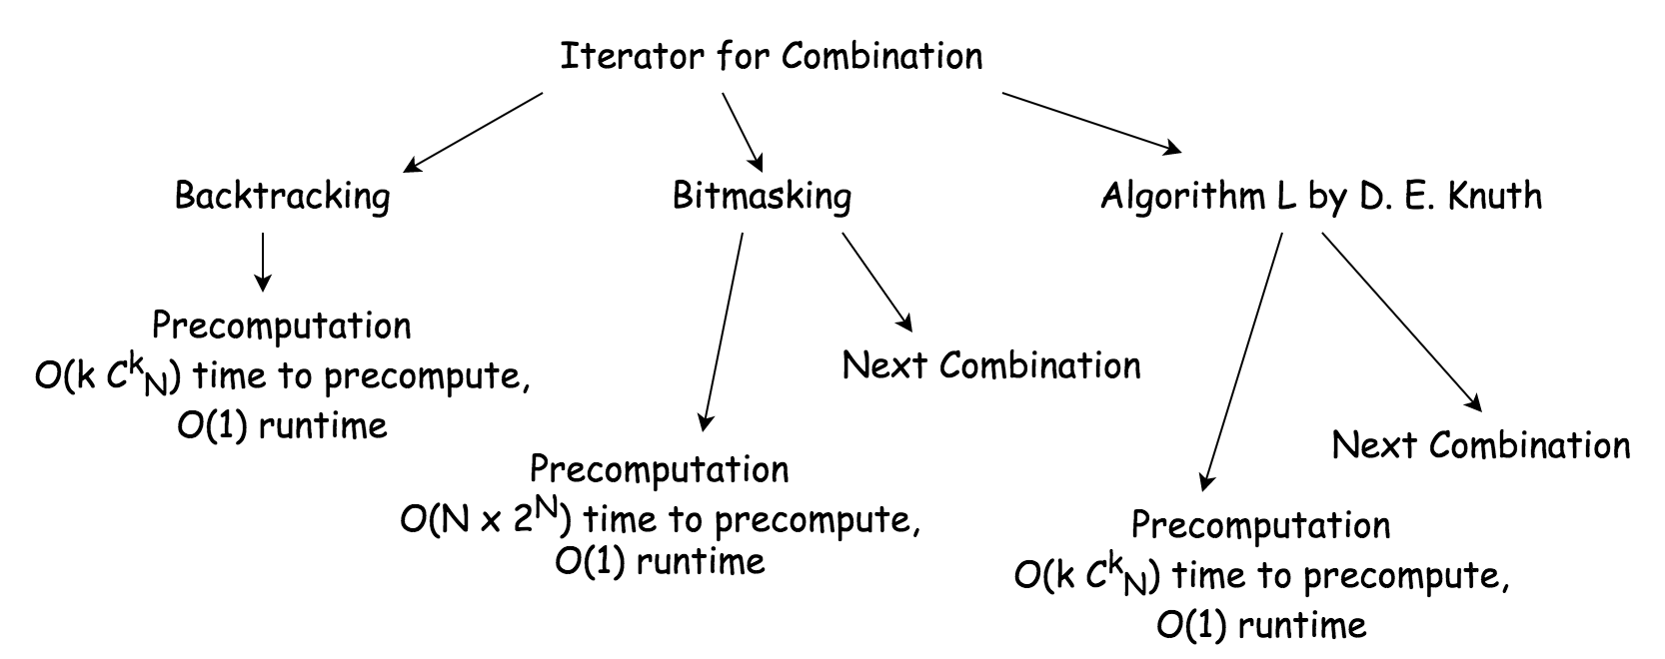

**Bitmasking**

It's more simple to generate numbers than combinations. So let us generate numbers, and then use their binary representations, bitmasks.

The idea is that we map each bitmask of length n to a combination. Each bit is mapped to a character, the lowest bit to the last character, the highest bit - to the first character.

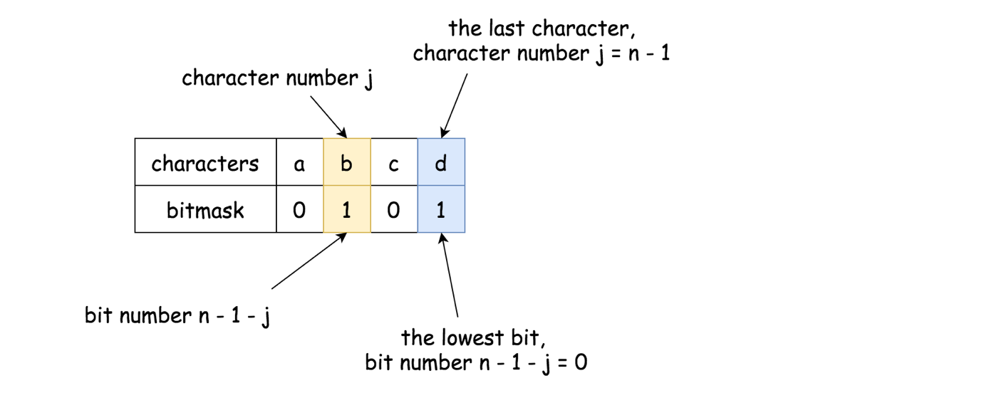

The character characters[i] is present in the combination if bit at the n - 1 - ith position is set.

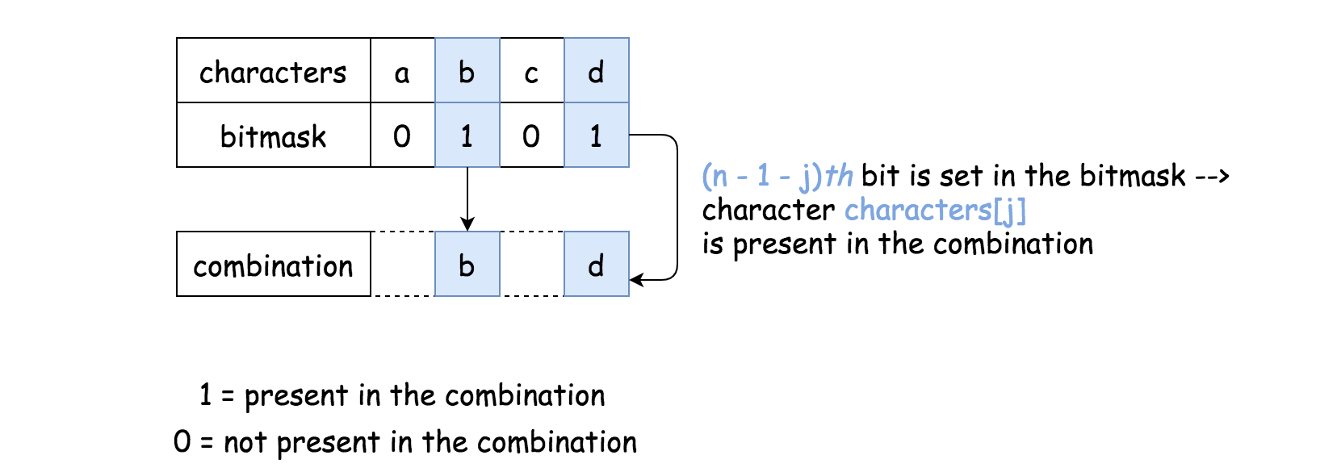

(1111)_2 - abcd \\ (0011)_2 - cd \\ (0101)_2 - bd \\ (0110)_2 - bc \\ (1001)_2 - ad \\ (1010)_2 - ac \\ (1100)_2 - ab(1111)2​−*abcd*(0011)2​−*cd*(0101)2​−*bd*(0110)2​−*bc*(1001)2​−*ad*(1010)2​−*ac*(1100)2​−*ab*

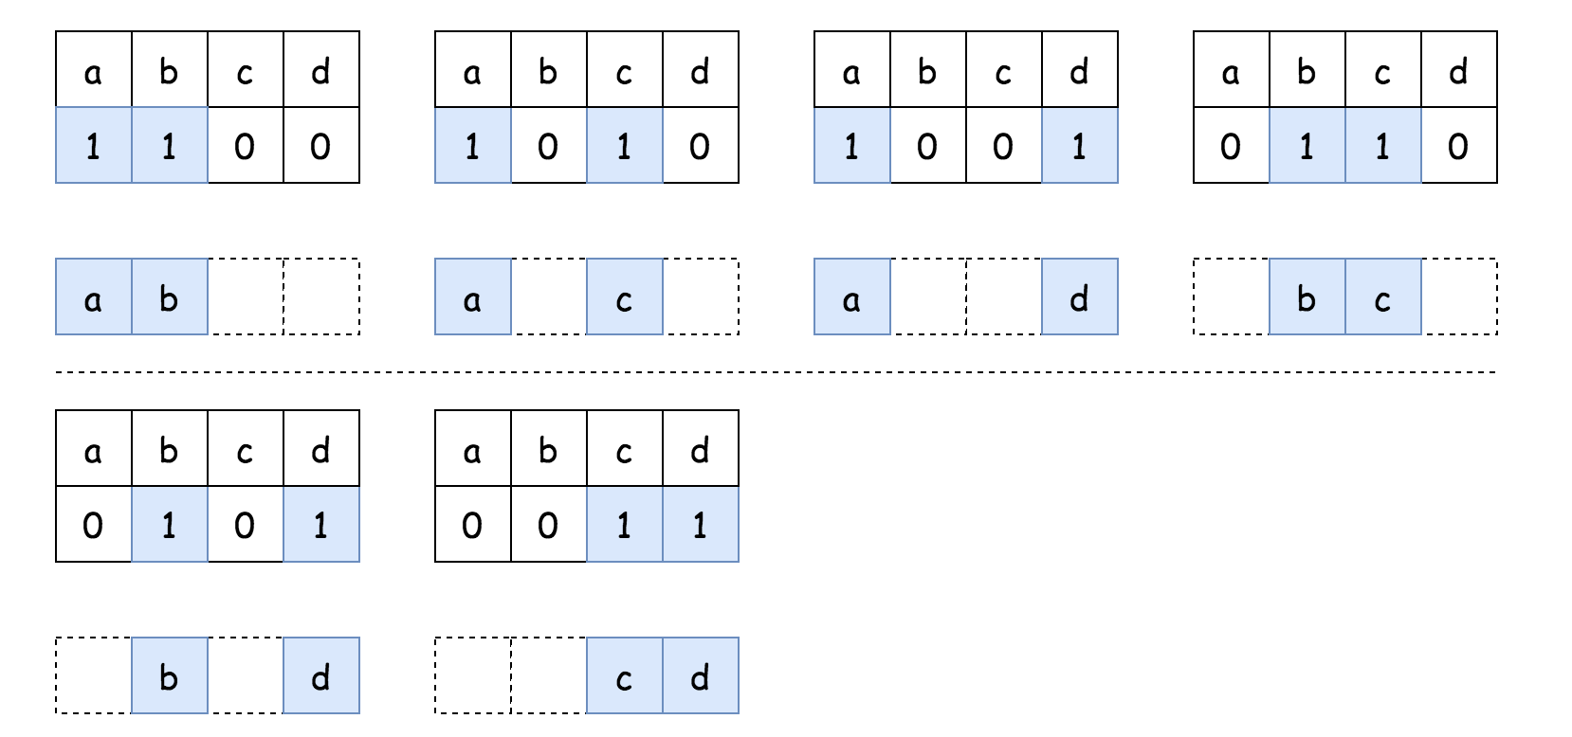

In this article, we're going to keep bitmasking approach as simple as possible, having \mathcal{O}(2^N \cdot N)O(2*N*⋅*N*) time complexity for the precomputation case.

**Algorithm L by D. E. Knuth**

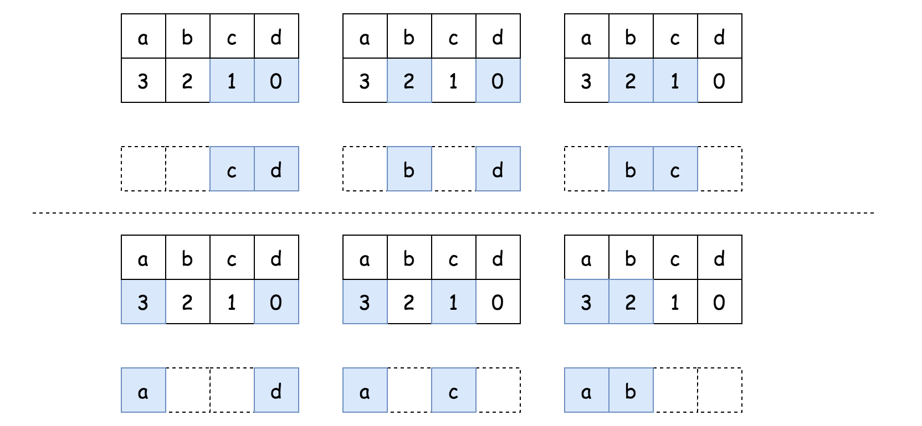

Algorithm L is an efficient BFS approach to generate lexicographic (i.e. binary sorted) combinations. It works by generating the combinations of indexes.

The advantage of this algorithm is that it "jumps" from one combination to another instead of brute-forcing 2^N2*N* bitmasks. In total, there are C^k_N*CNk*​ combinations of length k*k*, and hence one needs \mathcal{O}(k C_N^k)O(*kCNk*​) time for the precomputation.

This approach is better than simple bitmasking: \mathcal{O}(k C_N^k)O(*kCNk*​) vs \mathcal{O}(2^N \cdot N)O(2*N*⋅*N*).

#### Approach 1: Bitmasking: Precomputation

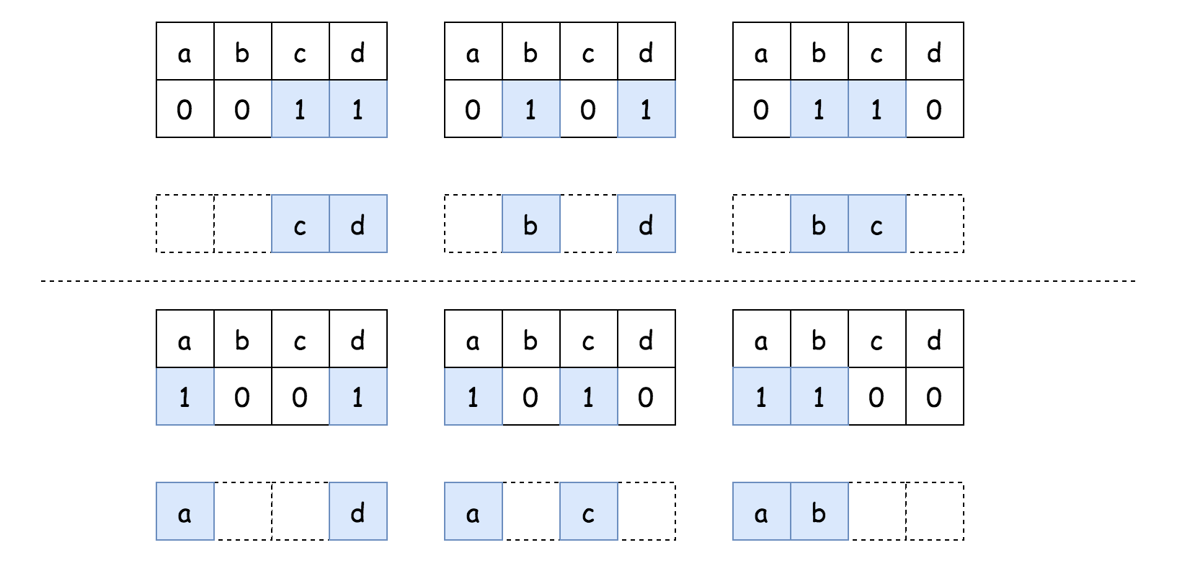

**Algorithm**

* Generate all possible binary bitmasks of length n*n*: from 00 to 2^n - 12*n*−1.
* Use bitmasks with k*k* set bits to generate combinations with k*k* elements. If the n - 1 - jth bit set in the bitmask, it indicates the presence of the character characters[j] in the combination, and vise versa.

Bit manipulation trick. To test if the ith bit is set in the bitmask, check the following: bitmask & (1 << i) != 0. It shifts the first 1-bit i positions to the left and then uses logical AND operation to eliminate all bits from bitmask but ith. Hence, the result is nonzero only if ith bit is set in the bitmask.

* Now you have all combinations precomputed. Pop them out one by one at each request.

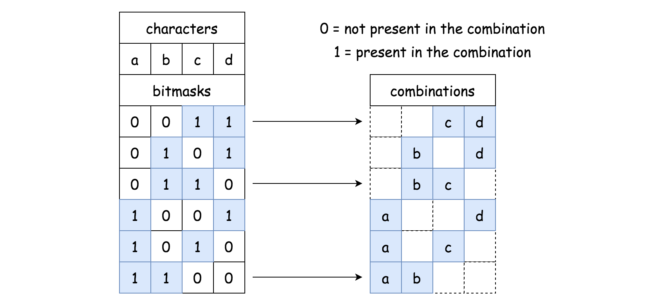

**Implementation**

|  |
| --- |
| class CombinationIterator {  public Deque < String > combinations = new ArrayDeque < String > ();  public CombinationIterator(String characters, int combinationLength) {  int n = characters.length();  int k = combinationLength;  // generate bitmasks from 0..00 to 1..11  for (int bitmask = 0; bitmask < 1 << n; bitmask++) {  // use bitmasks with k 1-bits  if (Integer.bitCount(bitmask) == k) {  // convert bitmask into combination  // 111 --> "abc", 000 --> ""  // 110 --> "ab", 101 --> "ac", 011 --> "bc"  StringBuilder curr = new StringBuilder();  for (int j = 0; j < n; j++) {  if ((bitmask & (1 << n - j - 1)) != 0) {  curr.append(characters.charAt(j));  }  }  combinations.push(curr.toString());  }  }  }  public String next() {  return combinations.pop();  }  public boolean hasNext() {  return (!combinations.isEmpty());  }  } |

**Complexity Analysis**

* Time Complexity:
  + \mathcal{O}(2^N \cdot N)O(2*N*⋅*N*) to generate 2^N2*N* bitmasks and then count a number of bits set in each bitmask in \mathcal{O}(N)O(*N*) time.
  + \mathcal{O}(1)O(1) runtime, i.e. for each next() call.
* Space Complexity: \mathcal{O}(k \cdot C_N^k)O(*k*⋅*CNk*​) to keep C_N^k*CNk*​ combinations of length k*k*.

#### Approach 2: Bitmasking: Next Combination



During precomputation, we've generated combinations in the descending order. That was done to pop them out later in the ascending order easily.

For the runtime generation at each next() call, the strategy should be changed: the combinations should be generated directly in the ascending order.

**Algorithm**

* Start from the "highest" bitmask: 1^{(k)}0^{(n - k)} = \underbrace{1...1}_\text{k times} \space \underbrace{0...0}_\text{n-k times}1(*k*)0(*n*−*k*)=k times1...1​​ n-k times0...0​​.
* At each step, generate a combination out of the current bitmask. If the n - 1 - jth bit set in the bitmask, that means the presence of the character characters[j] in the combination, and vise versa.
* Generate the next bitmask. Decrease bitmask gradually till you meet a bitmask with exactly k*k* set bits.

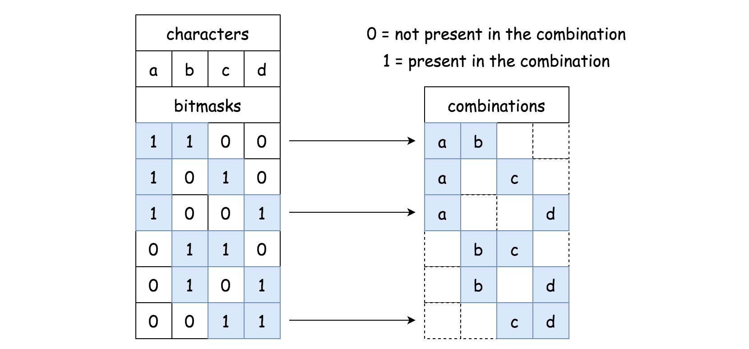

**Implementation**

|  |
| --- |
| class CombinationIterator {  int bitmask, n, k;  String chars;  public CombinationIterator(String characters, int combinationLength) {  n = characters.length();  k = combinationLength;  chars = characters;  // generate first bitmask 1(k)0(n - k)  bitmask = (1 << n) - (1 << n - k);  }  public String next() {  // convert bitmask into combination  // 111 --> "abc", 000 --> ""  // 110 --> "ab", 101 --> "ac", 011 --> "bc"  StringBuilder curr = new StringBuilder();  for (int j = 0; j < n; j++) {  if ((bitmask & (1 << n - j - 1)) != 0) {  curr.append(chars.charAt(j));  }  }  // generate next bitmask  bitmask--;  while (bitmask > 0 && Integer.bitCount(bitmask) != k) {  bitmask--;  }  return curr.toString();  }  public boolean hasNext() {  return bitmask > 0;  }  } |

**Complexity Analysis**

* Time Complexity: \mathcal{O}(2^N \cdot N / C_N^k)O(2*N*⋅*N*/*CNk*​) in average. To generate C_N^k*CNk*​ combinations, one has to parse 2^N2*N* bitmasks and to check a number of bits set in each bitmask, that makes an average computation cost per combination to be equal to \mathcal{O}(2^N \cdot N / C_N^k)O(2*N*⋅*N*/*CNk*​).
* Space Complexity: \mathcal{O}(k)O(*k*) to keep the current combination of length k*k*.

#### Approach 3: Algorithm L by D. E. Knuth: Lexicographic Combinations: Precomputation

Algorithm L is an efficient BFS that generates one by one the combinations of indexes. Here is how it works:



3210 - abcd \\ 01 - cd \\ 02 - bd \\ 12 - bc \\ 03 - ad \\ 13 - ac \\ 23 - ab \\3210−*abcd*01−*cd*02−*bd*12−*bc*03−*ad*13−*ac*23−*ab*

**Algorithm**

The algorithm is quite straightforward:

* Initialize nums to be a list of integers from 00 to k*k*. Add n*n* as the last element. It serves as a sentinel. Set the pointer at the beginning of the list j = 0.
* While j < k:
  + Convert the first k*k* elements (i.e. all elements but the sentinel) from nums into the combination to save.
  + Find the first number in nums such that nums[j + 1] != nums[j] + 1 and increase it by one nums[j] += 1 to move to the next combination.
* Now you have all combinations precomputed. Pop them out one by one at each request.

|  |
| --- |
| class CombinationIterator {  public Deque < String > combinations = new ArrayDeque < String > ();  public CombinationIterator(String characters, int combinationLength) {  int n = characters.length(), k = combinationLength;  // init the first combination  int[] nums = new int[k + 1];  for (int i = 0; i < k; ++i) {  nums[i] = i;  }  nums[k] = n;  int j = 0;  while (j < k) {  // add current combination  StringBuilder sb = new StringBuilder();  for (int i = k - 1; i > -1; i--) {  sb.append(characters.charAt(n - 1 - nums[i]));  }  combinations.push(sb.toString());  // Generate next combination.  // Find the first j such that nums[j] + 1 != nums[j + 1].  // Increase nums[j] by one.  j = 0;  while ((j < k) && (nums[j + 1] == nums[j] + 1)) {  nums[j] = j;  j++;  }  nums[j]++;  }  }  public String next() {  return combinations.pop();  }  public boolean hasNext() {  return (!combinations.isEmpty());  }  } |

**Complexity Analysis**

* Time Complexity: \mathcal{O}(k \times C_N^k)O(*k*×*CNk*​) for the precomputation and \mathcal{O}(1)O(1) during the runtime, i.e. for each next() call. The algorithm generates new combination from the previous one in \mathcal{O}(k)O(*k*) time, and then uses \mathcal{O}(k)O(*k*) time to save it for later usage. In total there are C_N^k*CNk*​ combinations, that makes precomputation time complexity to be equal to \mathcal{O}(k \times C_N^k)O(*k*×*CNk*​). Runtime complexity is \mathcal{O}(1)O(1).
* Space Complexity: \mathcal{O}(k \times C_N^k)O(*k*×*CNk*​) to keep C_N^k*CNk*​ combinations of length k*k*.

#### Approach 4: Algorithm L by D. E. Knuth: Lexicographic Combinations: Next Combination

For the runtime generation, the strategy should be changed: the combinations will be generated directly in the ascending order.

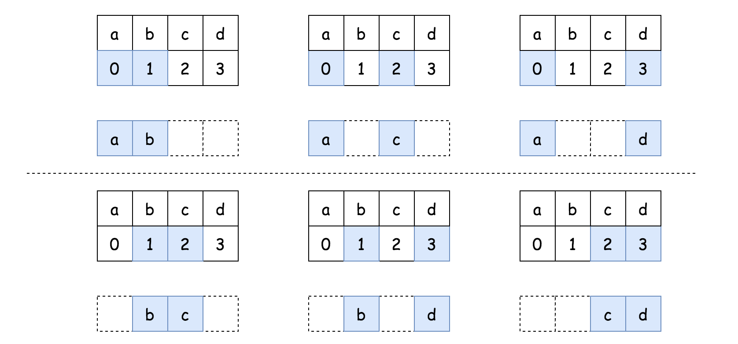

**Algorithm**

* Initialize nums as a list of integers from 00 to k*k*.
* At each step:
  + Convert nums into the combination to save.
  + Generate next combination:
    - Set the pointer at the end of the list j = k - 1.
    - Find the first j such that nums[j] == n - k + j and increase nums[j] by one nums[j] += 1.
    - Set nums[i] = nums[j] + i - j for every i in range (j + 1, k) to move to the next combination.

**Implementation**

|  |
| --- |
| class CombinationIterator {  int[] nums;  boolean has_next;  int n, k;  String chars;  public CombinationIterator(String characters, int combinationLength) {  n = characters.length();  k = combinationLength;  chars = characters;  // init the first combination  has_next = true;  nums = new int[k];  for (int i = 0; i < k; ++i) {  nums[i] = i;  }  }  public String next() {  StringBuilder curr = new StringBuilder();  for (int j: nums) {  curr.append(chars.charAt(j));  }  // Generate next combination.  // Find the first j such that nums[j] != n - k + j.  // Increase nums[j] by one.  int j = k - 1;  while (j >= 0 && nums[j] == n - k + j) {  j--;  }  if (j >= 0) {  nums[j]++;  for (int i = j + 1; i < k; i++) {  nums[i] = nums[j] + i - j;  }  } else {  has_next = false;  }  return curr.toString();  }  public boolean hasNext() {  return has_next;  }  } |

**Complexity Analysis**

* Time Complexity: \mathcal{O}(k)O(*k*) both for init() and next() functions. The algorithm generates a new combination from the previous one in \mathcal{O}(k)O(*k*) time.
* Space Complexity: \mathcal{O}(k)O(*k*) to keep the current combination of length k*k*.

**Longest Palindrome**

Given a string s which consists of lowercase or uppercase letters, return *the length of the****longest palindrome*** that can be built with those letters.

Letters are **case sensitive**, for example, "Aa" is not considered a palindrome here.

**Example 1:**

**Input:** s = "abccccdd"

**Output:** 7

**Explanation:**

One longest palindrome that can be built is "dccaccd", whose length is 7.

**Example 2:**

**Input:** s = "a"

**Output:** 1

**Example 3:**

**Input:** s = "bb"

**Output:** 2

**Constraints:**

* 1 <= s.length <= 2000
* s consists of lowercase **and/or** uppercase English letters only.

#### Approach #1: Greedy [Accepted]

**Intuition**

A palindrome consists of letters with equal partners, plus possibly a unique center (without a partner). The letter i from the left has its partner i from the right. For example in 'abcba', 'aa' and 'bb' are partners, and 'c' is a unique center.

Imagine we built our palindrome. It consists of as many partnered letters as possible, plus a unique center if possible. This motivates a greedy approach.

**Algorithm**

For each letter, say it occurs v times. We know we have v // 2 * 2 letters that can be partnered for sure. For example, if we have 'aaaaa', then we could have 'aaaa' partnered, which is 5 // 2 * 2 = 4 letters partnered.

At the end, if there was any v % 2 == 1, then that letter could have been a unique center. Otherwise, every letter was partnered. To perform this check, we will check for v % 2 == 1 and ans % 2 == 0, the latter meaning we haven't yet added a unique center to the answer.

|  |
| --- |
| class Solution {  public int longestPalindrome(String s) {  int[] count = new int[128];  for (char c: s.toCharArray())  count[c]++;  int ans = 0;  for (int v: count) {  ans += v / 2 * 2;  if (ans % 2 == 0 && v % 2 == 1)  ans++;  }  return ans;  }  } |

**Complexity Analysis**

* Time Complexity: O(N)*O*(*N*), where N*N* is the length of s. We need to count each letter.
* Space Complexity: O(1)*O*(1), the space for our count, as the alphabet size of s is fixed. We should also consider that in a bit complexity model, technically we need O(\log N)*O*(log*N*) bits to store the count values.

|  |
| --- |
| public int longestPalindrome(String s) {  if (s == null || s.length() < 1) return 0;  Set<Character> set = new HashSet<>();  for (int i = 0; i < s.length(); i++) {  if (set.contains(s.charAt(i))) set.remove(s.charAt(i));  else set.add(s.charAt(i));  }  if (set.size() <= 1) return s.length();  return s.length() - set.size() + 1;    } |

**Find Permutation**

By now, you are given a **secret signature** consisting of character 'D' and 'I'. 'D' represents a decreasing relationship between two numbers, 'I' represents an increasing relationship between two numbers. And our **secret signature** was constructed by a special integer array, which contains uniquely all the different number from 1 to n (n is the length of the secret signature plus 1). For example, the secret signature "DI" can be constructed by array [2,1,3] or [3,1,2], but won't be constructed by array [3,2,4] or [2,1,3,4], which are both illegal constructing special string that can't represent the "DI" **secret signature**.

On the other hand, now your job is to find the lexicographically smallest permutation of [1, 2, ... n] could refer to the given **secret signature** in the input.

**Example 1:**

**Input:** "I"

**Output:** [1,2]

**Explanation:** [1,2] is the only legal initial spectial string can construct secret signature "I", where the number 1 and 2 construct an increasing relationship.

**Example 2:**

**Input:** "DI"

**Output:** [2,1,3]

**Explanation:** Both [2,1,3] and [3,1,2] can construct the secret signature "DI",   
but since we want to find the one with the smallest lexicographical permutation, you need to output [2,1,3]

**Note:**

• The input string will only contain the character 'D' and 'I'.

• The length of input string is a positive integer and will not exceed 10,000

## Solution

#### Approach #1 Using Stack [Accepted]

Let's revisit the important points of the given problem statement. For a given n*n*, we need to use all the integers in the range (1,n)(1,*n*) to generate a lexicographically smallest permutation of these n*n* numbers which satsfies the pattern given in the string s*s*.

Firstly, we note that the lexicographically smallest permutation that can be generated(irrelevant of the given pattern s*s*) using the n*n* integers from (1,n)(1,*n*) is [1, 2, 3,.., n][1,2,3,..,*n*](say min*min*). Thus, while generating the required permutation, we can surely say that the permutation generated should be as close as possible to min*min*.

Now, we can also note that the number generated will be the smallest possible only if the digits lying towards the most significant positions are as small as possible while satisfying the given pattern. Now, to understand how these observations help in providing the solution of the given problem, we'll look at a simple example.

Say, the given pattern s*s* is "DDIIIID". This corresponds to n=8*n*=8. Thus, the min*min* permutation possible will be [1, 2, 3, 4, 5, 6, 7, 8]. Now, to satisfy the first two "DD" pattern, we can observe that the best course of action to generate the smallest arrangement will be to rearrange only 1, 2, 3, because these are the smallest numbers that can be placed at the three most significant positions to generate the smallest arrangement satisfying the given pattern till now, leading to the formation of [3, 2, 1, 4, 5, 6, 7, 8] till now. We can note that placing any number larger than 3 at any of these positions will lead to the generation of a lexicographically larger arrangement as discussed above.

We can also note that irrespective of how we rearrange the first three 1, 2, 3, the relationship of the last number among them with the next number always satisfies the criteria required for satisfying the first I in s*s*. Further, note that, the pattern generated till now already satisfies the subpattern "IIII" in s*s*. This will always be satisfied since the min*min* number considered originally always satisfies the increasing criteria.

Now, when we find the last "D" in the pattern s*s*, we again need to make rearrangements in the last two positions only and we need to use only the numbers 7, 8 in such rearrangements at those positions. This is because, again, we would like to keep the larger number towards the least significant possible as much as possible to generate the lexicographically smallest arrangement. Thus, to satisfy the last "D" the best arrangement of the last two numbers is 8, 7 leading to the generation of [3, 2, 1, 4, 5, 6, 8, 7] as the required output.

Based on the above example, we can summarize that, to generate the required arrangement, we can start off with the min*min* number that can be formed for the given n*n*. Then, to satisfy the given pattern s*s*, we need to reverse only those subsections of the min*min* array which have a D in the pattern at their corresponding positions.

To perform these operations, we need not necessarily create the min*min* array first, because it simply consists of numbers from 11 to n*n* in ascending order.

To perform the operations discussed above, we can make use of a stack*stack*. We can start considering the numbers i*i* from 11 to n*n*. For every current number, whenver we find a D in the pattern s*s*, we just push that number onto the stack*stack*. This is done so that, later on, when we find the next I, we can pop off these numbers from the stack leading to the formation of a reversed (descending) subpattern of those numbers corrresponding to the D's in s*s*(as discussed above).

When we encounter an I in the pattern, as discussed above, we push the current number as well onto the stack*stack* and then pop-off all the numbers on the stack*stack* and append these numbers to the resultant pattern formed till now.

Now, we could reach the end of the pattern s*s* with a trail of D's at the end. In this case, we won't find an ending I to pop-off the numbers on the stack*stack*. Thus, at the end, we push the value n*n* on the stack and then pop all the values on the stack*stack* and append them to the resultant pattern formed till now. Now, if the second last character in s*s* was an I, n*n* will be appended at the end of the resultant arrangement correctly. If the second last character was a D, the reversed pattern appended at the end of the resultant arrangement will be reversed including the last number n*n*. In both the cases, the resultant arrangement turns out to be correct.

The following animation better illustrates the process.



|  |
| --- |
| public class Solution {  public int[] findPermutation(String s) {  int[] res = new int[s.length() + 1];  Stack < Integer > stack = new Stack < > ();  int j = 0;  for (int i = 1; i <= s.length(); i++) {  if (s.charAt(i - 1) == 'I') {  stack.push(i);  while (!stack.isEmpty())  res[j++] = stack.pop();  } else  stack.push(i);  }  stack.push(s.length() + 1);  while (!stack.isEmpty())  res[j++] = stack.pop();  return res;  }  } |

**Complexity Analysis**

* Time complexity : O(n)*O*(*n*). n*n* numbers will be pushed and popped from the stack*stack*. Here, n*n* refers to the number of elements in the resultant arrangement.
* Space complexity : O(n)*O*(*n*). The stack*stack* can grow upto a depth of n*n* in the worst case.

#### Approach #2 Reversing the subarray [Accepted]

**Algorithm**

In order to reverse the subsections of the min*min* array, as discussed in the last approach, we can also start by initializing the resultant arrangement res*res* with the min*min* array i.e. by filling with elements (1,n)(1,*n*) in ascending order. Then, while traversing the pattern s*s*, we can keep a track of the starting and ending indices in res*res* corresponding to the D's in the pattern s*s*, and reverse the portions of the sub-arrays in res*res* corresponding to these indices. The reasoning behind this remains the same as discussed in the last approach.

The following animation illustrates the process.



|  |
| --- |
| public class Solution {  public int[] findPermutation(String s) {  int[] res = new int[s.length() + 1];  for (int i = 0; i < res.length; i++)  res[i] = i + 1;  int i = 1;  while (i <= s.length()) {  int j = i;  while (i <= s.length() && s.charAt(i - 1) == 'D')  i++;  reverse(res, j - 1, i);  i++;  }  return res;  }  public void reverse(int[] a, int start, int end) {  for (int i = 0; i < (end - start) / 2; i++) {  int temp = a[i + start];  a[i + start] = a[end - i - 1];  a[end - i - 1] = temp;  }  }  } |

**Complexity Analysis**

* Time complexity : O(n)*O*(*n*). The resultant array of size n*n* is traversed atmost three times, in the worst case e.g. "DDDDDD"
* Space complexity : O(1)*O*(1). Constant extra space is used.

#### Approach #3 Two pointers [Accepted]

**Algorithm**

Instead of initializing the res*res* array once with ascending numbers, we can save one iteration over res*res* if we fill it on the fly. To do this, we can keep on filling the numbers in ascending order in res*res* for I's found in the pattern s*s*. Whenever we find a D in the pattern s*s*, we can store the current position(counting from 1) being filled in the res*res* array in a pointer j*j*. Now, whenever we find the first I following this last consecutive set of D's, say at the i^{th}*ith* position(counting from 1) in res*res*, we know, that the elements from j^{th}*jth* position to the i^{th}*ith* position in res*res* need to be filled with the numbers from j*j* to i*i* in reverse order. Thus, we can fill the numbers in res*res* array starting from the j^{th}*jth* position, with i*i* being the number filled at that position and continue the filling in descending order till reaching the i^{th}*ith* position. In this way, we can generate the required arrangement without initializing res*res*.

|  |
| --- |
| public class Solution {  public int[] findPermutation(String s) {  int[] res = new int[s.length() + 1];  res[0]=1;  int i = 1;  while (i <= s.length()) {  res[i]=i+1;  int j = i;  if(s.charAt(i-1)=='D')  {  while (i <= s.length() && s.charAt(i - 1) == 'D')  i++;  for (int k = j - 1, c = i; k <= i - 1; k++, c--) {  res[k] = c;  }  }  else  i++;  }  return res;  }  } |

**Complexity Analysis**

* Time complexity : O(n)*O*(*n*). The resultant array of size n*n* is traversed atmost two times, in the worst case e.g. "DDDDDD"
* Space complexity : O(1)*O*(1). Constant extra space is used.

**Non-overlapping Intervals**

Given a collection of intervals, find the minimum number of intervals you need to remove to make the rest of the intervals non-overlapping.

**Example 1:**

**Input:** [[1,2],[2,3],[3,4],[1,3]]

**Output:** 1

**Explanation:** [1,3] can be removed and the rest of intervals are non-overlapping.

**Example 2:**

**Input:** [[1,2],[1,2],[1,2]]

**Output:** 2

**Explanation:** You need to remove two [1,2] to make the rest of intervals non-overlapping.

**Example 3:**

**Input:** [[1,2],[2,3]]

**Output:** 0

**Explanation:** You don't need to remove any of the intervals since they're already non-overlapping.

**Note:**

1. You may assume the interval's end point is always bigger than its start point.
2. Intervals like [1,2] and [2,3] have borders "touching" but they don't overlap each other.

## Summary

Given a collection of intervals, we need to find the minimum number of intervals to be removed to make the rest of the intervals non-overlapping.

## Solution

#### Approach #1 Brute Force [Time Limit Exceeded]

In the brute force approach, we try to remove the overlapping intervals in different combinations and then check which combination needs the minimum number of removals. To do this, firstly we sort the given intervals based on the starting point. Then, we make use of a recursive function eraseOverlapIntervals which takes the index of the previous interval prev*prev* and the index of the current interval curr*curr* (which we try to add to the list of intervals not removed), and returns the count of intervals that need to be removed from the current index onwards.

We start by using prev=-1*prev*=−1 and curr=0*curr*=0. In each recursive call, we check if the current interval overlaps with the previous interval. If not, we need not remove the current interval from the final list and we can call the function eraseOverlapIntervals with prev=curr*prev*=*curr* and curr=curr + 1*curr*=*curr*+1. The result of this function call in which we have included the current element is stored in taken*taken* variable.

We also make another function call by removing the current interval because this could be overlapping with the upcoming intervals in the next function call and thus, its removal could eventually require lesser total number of removals. Thus, the recursive call takes the arguments prev=prev*prev*=*prev* and curr=curr + 1*curr*=*curr*+1. Since, we have removed one interval, the result if the current interval isn't included is the sum of the value returned by the function call incremented by 1, which is stored in notTaken*notTaken* variable. While returning the count of removals following a particular index, we return the minimum of taken*taken* and notTaken*notTaken*.

|  |
| --- |
| class Solution {  class myComparator implements Comparator<int[]> {  public int compare(int[] a, int[] b) {  return a[1] - b[1];  }  }  public int eraseOverlapIntervals(int[][] intervals) {  Arrays.sort(intervals, new myComparator());  return erase_Overlap_Intervals(-1, 0, intervals);  }  public int erase_Overlap_Intervals(int prev, int curr, int[][] intervals) {  if (curr == intervals.length) {  return 0;  }  int taken = Integer.MAX_VALUE, nottaken;  if (prev == -1 || intervals[prev][1] <= intervals[curr][0]) {  taken = erase_Overlap_Intervals(curr, curr + 1, intervals);  }  nottaken = erase_Overlap_Intervals(prev, curr + 1, intervals) + 1;  return Math.min(taken, nottaken);  }  } |

**Complexity Analysis**

* Time complexity : O(2^n)*O*(2*n*). Total possible number of Combinations of subsets are 2^n2*n* .
* Space complexity : O(n)*O*(*n*). Depth of recursion is n*n*.

#### Approach #2 Using DP based on starting point [Accepted]

**Algorithm**

The given problem can be simplified to a great extent if we sort the given interval list based on the starting points. Once it's done, we can make use of a dp*dp* array, scuh that dp[i]*dp*[*i*] stores the maximum number of valid intervals that can be included in the final list if the intervals upto the i^{th}*ith* interval only are considered, including itself. Now, while finding dp[i+1]*dp*[*i*+1], we can't consider the value of dp[i]*dp*[*i*] only, because it could be possible that the i^{th}*ith* or any previous interval could be overlapping with the (i+1)^{th}(*i*+1)*th* interval. Thus, we need to consider the maximum of all dp[j]*dp*[*j*]'s such that j \leq i*j*≤*i* and j^{th}*jth* interval and i^{th}*ith* don't overlap, to evaluate dp[i+1]*dp*[*i*+1]. Therefore, the equation for dp[i+1]*dp*[*i*+1] becomes:

dp[i+1]= \max(dp[j]) + 1,*dp*[*i*+1]=max(*dp*[*j*])+1,

such that j^{th}*jth* interval and i^{th}*ith* don't overlap, for all j \leq i*j*≤*i*.

In the end, to obtain the maximum number of intervals that can be included in the final list(ans*ans*) we need to find the maximum value in the dp*dp* array. The final result will be the total number of intervals given less the result just obtained(intervals.length-ans*intervals*.*length*−*ans*).

The animation below illustrates the approach more clearly:



|  |
| --- |
| class Solution {  class myComparator implements Comparator<int[]> {  public int compare(int[] a, int[] b) {  return a[1] - b[1];  }  }  public boolean isOverlapping(int[] i, int[] j) {  return i[1] > j[0];  }  public int eraseOverlapIntervals(int[][] intervals) {  if (intervals.length == 0) {  return 0;  }  Arrays.sort(intervals, new myComparator());  int dp[] = new int[intervals.length];  dp[0] = 1;  int ans = 1;  for (int i = 1; i < dp.length; i++) {  int max = 0;  for (int j = i - 1; j >= 0; j--) {  if (!isOverlapping(intervals[j], intervals[i])) {  max = Math.max(dp[j], max);  }  }  dp[i] = max + 1;  ans = Math.max(ans, dp[i]);  }  return intervals.length - ans;  }  } |

**Complexity Analysis**

* Time complexity : O(n^2)*O*(*n*2). Two nested loops are required to fill dp*dp* array.
* Space complexity : O(n)*O*(*n*). dp*dp* array of size n*n* is used.

#### Approach #3 Using DP based on the end points [Accepted]

**Algorithm**

In the DP approach just discussed above, for calculating the value of every dp[i]*dp*[*i*], we need to traverse the dp*dp* array back till the starting index. This overhead can be removed, if we use an interval list sorted on the basis of the end points. Thus, now, again we use the same kind of dp*dp* array, where dp[i]*dp*[*i*] is used to store the maximum number of intervals that can be included in the final list if the intervals only upto the i^{th}*ith* index in the sorted list are considered. Thus, in order to find dp[i+1]*dp*[*i*+1] now, we've to consider two cases:

**Case 1:**

The interval corresponding to (i+1)^{th}(*i*+1)*th* interval needs to be included in the final list to obtain the minimum number of removals:

In this case, we need to traverse back in the sorted interval array form the (i+1)^{th}(*i*+1)*th* index upto the starting index to find the first interval which is non-overlapping. This is because, if we are including the current interval, we need to remove all the intervals which are overlapping with the current interval. But, we need not go back till the starting index everytime. Instead we can stop the traversal as soon as we hit the first non-overlapping interval and use its dp[j] + 1*dp*[*j*]+1 to fill in dp[i+1]*dp*[*i*+1], since dp[j]*dp*[*j*] will be the element storing the maximum number of intervals that can be included considering elements upto the j^{th}*jth* index.

**Case 2:**

The interval corresponding to (i+1)^{th}(*i*+1)*th* interval needs to be removed from the final list to obtain the minimum number of removals:

In this case, the current element won't be included in the final list. So, the count of intervals to be included upto (i+1)^{th}(*i*+1)*th* index is the same as the count of intervals upto the i^{th}*ith* index. Thus, we can use dp[i]*dp*[*i*]'s value to fill in dp[i+1]*dp*[*i*+1].

The value finally entered in dp[i+1]*dp*[*i*+1] will be the maximum of the above two values.

The final result will again be the total count of intervals less the result obtained at the end from the dp*dp* array.

The animation below illustrates the approach more clearly:



|  |
| --- |
| class Solution {  class myComparator implements Comparator<int[]> {  public int compare(int[] a, int[] b) {  return a[1] - b[1];  }  }  public boolean isOverlapping(int[] i, int[] j) {  return i[1] > j[0];  }  public int eraseOverlapIntervals(int[][] intervals) {  if (intervals.length == 0) {  return 0;  }  Arrays.sort(intervals, new myComparator());  int dp[] = new int[intervals.length];  dp[0] = 1;  int ans = 1;  for (int i = 1; i < dp.length; i++) {  int max = 0;  for (int j = i - 1; j >= 0; j--) {  if (!isOverlapping(intervals[j], intervals[i])) {  max = Math.max(dp[j], max);  break;  }  }  dp[i] = Math.max(max + 1, dp[i - 1]);  ans = Math.max(ans, dp[i]);  }  return intervals.length - ans;  }  } |

**Complexity Analysis**

* Time complexity : O(n^2)*O*(*n*2). Two nested loops are required to fill dp*dp* array.
* Space complexity : O(n)*O*(*n*). dp*dp* array of size n*n* is used.

#### Approach #4 Using Greedy Approach based on starting points [Accepted]

**Algorithm**

If we sort the given intervals based on starting points, the greedy approach works very well. While considering the intervals in the ascending order of starting points, we make use of a pointer prev*prev* pointer to keep track of the interval just included in the final list. While traversing, we can encounter 3 possibilities as shown in the figure:

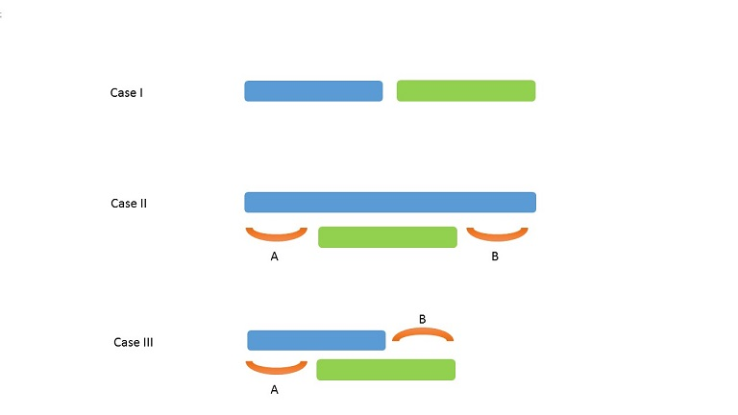

**Case 1:**

The two intervals currently considered are non-overlapping:

In this case, we need not remove any interval and we can continue by simply assigning the prev*prev* pointer to the later interval and the count of intervals removed remains unchanged.

**Case 2:**

The two intervals currently considered are overlapping and the end point of the later interval falls before the end point of the previous interval:

In this case, we can simply take the later interval. The choice is obvious since choosing an interval of smaller width will lead to more available space labelled as A*A* and B*B*, in which more intervals can be accommodated. Hence, the prev*prev* pointer is updated to current interval and the count of intervals removed is incremented by 1.

**Case 3:**

The two intervals currently considered are overlapping and the end point of the later interval falls after the end point of the previous interval:

In this case, we can work in a greedy manner and directly remove the later interval. To understand why this greedy approach works, we need to see the figure below, which includes all the subcases possible. It is clear from the figures that we choosing interval 1 always leads to a better solution in the future. Thus, the prev*prev* pointer remains unchanged and the count of intervals removed is incremented by 1.

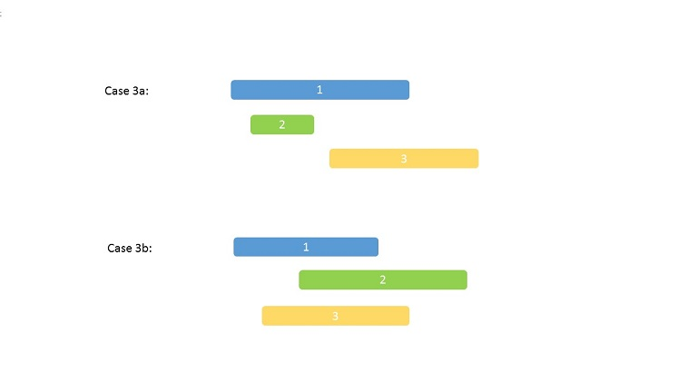

|  |
| --- |
| class Solution {  class myComparator implements Comparator<int[]> {  public int compare(int[] a, int[] b) {  return a[1] - b[1];  }  }  public int eraseOverlapIntervals(int[][] intervals) {  if (intervals.length == 0) {  return 0;  }  Arrays.sort(intervals, new myComparator());  int end = intervals[0][1], prev = 0, count = 0;  for (int i = 1; i < intervals.length; i++) {  if (intervals[prev][1] > intervals[i][0]) {  if (intervals[prev][1] > intervals[i][1]) {  prev = i;  }  count++;  } else {  prev = i;  }  }  return count;  }  } |

**Complexity Analysis**

* Time complexity : O\big(n \log(n)\big)*O*(*n*log(*n*)). Sorting takes O\big(n \log(n)\big)*O*(*n*log(*n*)) time.
* Space complexity : O(1)*O*(1). No extra space is used.

#### Approach #5 Using Greedy Approach based on end points [Accepted]

**Algorithm**

The Greedy approach just discussed was based on choosing intervals greedily based on the starting points. But in this approach, we go for choosing points greedily based on the end points. For this, firstly we sort the given intervals based on the end points. Then, we traverse over the sorted intervals. While traversing, if there is no overlapping between the previous interval and the current interval, we need not remove any interval. But, if an overlap exists between the previous interval and the current interval, we always drop the current interval.

To explain how it works, again we consider every possible arrangement of the intervals.

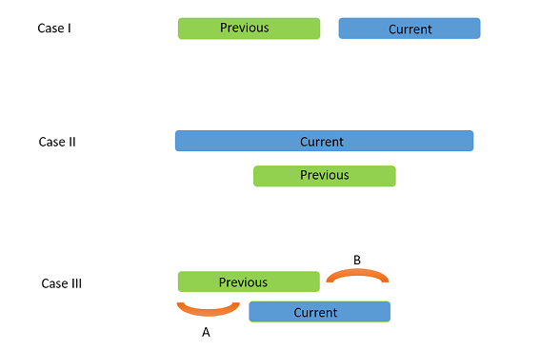

**Case 1:**

The two intervals currently considered are non-overlapping:

In this case, we need not remove any interval and for the next iteration the current interval becomes the previous interval.

**Case 2:**

The two intervals currently considered are overlapping and the starting point of the later interval falls before the starting point of the previous interval:

In this case, as shown in the figure below, it is obvious that the later interval completely subsumes the previous interval. Hence, it is advantageous to remove the later interval so that we can get more range available to accommodate future intervals. Thus, previous interval remains unchanged and the current interval is updated.

**Case 3:**

The two intervals currently considered are overlapping and the starting point of the later interval falls before the starting point of the previous interval:

In this case, the only opposition to remove the current interval arises because it seems that more intervals could be accommodated by removing the previous interval in the range marked by A*A*. But that won't be possible as can be visualized with a case similar to Case 3a and 3b shown above. But, if we remove the current interval, we can save the range B*B* to accommodate further intervals. Thus, previous interval remains unchanged and the current interval is updated.

|  |
| --- |
| class Solution {  class myComparator implements Comparator<int[]> {  public int compare(int[] a, int[] b) {  return a[1] - b[1];  }  }  public int eraseOverlapIntervals(int[][] intervals) {  if (intervals.length == 0) {  return 0;  }  Arrays.sort(intervals, new myComparator());  int end = intervals[0][1];  int count = 1;  for (int i = 1; i < intervals.length; i++) {  if (intervals[i][0] >= end) {  end = intervals[i][1];  count++;  }  }  return intervals.length - count;  }  } |

**Complexity Analysis**

* Time complexity : O\big(n \log(n)\big)*O*(*n*log(*n*)). Sorting takes O\big(n \log(n)\big)*O*(*n*log(*n*)) time.
* Space complexity : O(1)*O*(1). No extra space is used.

**Distribute Candies to People**

We distribute some number of candies, to a row of **n = num_people** people in the following way:

We then give 1 candy to the first person, 2 candies to the second person, and so on until we give n candies to the last person.

Then, we go back to the start of the row, giving n + 1 candies to the first person, n + 2 candies to the second person, and so on until we give 2 * n candies to the last person.

This process repeats (with us giving one more candy each time, and moving to the start of the row after we reach the end) until we run out of candies.  The last person will receive all of our remaining candies (not necessarily one more than the previous gift).

Return an array (of length num_people and sum candies) that represents the final distribution of candies.

**Example 1:**

**Input:** candies = 7, num_people = 4

**Output:** [1,2,3,1]

**Explanation:**

On the first turn, ans[0] += 1, and the array is [1,0,0,0].

On the second turn, ans[1] += 2, and the array is [1,2,0,0].

On the third turn, ans[2] += 3, and the array is [1,2,3,0].

On the fourth turn, ans[3] += 1 (because there is only one candy left), and the final array is [1,2,3,1].

**Example 2:**

**Input:** candies = 10, num_people = 3

**Output:** [5,2,3]

**Explanation:**

On the first turn, ans[0] += 1, and the array is [1,0,0].

On the second turn, ans[1] += 2, and the array is [1,2,0].

On the third turn, ans[2] += 3, and the array is [1,2,3].

On the fourth turn, ans[0] += 4, and the final array is [5,2,3].

**Constraints:**

* 1 <= candies <= 10^9
* 1 <= num_people <= 1000

   Show Hint #1

Give candy to everyone each "turn" first [until you can't], then give candy to one person per turn.

## Solution

#### Approach 1: Sum of Arithmetic Progression

**Intuition**

That sort of "Math" questions is to check on how far one could simplify the problem even before starting to code.

Naive idea here is to jump into code and start to give candies in a loop till the end of candies. Time complexity of such a solution would be \mathcal{O}(\max(G, N))O(max(*G*,*N*)), where G is a number of gifts and N is a number of people.

More elegant way would be to notice that candies distribution could be described by a simple formula. Using that formula one could solve the problem in \mathcal{O}(N)O(*N*) time by the straightforward generation of final distribution array.

Let's derive that formula step by step.

**Number of persons with complete gifts**

Candies gifts, except the last gift which contains the remaining, represent the arithmetic progression of natural numbers.

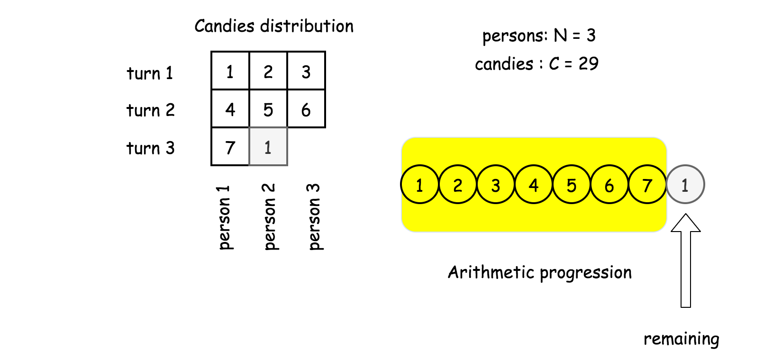

Let's assume that the progression has p elements, then the remaining is just a difference between number of candies C*C* and sum of the progression elements

\textrm{remaining} = C - \sum\limits_{k = 0}^{k = p}{k}remaining=*C*−*k*=0∑*k*=*p*​*k*

Sum of the natural numbers progression is a [school knowledge](https://en.wikipedia.org/wiki/1_%2B_2_%2B_3_%2B_4_%2B_%E2%8B%AF), and remaining could be rewritten as

\textrm{remaining} = C - \frac{p(p + 1)}{2}remaining=*C*−2*p*(*p*+1)​

It's known that remaining is larger or equal to 0 and smaller than the next progression number p + 1*p*+1.

0 \le C - \frac{p(p + 1)}{2} < p + 10≤*C*−2*p*(*p*+1)​<*p*+1

Simple calculations results in

\sqrt{2C + \frac{1}{4}} - \frac{3}{2} < p \le \sqrt{2C + \frac{1}{4}} - \frac{1}{2}2*C*+41​​−23​<*p*≤2*C*+41​​−21​

There is only one integer in this interval, and hence now one knows the number of elements in the arithmetic progression

p = \textrm{floor}\left(\sqrt{2C + \frac{1}{4}} - \frac{1}{2}\right)*p*=floor(2*C*+41​​−21​)

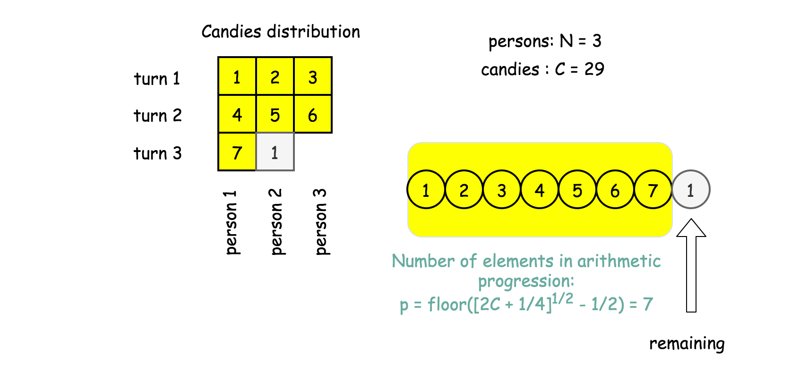

**Candies gain during the complete turns**

Now one could compute a number of complete turns when all N persons received a gift : rows = p / N.

During complete turns person number i receives in total

d[i] = i + (i + N) + (i + 2N) + ... (i + (\textrm{rows} - 1) N) = i \times \textrm{rows} + N \frac{\textrm{rows}(\textrm{rows} - 1)}{2}*d*[*i*]=*i*+(*i*+*N*)+(*i*+2*N*)+...(*i*+(rows−1)*N*)=*i*×rows+*N*2rows(rows−1)​

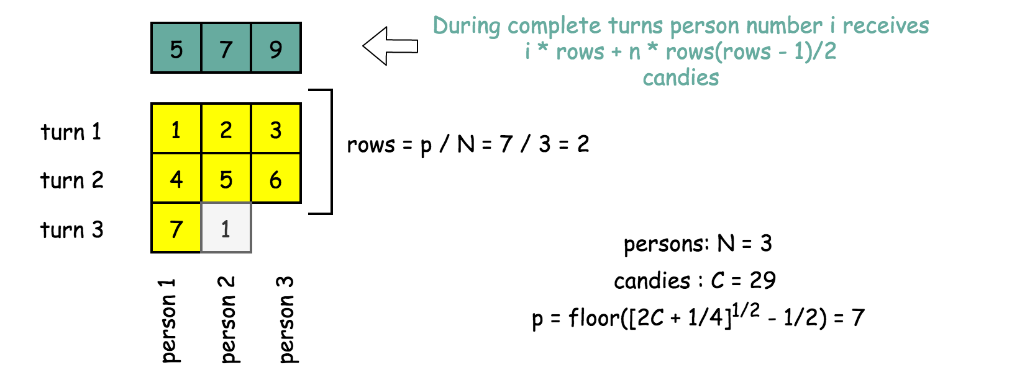

**Candies gain during the incomplete turn**

The last turn could be incomplete, i.e. not all persons receive their gifts.

One could compute a number of persons which received a complete gift : cols = p % N. These persons will receive one turn more candies

d[i] += i + N \times \textrm{rows}*d*[*i*]+=*i*+*N*×rows

And the last person with a gift will receive all remaining candies

d[\textrm{cols} + 1] += \textrm{remaining}*d*[cols+1]+=remaining

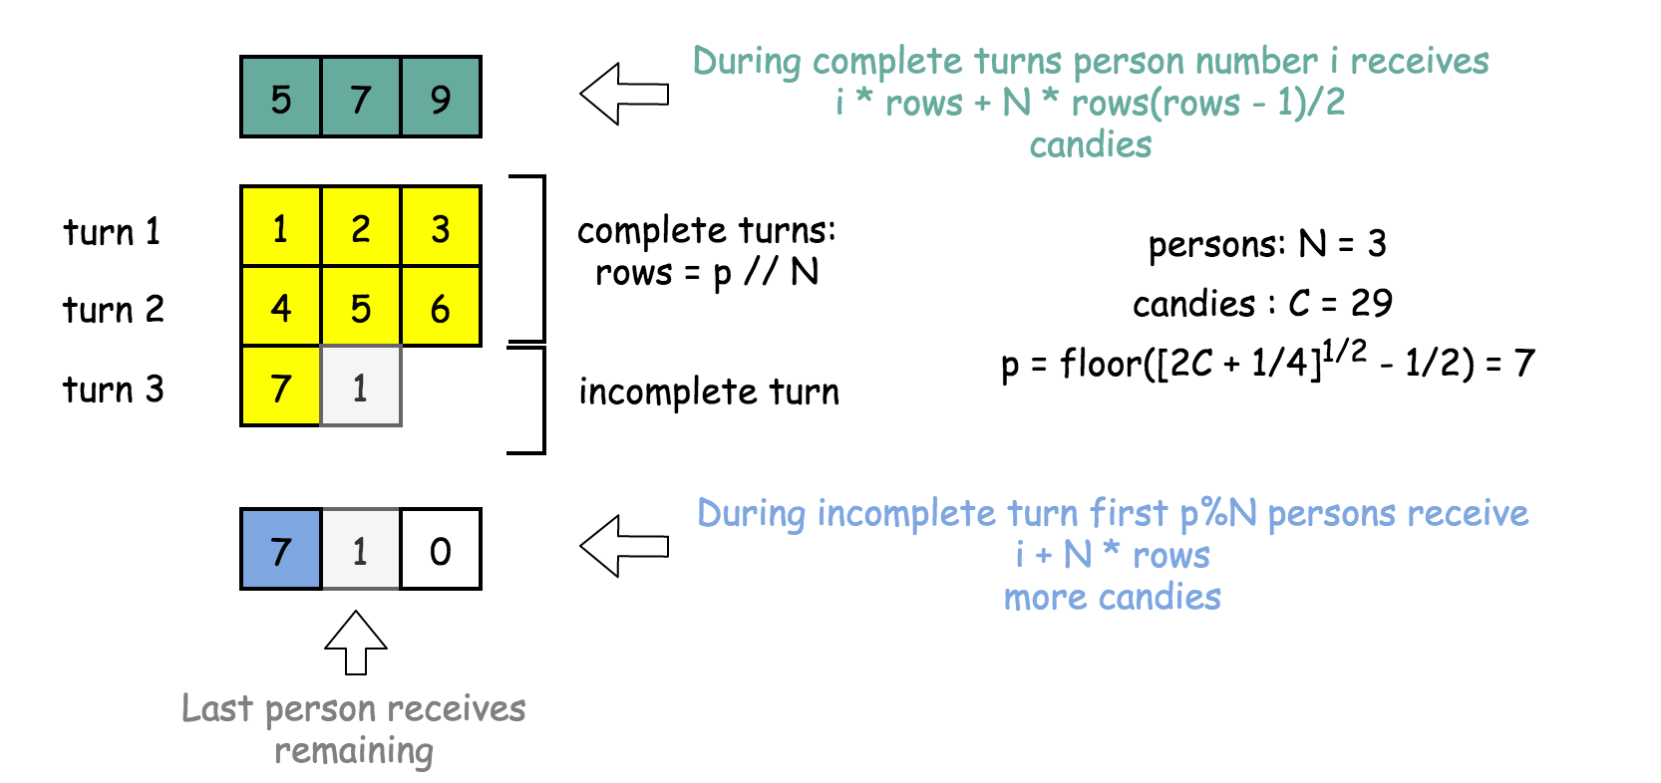

That's all, all distributed candies are computed.

**Algorithm**

* Compute number of persons with complete gifts

p = \textrm{floor}\left(\sqrt{2C + \frac{1}{4}} - \frac{1}{2}\right)*p*=floor(2*C*+41​​−21​)

and the last gift \textrm{remaining} = C - \frac{p(p + 1)}{2}remaining=*C*−2*p*(*p*+1)​.

* Compute the number of complete turns, when all persons receive their gifts : rows = p // n, and candies gain from these turns : d[i] = i \times \textrm{rows} + N \frac{\textrm{rows}(\textrm{rows} - 1)}{2}*d*[*i*]=*i*×rows+*N*2rows(rows−1)​
* Add one turn more candies to first p % N persons participated in the last incomplete turn : d[i] += i + N \times \textrm{rows}*d*[*i*]+=*i*+*N*×rows.
* Add remaining to the person after the first p % N persons.
* Return candies distribution d.

**Implementation**

|  |
| --- |
| class Solution {  public int[] distributeCandies(int candies, int num_people) {  int n = num_people;  // how many people received complete gifts  int p = (int)(Math.sqrt(2 * candies + 0.25) - 0.5);  int remaining = (int)(candies - (p + 1) * p * 0.5);  int rows = p / n, cols = p % n;  int[] d = new int[n];  for(int i = 0; i < n; ++i) {  // complete rows  d[i] = (i + 1) * rows + (int)(rows * (rows - 1) * 0.5) * n;  // cols in the last row  if (i < cols) d[i] += i + 1 + rows * n;  }  // remaining candies  d[cols] += remaining;  return d;  }  } |

**Complexity Analysis**

* Time complexity : \mathcal{O}(N)O(*N*) to create N elements of the output array.
* Space complexity : \mathcal{O}(N)O(*N*) to keep the output.

**Numbers With Same Consecutive Differences**

Return all **non-negative** integers of length n such that the absolute difference between every two consecutive digits is k.

Note that **every** number in the answer **must not** have leading zeros. For example, 01 has one leading zero and is invalid.

You may return the answer in **any order**.

**Example 1:**

**Input:** n = 3, k = 7

**Output:** [181,292,707,818,929]

**Explanation:** Note that 070 is not a valid number, because it has leading zeroes.

**Example 2:**

**Input:** n = 2, k = 1

**Output:** [10,12,21,23,32,34,43,45,54,56,65,67,76,78,87,89,98]

**Example 3:**

**Input:** n = 2, k = 0

**Output:** [11,22,33,44,55,66,77,88,99]

**Example 4:**

**Input:** n = 2, k = 2

**Output:** [13,20,24,31,35,42,46,53,57,64,68,75,79,86,97]

**Constraints:**

* 2 <= n <= 9
* 0 <= k <= 9

## Solution

#### Overview

The problem asks us to come up a list of digit combinations that follow the defined pattern. Before jumping to the implementation, it is always helpful to manually deduce some examples.

Suppose that we have N=3 and K=2, i.e. we should come up a series of 3-digits numbers, where for each number the difference between each adjacent digits is 2.

Let us try to build the number ***digit by digit***. Starting from the highest digit, we can pick the digit 1. Then for the next digit, we need to pick 3 (i.e. 1+21+2). Finally, for the last digit, we could have two choices: 5 and 1 (i.e. 3+2, 3-23+2,3−2). We illustrate the process in the following graph, where each **node** represents a digit that we pick, and the **level** of the node corresponds to the position that the digit situates in the final number.

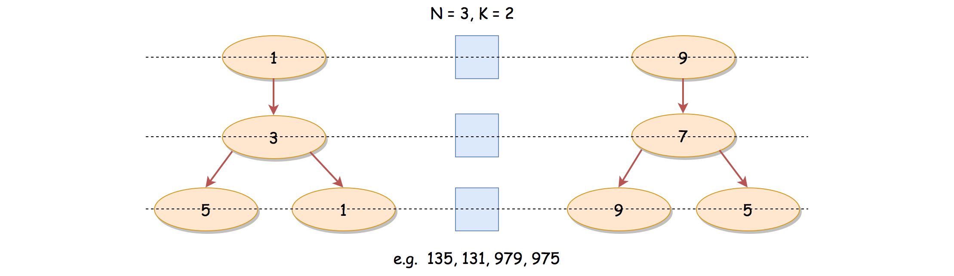

As one might notice that, we just converted the problem into a tree traversal problem, where each path from the root to a leaf forms a solution for the problem.

As we know, the common algorithms for the tree traversal problem would be ***DFS*** (Depth-First Search) and ***BFS*** (Breadth-First Search), which are exactly what we will present in the following sections.

#### Approach 1: DFS (Depth-First Search)

**Intuition**

If one is not familiar with the concepts of DFS and BFS, we have an Explore card called [Queue & Stack](https://leetcode.com/explore/learn/card/queue-stack/) where we cover the [DFS traversal](https://leetcode.com/explore/learn/card/queue-stack/232/practical-application-stack/) as well as the [BFS traversal](https://leetcode.com/explore/learn/card/queue-stack/231/practical-application-queue/).

In this section, we will start from the DFS strategy, which arguably is more intuitive for this problem.

As we stated in the overview section, we could build a valid digit combination digit by digit or (node by node in terms of tree).

For a number consisting of N digits, we start from the highest digit and walk through to the lowest digit. At each step, we might have several candidates that are eligible to be explored.

With the DFS strategy, we prioritize the depth over the breadth, i.e. we pick one of the candidates and continue the exploration before moving on to the other candidates that are of the same level.

**Algorithm**

Intuitively we could implement the DFS algorithm with recursion. Here we define a recursive function DFS(N, num) (in Python) whose goal is to come up the combinations for the remaining N digits, starting from the current num. Note that, the signature of the function is slightly different in our Java implementation. Yet, the semantics of the function remains the same.

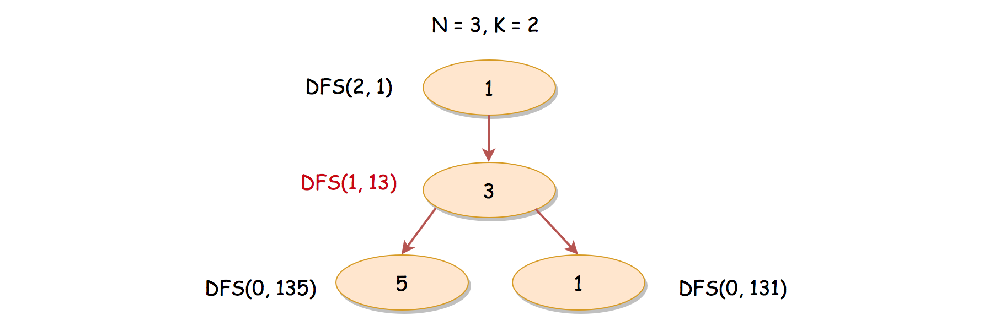

For instance, in the previous examples, where N=3 and K=2, and there is a moment we would invoke DFS(1, 13) which is to add another digit to the existing number 13 so that the final number meets the requirements. If the DFS function works properly, we should have the numbers of 135 and 131 as results after the invocation.

We could implement the recursive function in the following steps:

* As a base case, when N=0 i.e. no more remaining digits to complete, we could return the current num as the result.
* Otherwise, there are still some remaining digits to be added to the current number, e.g. 13. There are two potential cases to explore, based on the last digit of the current number which we denote as tail_digit.
  + Adding the difference K to the last digit, i.e. tail_digit + K.
  + Deducting the difference K from the last digit, i.e. tail_digit - K.
* If the result of either above case falls into the valid digit range (i.e. [0, 9][0,9]), we then continue the exploration by invoking the function itself.

Once we implement the DFS(N, num) function, we then simply call this function over the scope of [1, 9][1,9], i.e. the valid digits for the highest position.

**Note**: If we are asked to return numbers of a single digit (i.e. *N=1*), then regardless of *K*, all digits are valid, including zero. We treat this as a special case in the code, since in our implementation of DFS function, we will never return zero as the result.

|  |
| --- |
| class Solution {  public int[] numsSameConsecDiff(int N, int K) {  if (N == 1)  return new int[] {0, 1, 2, 3, 4, 5, 6, 7, 8, 9};  List<Integer> results = new ArrayList<Integer>();  for (int num = 1; num < 10; ++num)  this.DFS(N - 1, num, K, results);  // convert the ArrayList to int[]  return results.stream().mapToInt(i->i).toArray();  }  protected void DFS(int N, int num, int K, List<Integer> results) {  if (N == 0) {  results.add(num);  return;  }  List<Integer> nextDigits = new ArrayList<>();  Integer tailDigit = num % 10;  nextDigits.add(tailDigit + K);  if (K != 0)  nextDigits.add(tailDigit - K);  for (Integer nextDigit : nextDigits) {  if (0 <= nextDigit && nextDigit < 10) {  Integer newNum = num * 10 + nextDigit;  this.DFS(N - 1, newNum, K, results);  }  }  }  } |

**Complexity Analysis**

Let N*N* be the number of digits for a valid combination, and K*K* be the difference between digits.

First of all, let us estimate the number of potential solutions. For the highest digit, we could have 9 potential candidates. Starting from the second highest position, we could have at most 2 candidates for each position. Therefore, at most, we could have 9 \cdot 2^{N-1}9⋅2*N*−1 solutions, for N > 1*N*>1.

* Time Complexity: \mathcal{O}(2^{N})O(2*N*)
  + Essentially, the execution of the algorithm will unfolder itself as a binary tree, where each node in the tree represents an invocation of the DFS() function. The execution of the DFS() function itself takes a constant time. Therefore, the overall time complexity is proportional to the number of nodes in the execution binary tree.
  + In the worst case, the total number of nodes in a binary tree of depth N-1*N*−1 is 2^N2*N*. Hence, the overall time complexity of the algorithm is \mathcal{O}(2^{N})O(2*N*).
  + Note that, when K = 0*K*=0, at each position, there is only one possible candidate, e.g. 333333. In total, we would have 9 numbers in the result set, and each number is of N*N* digits. The time complexity would then be reduced down to \mathcal{O}(N)O(*N*).
* Space Complexity: \mathcal{O}(2^{N})O(2*N*)
  + Since we adopt a recursive solution, we would have some additional memory consumption on the function call stack. The maximum number of consecutive calls on the recursion function is N*N*. Hence, the space complexity for the call stack is \mathcal{O}(N)O(*N*).
  + We use a list to keep all the solutions, which could amount to 9 \cdot 2^{N-1}9⋅2*N*−1 number of elements.
  + To sum up, the overall space complexity of the algorithm is \mathcal{O}(N) + \mathcal{O}(9 \cdot 2^{N-1}) = \mathcal{O}(2^{N})O(*N*)+O(9⋅2*N*−1)=O(2*N*).

#### Approach 2: BFS (Breadth-First Search)

**Intuition**

It might be more intuitive to come up a DFS solution as we presented before. However, it is also viable to solve this problem with BFS (Breadth-First Search) traversal strategy.

Rather than building the solution one by one, we could do it batch by batch, i.e. level by level.

Each level contains the numbers that are of the same amount of digits. Also, each level corresponds to the solutions with a specific number of digits.

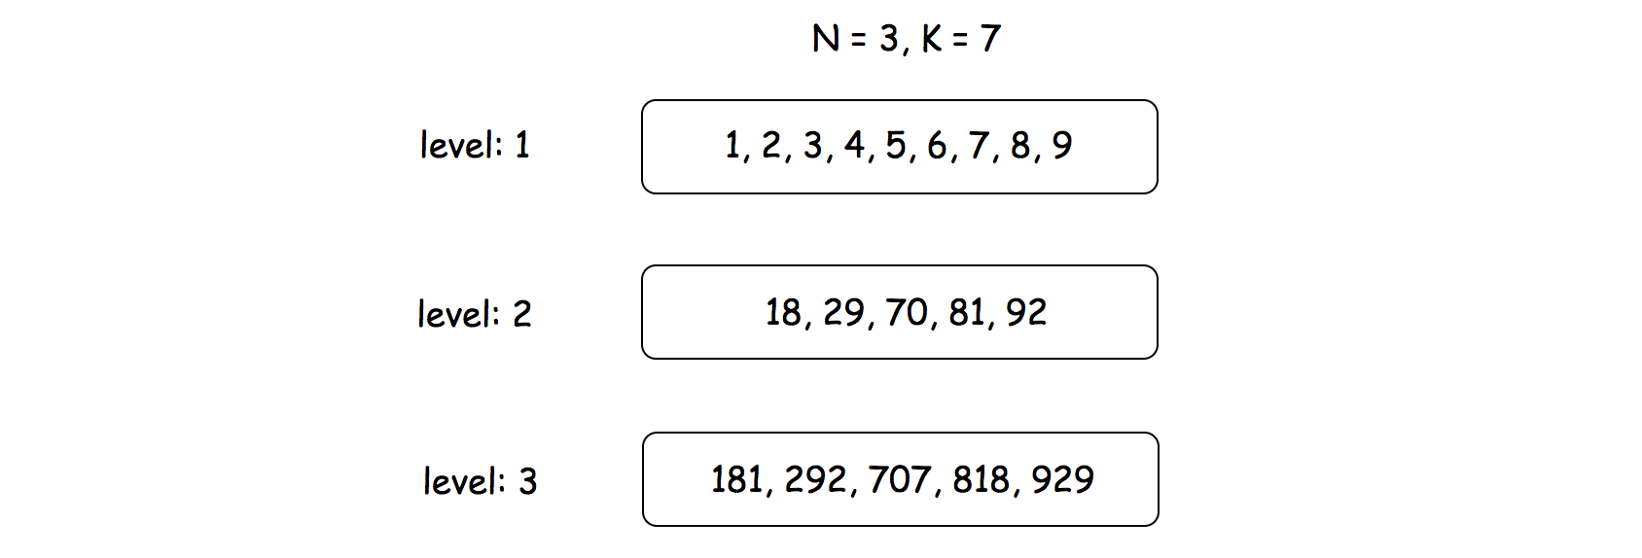

For example, given N=3 and K=7, at the first level, we would have potentially 9 candidates (i.e. [1, 2, 3, 4, 5, 7, 8, 9]). When we move on to the second level, the candidates are reduced down to [18, 29, 70, 81, 92]. Finally, at the last level, we would have the solutions as [181, 292, 707, 818, 929].

**Algorithm**

Here are a few steps to implement the BFS algorithm for this problem.

* We could implement the algorithm with nested two-levels loops, where the outer loop iterates through levels and the inner loop handles the elements within each level.
* We could use a list data structure to keep the numbers for a single level, i.e. here we name the variable as queue.
* For each number in the queue, we could apply the same logics as in the DFS approach, except the last step, rather than making a recursive call for the next number we simply append the number to the queue for the next level.

|  |
| --- |
| class Solution {  public int[] numsSameConsecDiff(int N, int K) {  if (N == 1)  return new int[] {0, 1, 2, 3, 4, 5, 6, 7, 8, 9};  List<Integer> queue = Arrays.asList(1, 2, 3, 4, 5, 6, 7, 8, 9);  for(int level = 1; level < N; ++ level) {  ArrayList<Integer> nextQueue = new ArrayList<>();  // iterate through each number within the level  for (Integer num : queue) {  Integer tailDigit = num % 10;  ArrayList<Integer> nextDigits = new ArrayList<>();  nextDigits.add(tailDigit + K);  if (K != 0)  nextDigits.add(tailDigit - K);  for (Integer nextDigit : nextDigits) {  if (0 <= nextDigit && nextDigit < 10) {  Integer newNum = num * 10 + nextDigit;  nextQueue.add(newNum);  }  }  }  // prepare for the next level  queue = nextQueue;  }  return queue.stream().mapToInt(i->i).toArray();  }  } |

**Complexity Analysis**

Let N*N* be the number of digits for a valid combination, and K*K* be the difference between digits.

* Time Complexity: \mathcal{O}(2^{N})O(2*N*)
  + Essentially with the BFS approach, all the intermeidate candidates form a binary tree, same as the execution tree as in the DFS approach. Only this time, we traverse in a breadth-first manner, rather than the depth-first.
  + Therefore, the overall time complexity of the algorithm would be \mathcal{O}(2^{N})O(2*N*).
* Space Complexity: \mathcal{O}(2^{N})O(2*N*)
  + We use two queues to maintain the intermediate solutions, which contain no more than two levels of elements. The number of elements at the level of i*i* is up to 9 \cdot 2^{i-1}9⋅2*i*−1.
  + To sum up, the space complexity of the algorithm would be \mathcal{O}(9 \cdot 2^{N-1} + 9 \cdot 2^{N-2}) = \mathcal{O}(2^N)O(9⋅2*N*−1+9⋅2*N*−2)=O(2*N*).

**Goat Latin**

A sentence S is given, composed of words separated by spaces. Each word consists of lowercase and uppercase letters only.

We would like to convert the sentence to "*Goat Latin"* (a made-up language similar to Pig Latin.)

The rules of Goat Latin are as follows:

* If a word begins with a vowel (a, e, i, o, or u), append "ma" to the end of the word.  
  For example, the word 'apple' becomes 'applema'.
* If a word begins with a consonant (i.e. not a vowel), remove the first letter and append it to the end, then add "ma".  
  For example, the word "goat" becomes "oatgma".
* Add one letter 'a' to the end of each word per its word index in the sentence, starting with 1.  
  For example, the first word gets "a" added to the end, the second word gets "aa" added to the end and so on.

Return the final sentence representing the conversion from S to Goat Latin.

**Example 1:**

**Input:** "I speak Goat Latin"

**Output:** "Imaa peaksmaaa oatGmaaaa atinLmaaaaa"

**Example 2:**

**Input:** "The quick brown fox jumped over the lazy dog"

**Output:** "heTmaa uickqmaaa rownbmaaaa oxfmaaaaa umpedjmaaaaaa overmaaaaaaa hetmaaaaaaaa azylmaaaaaaaaa ogdmaaaaaaaaaa"

 Notes:

* S contains only uppercase, lowercase and spaces. Exactly one space between each word.
* 1 <= S.length <= 150.

#### Approach 1: Just Strings

The problem is pretty straightforward and the main intention is to focus on deep knowledge about Strings and other abstract types, how they are stored in memory, and their performance characteristics across languages and platforms.

Depending on the language, splitting strings into words (or tokens) can be functionally easy (e.g. python) or a major hassle (e.g. C++).

Similarly, building strings can show a wide gamut of performance:

* For languages where strings are immutable (e.g. Java, Python), building strings by simply concatenating existing ones is usually a very expensive process, because it generates entirely new strings. [[1]](https://leetcode.com/problems/goat-latin/solution/#fn1)  
  Such languages usually solve this problem by providing a function to efficiently join a collection of strings (all of whose lengths are known before-hand). [[2]](https://leetcode.com/problems/goat-latin/solution/#fn2)
* Other languages, which treat strings as mutable data types (e.g. C++), have fairly efficient concatenation operators / functions, usually providing an acceptable amortized performance. [[3]](https://leetcode.com/problems/goat-latin/solution/#fn3)

Back to the problem; note that the following two suffixes are added to every word:

* The string "ma" is appended to the word.
* A string comprised entirely of character 'a' is appended to the resulting word. This string increases in length with every word processed.

**Algorithm**

1. Split the sentence into words. Words are separated by a single space.
2. For each word:
   * If the word doesn't start with a vowel, we rotate the first character; it is removed from the word and appended at the end of the word.
   * Append the final word to our generated sentence, along with the required suffixes.
   * Finally add a single space character.
3. Remove the extraneous last space from the generated sentence.

|  |
| --- |
| class Solution {  private static Set<Character> vowels =  new HashSet<>() {  {  add('a');  add('e');  add('i');  add('o');  add('u');  add('A');  add('E');  add('I');  add('O');  add('U');  }  };  public String toGoatLatin(String S) {  String suff = "";  StringBuilder sb = new StringBuilder();  for (String tok : S.split(" ")) {  suff += 'a'; // Java compiler converts this into a temporary StringBuilder  if (!vowels.contains(tok.charAt(0))) {  tok = tok.substring(1) + tok.charAt(0);  }  sb.append(tok).append("ma").append(suff).append(' ');  }  sb.deleteCharAt(sb.length() - 1); // remove extra space  return sb.toString();  }  } |

**Complexity Analysis**

Before we get on to computing complexity of the entire algorithm, let's first break it down into its constituent operations:

* **OP-1**: Testing whether a word starts with a vowel is a constant time operation, and take constant space of storing the vowels.
* **OP-2**: Appending the character 'a' to the suffix in each iteration of the loop takes amortized constant time. The suffix grows by one character with each iteration.
* **OP-3**: Rotating the word is basically two operations: deleting the first character, and then appending the first character to the resultant string. This takes time and space linear to the length of the word.
* **OP-4**: Appending the suffixes and space take time amortized to length of the concatenated word. The space is also linear to the length of the concatenated word.
* **OP-5**: Joining the collection of words into the final output string takes length and space linear in length of the output string.
* **OP-6**: Removing the last extraneous space character takes constant time, and doesn't change the order of our space usage.

Now let's look at the overall complexity of our algorithm:

* Time Complexity: O(n^2)*O*(*n*2), where n*n* is the length of input string, in the worst case.

Let's assume that the average length of each word is w*w*. Thus, the number of words available is roughly k = \frac{n}{w}*k*=*wn*​. Let's also say that the worst has happened: every word starts with a consonent (so, we need to rotate every word).

* + **OP-1** and **OP-2** take O(k)*O*(*k*) time over k*k* words.
  + **OP-3** takes O(w)*O*(*w*) time for each of the k*k* words. Thus total time taken is about k \cdot O(w) \simeq O(n)*k*⋅*O*(*w*)≃*O*(*n*).
  + **OP-4** takes time linear to length of the concatenated word (i.e. the word, the suffixes, and a single space character). Over k*k* words, the time taken is:

\begin{gathered} \begin{aligned} &\quad \; O(w) + 1 \cdot O(1) + O(1) + O(1) \\ &+ O(w) + 2 \cdot O(1) + O(1) + O(1) \\ &+ O(w) + 3 \cdot O(1) + O(1) + O(1) \\ &+ O(w) + 4 \cdot O(1) + O(1) + O(1) \\ &+\; ... \\ &+ O(w) + k \cdot O(1) + O(1) + O(1) \\ &= k \cdot O(w) + (1 + 2 + 3 + ... + k) \cdot O(1) + 2k \cdot O(1) \\ &\simeq O(n) + O(k^2) \end{aligned} \end{gathered}​*O*(*w*)+1⋅*O*(1)+*O*(1)+*O*(1)+*O*(*w*)+2⋅*O*(1)+*O*(1)+*O*(1)+*O*(*w*)+3⋅*O*(1)+*O*(1)+*O*(1)+*O*(*w*)+4⋅*O*(1)+*O*(1)+*O*(1)+...+*O*(*w*)+*k*⋅*O*(1)+*O*(1)+*O*(1)=*k*⋅*O*(*w*)+(1+2+3+...+*k*)⋅*O*(1)+2*k*⋅*O*(1)≃*O*(*n*)+*O*(*k*2)​​

* + **OP-5** takes the same time as, the total time **OP-4** takes over k*k* words, i.e. \sim O(n) + O(k^2)∼*O*(*n*)+*O*(*k*2). This is because **OP-5** is just joining all the characters generated by **OP-4**, after all k*k* iterations of **OP-4**.
  + **OP-6** takes constant time O(1)*O*(1).

Overall, the time required is in the order of \sim O(n) + O(k^2)∼*O*(*n*)+*O*(*k*2). [[4]](https://leetcode.com/problems/goat-latin/solution/#fn4)

In the worst case, each word is only a single character long. Thus k = n*k*=*n*; the overall time complexity becomes \sim O(n) + O(n^2) \; \simeq \; O(n^2)∼*O*(*n*)+*O*(*n*2)≃*O*(*n*2) in the worst case.

* Space Complexity: O(n^2)*O*(*n*2), where n*n* is the length of input string, in the worst case.

Let's make the same assumptions we made for time complexity analysis:

* + **OP-1** takes constant extra space.
  + **OP-2** takes a maximum space in the length of the suffix string, i.e. O(k)*O*(*k*) space.
  + **OP-3** takes the same amount of space as the word itself (since overall length doesn't change due to rotation), i.e. O(w)*O*(*w*) space.
  + **OP-4** takes space linear to length of the concatenated word (i.e. the word, the suffixes, and a single space character). Over k*k* words, the space taken is:

\begin{gathered} \begin{aligned} &\quad \; O(w) + 1 \cdot O(1) + O(1) + O(1) \\ &+ O(w) + 2 \cdot O(1) + O(1) + O(1) \\ &+ O(w) + 3 \cdot O(1) + O(1) + O(1) \\ &+ O(w) + 4 \cdot O(1) + O(1) + O(1) \\ &+\; ... \\ &+ O(w) + k \cdot O(1) + O(1) + O(1) \\ &= k \cdot O(w) + (1 + 2 + 3 + ... + k) \cdot O(1) + 2k \cdot O(1) \\ &\simeq O(n) + O(k^2) \end{aligned} \end{gathered}​*O*(*w*)+1⋅*O*(1)+*O*(1)+*O*(1)+*O*(*w*)+2⋅*O*(1)+*O*(1)+*O*(1)+*O*(*w*)+3⋅*O*(1)+*O*(1)+*O*(1)+*O*(*w*)+4⋅*O*(1)+*O*(1)+*O*(1)+...+*O*(*w*)+*k*⋅*O*(1)+*O*(1)+*O*(1)=*k*⋅*O*(*w*)+(1+2+3+...+*k*)⋅*O*(1)+2*k*⋅*O*(1)≃*O*(*n*)+*O*(*k*2)​​

* + **OP-5** takes the same space as, the total space **OP-4** takes over k*k* words, i.e. \sim O(n) + O(k^2)∼*O*(*n*)+*O*(*k*2). This is because **OP-5** is just joining all the characters generated by **OP-4**, after all k*k* iterations of **OP-4**.
  + **OP-6** reduces constant space O(1)*O*(1).

Overall, the extra space required is in the order of \sim O(n) + O(k^2)∼*O*(*n*)+*O*(*k*2). [[4:1]](https://leetcode.com/problems/goat-latin/solution/#fn4)

In the worst case, each word is only a single character long. Thus k = n*k*=*n*; the overall space complexity becomes \sim O(n) + O(n^2) \; \simeq \; O(n^2)∼*O*(*n*)+*O*(*n*2)≃*O*(*n*2) in the worst case.

1. This can quickly lead to quadratic runtime complexity, just from concatenating strings! [This article](https://leetcode.com/articles/sort-characters-by-frequency/#remember-strings-are-immutable) has a nice introduction on immutable strings. [↩︎](https://leetcode.com/problems/goat-latin/solution/#fnref1)
2. In Java, that's usually the [StringBuilder](https://docs.oracle.com/javase/7/docs/api/java/lang/StringBuilder.html) class. In Python, [str.join()](https://docs.python.org/2/library/stdtypes.html" \l "str.join) will do the trick. [↩︎](https://leetcode.com/problems/goat-latin/solution/#fnref2)
3. Most implementations of C++'s [std::string](https://en.cppreference.com/w/cpp/string/basic_string) provide concatenation operations (e.g. + operator, string::append function etc.) which run in amortized linear time complexity. [↩︎](https://leetcode.com/problems/goat-latin/solution/#fnref3)
4. Notice that we discarded lower order terms (like O(1)*O*(1) and O(k)*O*(*k*)). That's because lower order terms do not contribute to algorithmic complexity as much as higher order terms do. The highest order term (and comparable terms) tend to *dominate* complexity anlysis. [↩︎](https://leetcode.com/problems/goat-latin/solution/#fnref4) [↩︎](https://leetcode.com/problems/goat-latin/solution/#fnref4:1)

**The Maze**

There is a ball in a maze with empty spaces (represented as 0) and walls (represented as 1). The ball can go through the empty spaces by rolling **up, down, left or right**, but it won't stop rolling until hitting a wall. When the ball stops, it could choose the next direction.

Given the maze, the ball's start position and the destination, where start = [startrow, startcol] and destination = [destinationrow, destinationcol], return true if the ball can stop at the destination, otherwise return false.

You may assume that **the borders of the maze are all walls** (see examples).

**Example 1:**

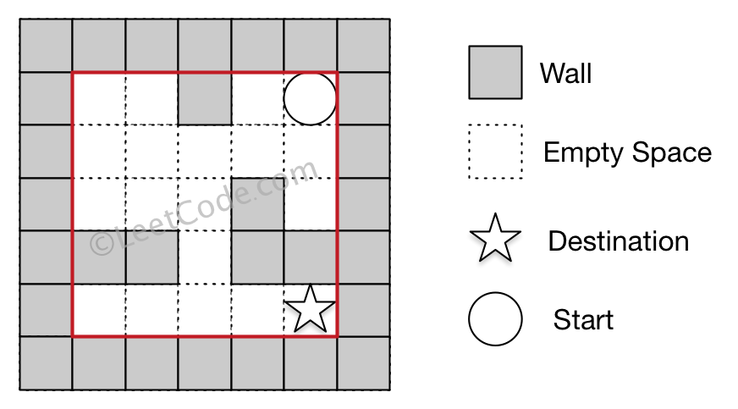

**Input:** maze = [[0,0,1,0,0],[0,0,0,0,0],[0,0,0,1,0],[1,1,0,1,1],[0,0,0,0,0]], start = [0,4], destination = [4,4]

**Output:** true

**Explanation:** One possible way is : left -> down -> left -> down -> right -> down -> right.

**Example 2:**

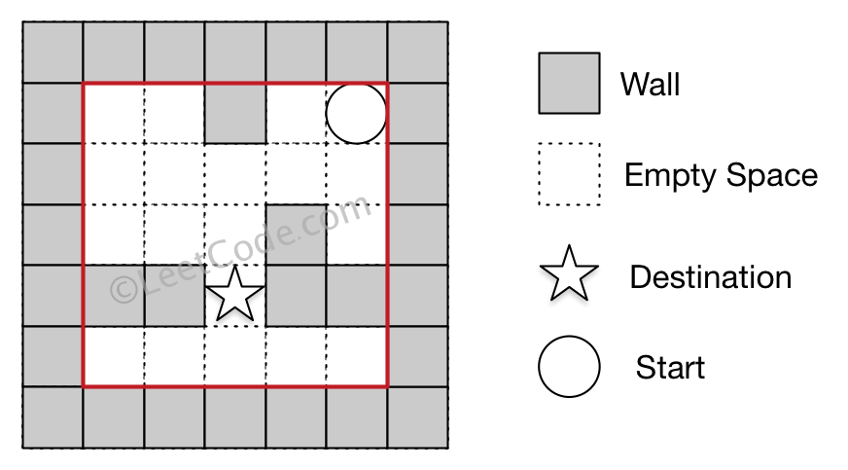

**Input:** maze = [[0,0,1,0,0],[0,0,0,0,0],[0,0,0,1,0],[1,1,0,1,1],[0,0,0,0,0]], start = [0,4], destination = [3,2]

**Output:** false

**Explanation:** There is no way for the ball to stop at the destination. Notice that you can pass through the destination but you cannot stop there.

**Example 3:**

**Input:** maze = [[0,0,0,0,0],[1,1,0,0,1],[0,0,0,0,0],[0,1,0,0,1],[0,1,0,0,0]], start = [4,3], destination = [0,1]

**Output:** false

**Constraints:**

* 1 <= maze.length, maze[i].length <= 100
* maze[i][j] is 0 or 1.
* start.length == 2
* destination.length == 2
* 0 <= startrow, destinationrow <= maze.length
* 0 <= startcol, destinationcol <= maze[i].length
* Both the ball and the destination exist on an empty space, and they will not be at the same position initially.
* The maze contains **at least 2 empty spaces**.

## Solution

#### Approach 1: Depth First Search

We can view the given search space in the form of a tree. The root node of the tree represents the starting position. Four different routes are possible from each position i.e. left, right, up or down. These four options can be represented by 4 branches of each node in the given tree. Thus, the new node reached from the root traversing over the branch represents the new position occupied by the ball after choosing the corresponding direction of travel.

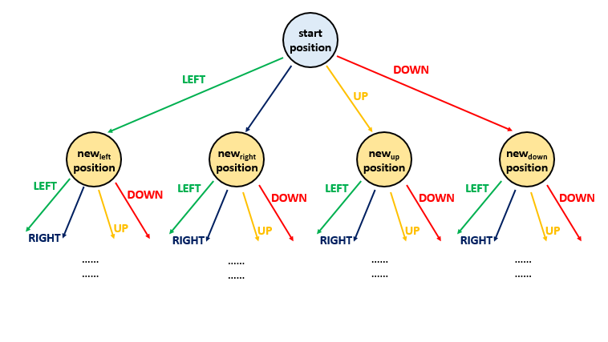

In order to do this traversal, one of the simplest schemes is to undergo depth first search. In this case, we choose one path at a time and try to go as deep as possible into the levels of the tree before going for the next path. In order to implement this, we make use of a recursive function dfs(maze, start, desination, visited). This function takes the given maze*maze* array, the start*start* position and the destination*destination* position as its arguments along with a visited*visited* array. visited*visited* array is a 2-D boolean array of the same size as that of maze*maze*. A True value at visited[i][j]*visited*[*i*][*j*] represents that the current position has already been reached earlier during the path traversal. We make use of this array so as to keep track of the same paths being repeated over and over. We mark a True at the current position in the visited*visited* array once we reach that particular positon in the maze*maze*.

From every start*start* position, we can move continuously in either left, right, upward or downward direction till we reach the boundary or a wall. Thus, from the start*start* position, we determine all the end points which can be reached by choosing the four directions. For each of the cases, the new endpoint will now act as the new start point for the traversals. The destination, obviously remains unchanged. Thus, now we call the same function four times for the four directions, each time with a new start point obtained previously.

If any of the function call returns a True value, it means we can reach the desination.

The following animation depicts the process:



|  |
| --- |
| public class Solution {  public boolean hasPath(int[][] maze, int[] start, int[] destination) {  boolean[][] visited = new boolean[maze.length][maze[0].length];  return dfs(maze, start, destination, visited);  }  public boolean dfs(int[][] maze, int[] start, int[] destination, boolean[][] visited) {  if (visited[start[0]][start[1]])  return false;  if (start[0] == destination[0] && start[1] == destination[1])  return true;  visited[start[0]][start[1]] = true;  int r = start[1] + 1, l = start[1] - 1, u = start[0] - 1, d = start[0] + 1;  while (r < maze[0].length && maze[start[0]][r] == 0) // right  r++;  if (dfs(maze, new int[] {start[0], r - 1}, destination, visited))  return true;  while (l >= 0 && maze[start[0]][l] == 0) //left  l--;  if (dfs(maze, new int[] {start[0], l + 1}, destination, visited))  return true;  while (u >= 0 && maze[u][start[1]] == 0) //up  u--;  if (dfs(maze, new int[] {u + 1, start[1]}, destination, visited))  return true;  while (d < maze.length && maze[d][start[1]] == 0) //down  d++;  if (dfs(maze, new int[] {d - 1, start[1]}, destination, visited))  return true;  return false;  }  } |

**Complexity Analysis**

* Time complexity : O(mn)*O*(*mn*). Complete traversal of maze will be done in the worst case. Here, m*m* and n*n* refers to the number of rows and coloumns of the maze.
* Space complexity : O(mn)*O*(*mn*). visited*visited* array of size m*n*m*∗*n* is used.

#### Approach 2: Breadth First Search

**Algorithm**

The same search space tree can also be explored in a Depth First Search manner. In this case, we try to explore the search space on a level by level basis. i.e. We try to move in all the directions at every step. When all the directions have been explored and we still don't reach the destination, then only we proceed to the new set of traversals from the new positions obtained.

In order to implement this, we make use of a queue*queue*. We start with the ball at the start*start* position. For every current position, we add all the new positions possible by traversing in all the four directions(till reaching the wall or boundary) into the queue*queue* to act as the new start positions and mark these positions as True in the visited*visited* array. When all the directions have been covered up, we remove a position value, s*s*, from the front of the queue*queue* and again continue the same process with s*s* acting as the new start*start* position.

Further, in order to choose the direction of travel, we make use of a dir*dir* array, which contains 4 entries. Each entry represents a one-dimensional direction of travel. To travel in a particular direction, we keep on adding the particular entry of the dirs*dirs* array till we hit a wall or a boundary. For a particular start position, we do this process of dir*dir* addition for all all the four directions possible.

If we hit the destination position at any moment, we return a True directly indicating that the destination*destination* position can be reached starting from the start*start* position.

The following animation depicts the process:



|  |
| --- |
| public class Solution {  public boolean hasPath(int[][] maze, int[] start, int[] destination) {  boolean[][] visited = new boolean[maze.length][maze[0].length];  int[][] dirs={{0, 1}, {0, -1}, {-1, 0}, {1, 0}};  Queue < int[] > queue = new LinkedList < > ();  queue.add(start);  visited[start[0]][start[1]] = true;  while (!queue.isEmpty()) {  int[] s = queue.remove();  if (s[0] == destination[0] && s[1] == destination[1])  return true;  for (int[] dir: dirs) {  int x = s[0] + dir[0];  int y = s[1] + dir[1];  while (x >= 0 && y >= 0 && x < maze.length && y < maze[0].length && maze[x][y] == 0) {  x += dir[0];  y += dir[1];  }  if (!visited[x - dir[0]][y - dir[1]]) {  queue.add(new int[] {x - dir[0], y - dir[1]});  visited[x - dir[0]][y - dir[1]] = true;  }  }  }  return false;  }  } |

**Complexity Analysis**

* Time complexity : O(mn)*O*(*mn*). Complete traversal of maze will be done in the worst case. Here, m*m* and n*n* refers to the number of rows and coloumns of the maze.
* Space complexity : O(mn)*O*(*mn*). visited*visited* array of size m*n*m*∗*n* is used and queue*queue* size can grow upto m*n*m*∗*n* in worst case.

**Random Point in Non-overlapping Rectangles**

Given a list of **non-overlapping** axis-aligned rectangles rects, write a function pick which randomly and uniformily picks an **integer point** in the space covered by the rectangles.

Note:

1. An **integer point** is a point that has integer coordinates.
2. A point on the perimeter of a rectangle is **included** in the space covered by the rectangles.
3. ith rectangle = rects[i] = [x1,y1,x2,y2], where [x1, y1] are the integer coordinates of the bottom-left corner, and [x2, y2] are the integer coordinates of the top-right corner.
4. length and width of each rectangle does not exceed 2000.
5. 1 <= rects.length <= 100
6. pick return a point as an array of integer coordinates [p_x, p_y]
7. pick is called at most 10000 times.

**Example 1:**

**Input:**

["Solution","pick","pick","pick"]

[[[[1,1,5,5]]],[],[],[]]

**Output:**

[null,[4,1],[4,1],[3,3]]

**Example 2:**

**Input:**

["Solution","pick","pick","pick","pick","pick"]

[[[[-2,-2,-1,-1],[1,0,3,0]]],[],[],[],[],[]]

**Output:**

[null,[-1,-2],[2,0],[-2,-1],[3,0],[-2,-2]]

**Explanation of Input Syntax:**

The input is two lists: the subroutines called and their arguments. Solution's constructor has one argument, the array of rectangles rects. pick has no arguments. Arguments are always wrapped with a list, even if there aren't any.

## Solution

#### Approach 1: Prefix Sum and Binary Search

**Intuition**

Some rectangles may be more likely to be sampled from than others, since some may contain more points than others, and each point has an equal chance of being sampled. Is there a way to select a rectangle to sample from, such that the probabilities are proportional to the number of points contained in each rectangle? Is there a way to do this using less than O(\text{total number of points})*O*(total number of points) space?

**Algorithm**

Create a weight array w*w*, where w[i]*w*[*i*] is the number of points in \text{rects}[i]rects[*i*].

Compute the prefix sum array p*p*, where p[x] = \sum_{i=0}^{x}w[i]*p*[*x*]=∑*i*=0*x*​*w*[*i*].

Generate a random integer \text{targ}targ in the range [0, \sum_{i=0}^{n}w[i]][0,∑*i*=0*n*​*w*[*i*]], where \sum_{i=0}^{n}w[i]∑*i*=0*n*​*w*[*i*] is the total number of points in all rectangles.

Use binary search to find the index x*x* where x*x* is the lowest index such that \text{targ} < p[x]targ<*p*[*x*]. \text{rects}[x]rects[*x*] is the rectangle that we will sample from.

Note that for some index i*i*, all integers v*v* where p[i] - w[i] \leq v < p[i]*p*[*i*]−*w*[*i*]≤*v*<*p*[*i*] map to this index. Therefore, rectangles will be sampled proportionally to the rectangle weights.

The only step remaining is to choose a random point in \text{rects}[x]rects[*x*]. Generating random \text{x\_coordinate}x_coordinate and \text{y\_coordinate}y_coordinate within this rectangle area will suffice, but we can also reuse \text{targ}targ by mapping it to the point

\text{x\_coordinate} = x1 + (\text{targ}-p[i]+w[i]) \% (x2-x1+1) \\ \text{y\_coordinate} = y1 + (\text{targ}-p[i]+w[i]) / (x2-x1+1)x_coordinate=*x*1+(targ−*p*[*i*]+*w*[*i*])%(*x*2−*x*1+1)y_coordinate=*y*1+(targ−*p*[*i*]+*w*[*i*])/(*x*2−*x*1+1)

This strategy is useful when calls to the random number generator are expensive.

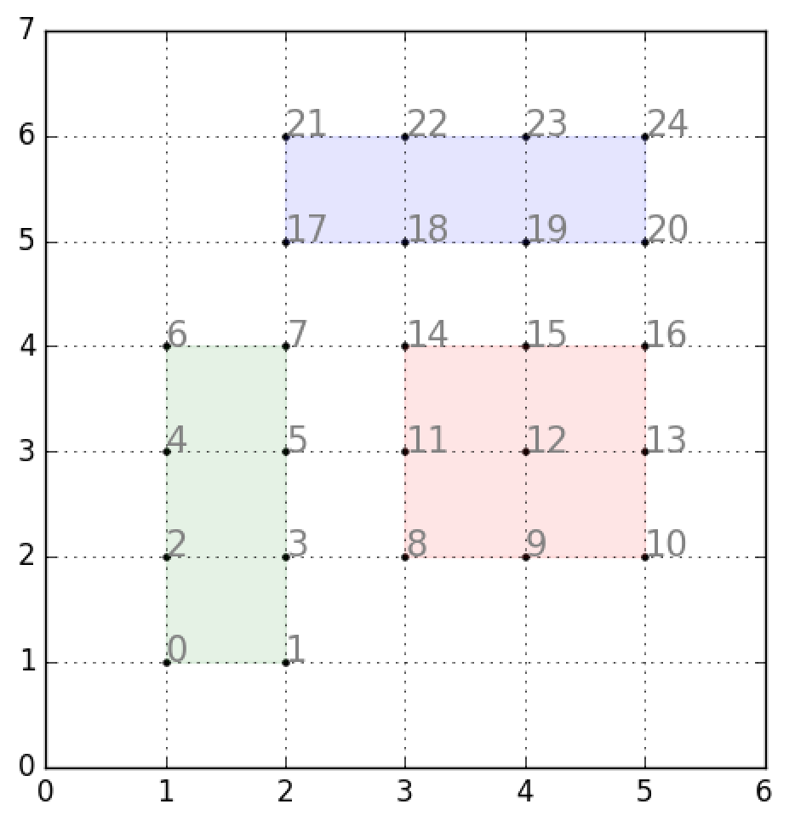

Mapping from targ to x_coordinate and y_coordinate for rects = [[1, 1, 2, 4], [3, 2, 5, 4], [2, 5, 5, 6]]

|  |
| --- |
| class Solution {  int[][] rects;  List<Integer> psum = new ArrayList<>();  int tot = 0;  Random rand = new Random();  public Solution(int[][] rects) {  this.rects = rects;  for (int[] x : rects){  tot += (x[2] - x[0] + 1) * (x[3] - x[1] + 1);  psum.add(tot);  }  }  public int[] pick() {  int targ = rand.nextInt(tot);  int lo = 0;  int hi = rects.length - 1;  while (lo != hi) {  int mid = (lo + hi) / 2;  if (targ >= psum.get(mid)) lo = mid + 1;  else hi = mid;  }  int[] x = rects[lo];  int width = x[2] - x[0] + 1;  int height = x[3] - x[1] + 1;  int base = psum.get(lo) - width * height;  return new int[]{x[0] + (targ - base) % width, x[1] + (targ - base) / width};  }  } |

**Complexity Analysis**

* Time Complexity: O(N)*O*(*N*) preprocessing. O(\log N)*O*(log*N*) pick.
* Space Complexity: O(N)*O*(*N*)

**Stream of Characters**

Implement the StreamChecker class as follows:

* StreamChecker(words): Constructor, init the data structure with the given words.
* query(letter): returns true if and only if for some k >= 1, the last k characters queried (in order from oldest to newest, including this letter just queried) spell one of the words in the given list.

**Example:**

StreamChecker streamChecker = new StreamChecker(["cd","f","kl"]); // init the dictionary.

streamChecker.query('a'); // return false

streamChecker.query('b'); // return false

streamChecker.query('c'); // return false

streamChecker.query('d'); // return true, because 'cd' is in the wordlist

streamChecker.query('e'); // return false

streamChecker.query('f'); // return true, because 'f' is in the wordlist

streamChecker.query('g'); // return false

streamChecker.query('h'); // return false

streamChecker.query('i'); // return false

streamChecker.query('j'); // return false

streamChecker.query('k'); // return false

streamChecker.query('l'); // return true, because 'kl' is in the wordlist

**Note:**

* 1 <= words.length <= 2000
* 1 <= words[i].length <= 2000
* Words will only consist of lowercase English letters.
* Queries will only consist of lowercase English letters.
* The number of queries is at most 40000.

   Hide Hint #1

Put the words into a trie, and manage a set of pointers within that trie.

## Solution

#### Prerequisites

This design article uses [data structure Trie](https://leetcode.com/articles/add-and-search-word/). If you never worked with trie before, you might want to check [this introduction article](https://leetcode.com/articles/add-and-search-word/) first to simplify the further reading.

#### Approach 1: Trie

**Trie**

Trie is widely used in real life: autocomplete search, spell checker, T9 predictive text, [IP routing (longest prefix matching)](https://www.researchgate.net/figure/An-example-routing-table-and-the-corresponding-binary-trie-built-from-it_fig3_4236637), [some GCC containers](https://gcc.gnu.org/onlinedocs/libstdc++/ext/pb_ds/trie_based_containers.html).

Trie is something to think about if you're asked to design a structure to dynamically add and search strings.

**Intuition**

The first idea is to add all input words in the trie and then implement a standard search.

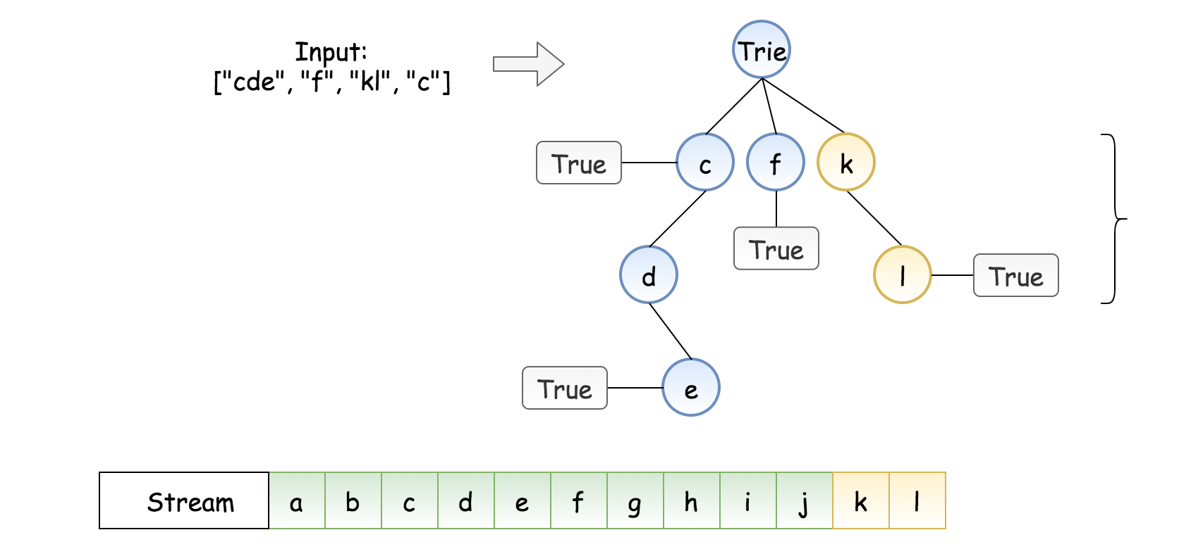

Figure 1. Naive implementation.

The problem is we don't know how many characters to match. On the example above, should we try to match the last three stream characters "jkl", the last two "kl", or the last one "l"?

The way to solve the problem is to notice that we always know the last character to match. That gives us an idea to build a trie of reversed words, and try to match the reversed stream of characters.

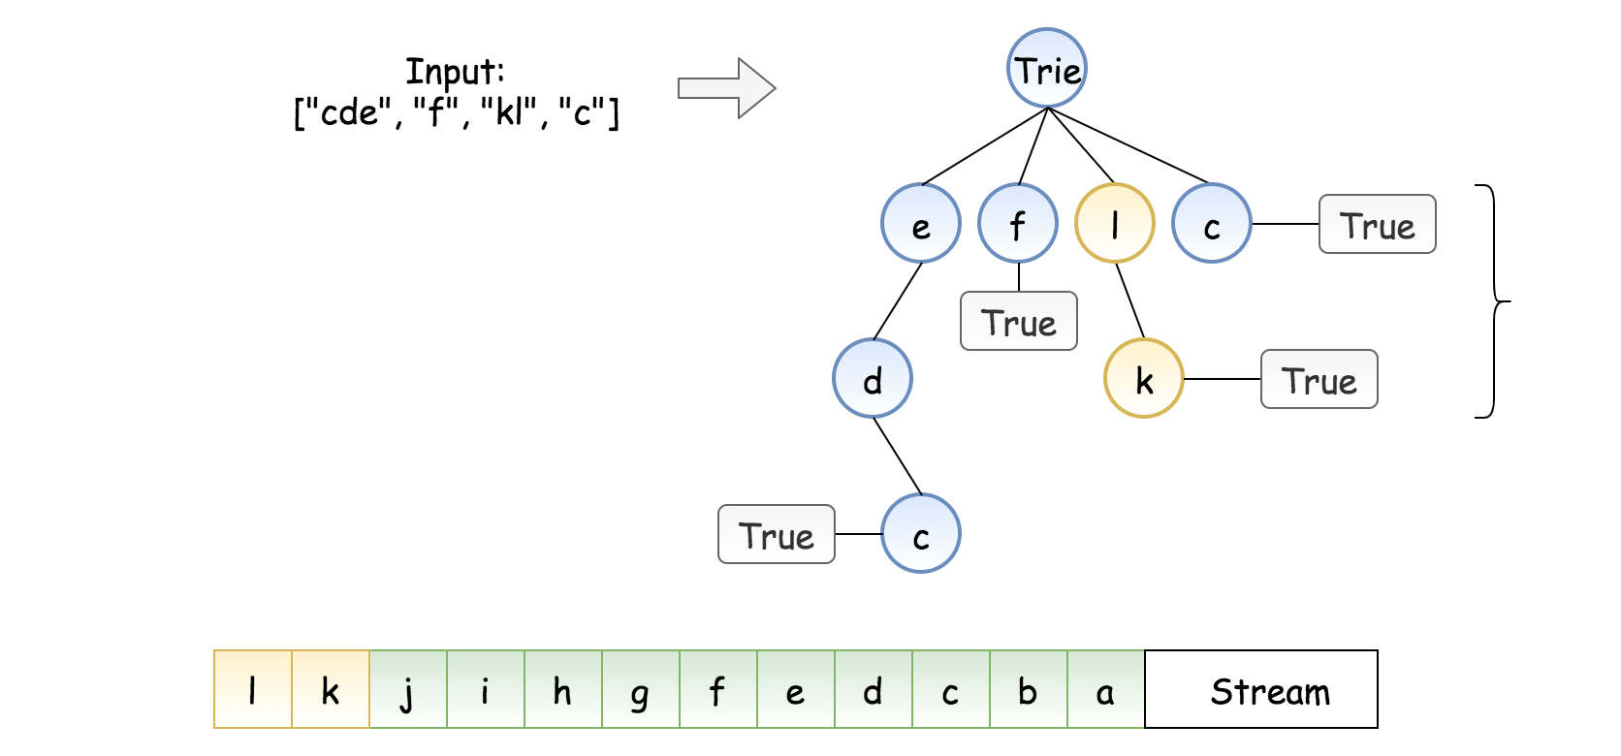

Figure 2. Trie of the reversed words and the reversed stream of characters.

This way, instead of multiple choices to match, we always have one path: to match character by character starting from the end of the stream. We could stop once we meet the "end of word" label, which means success. If we couldn't match a character before we meet that label, that means fail.

**Constructor StreamChecker**

Trie is usually implemented as nested hashmaps. At each step, one has to verify if the child node to add is already present. If yes, we go one level down. If not, we add the node into a trie and then go one step down. The particularity of the current problem is that we add in the trie the reversed words.

The last thing to discuss is how to store the reversed stream of characters. For that, we need a structure for which appendleft / addFirst operation takes a constant time. The good choice here is double ended queue, it's implemented as [deque](https://docs.python.org/3/library/collections.html#collections.deque) in Python, and as [ArrayDeque](https://docs.oracle.com/javase/8/docs/api/java/util/ArrayDeque.html) in Java.

|  |
| --- |
| class TrieNode {  Map<Character, TrieNode> children = new HashMap();  boolean word = false;  }  class StreamChecker {  TrieNode trie = new TrieNode();  Deque<Character> stream = new ArrayDeque();  public StreamChecker(String[] words) {  for (String word : words) {  TrieNode node = trie;  String reversedWord = new StringBuilder(word).reverse().toString();  for (char ch : reversedWord.toCharArray()) {  if (!node.children.containsKey(ch)) {  node.children.put(ch, new TrieNode());  }  node = node.children.get(ch);  }  node.word = true;  }  }  } |

**Complexity Analysis**

* Time complexity: \mathcal{O}(N \cdot M)O(*N*⋅*M*), where N*N* is a number of input words, and M*M* is the word length. We have N*N* words to process. At each step, we either examine or create a node in the trie. That takes only M*M* operations.
* Space complexity: \mathcal{O}(N \cdot M)O(*N*⋅*M*). In the worst-case newly inserted key doesn't share a prefix with the keys already added in the trie. We have to add N \cdot M*N*⋅*M* new nodes, which takes \mathcal{O}(N \cdot M)O(*N*⋅*M*) space.

**Query Implementation**

The search is very straightforward: we start from the end of the stream and check character by character, going down in trie.

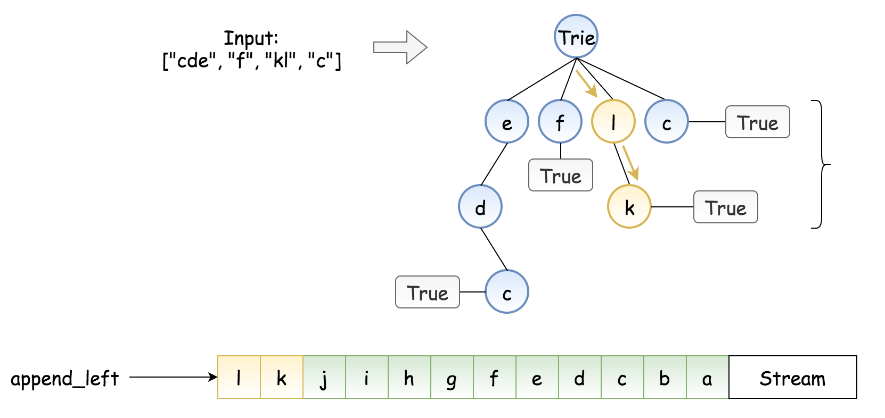

*Figure 3. Search in trie.*

|  |
| --- |
| public boolean query(char letter) {  stream.addFirst(letter);    TrieNode node = trie;  for (char ch : stream) {  if (node.word) {  return true;  }  if (!node.children.containsKey(ch)) {  return false;  }  node = node.children.get(ch);  }  return node.word;  } |

* Time complexity: \mathcal{O}(M)O(*M*), where M*M* is a max word length, *i.e.* the depth of trie.
* Space complexity: \mathcal{O}(M)O(*M*) to keep a stream of characters. One could limit the size of deque to be equal to the length of the longest input word.

**Implementation**

Let's bring everything together.

|  |
| --- |
| class TrieNode {  Map<Character, TrieNode> children = new HashMap();  boolean word = false;  }  class StreamChecker {  TrieNode trie = new TrieNode();  Deque<Character> stream = new ArrayDeque();  public StreamChecker(String[] words) {  for (String word : words) {  TrieNode node = trie;  String reversedWord = new StringBuilder(word).reverse().toString();  for (char ch : reversedWord.toCharArray()) {  if (!node.children.containsKey(ch)) {  node.children.put(ch, new TrieNode());  }  node = node.children.get(ch);  }  node.word = true;  }  }    public boolean query(char letter) {  stream.addFirst(letter);    TrieNode node = trie;  for (char ch : stream) {  if (node.word) {  return true;  }  if (!node.children.containsKey(ch)) {  return false;  }  node = node.children.get(ch);  }  return node.word;  }  } |

**Minimum Cost For Tickets**

In a country popular for train travel, you have planned some train travelling one year in advance.  The days of the year that you will travel is given as an array days.  Each day is an integer from 1 to 365.

Train tickets are sold in 3 different ways:

* a 1-day pass is sold for costs[0] dollars;
* a 7-day pass is sold for costs[1] dollars;
* a 30-day pass is sold for costs[2] dollars.

The passes allow that many days of consecutive travel.  For example, if we get a 7-day pass on day 2, then we can travel for 7 days: day 2, 3, 4, 5, 6, 7, and 8.

Return the minimum number of dollars you need to travel every day in the given list of days.

**Example 1:**

**Input:** days = [1,4,6,7,8,20], costs = [2,7,15]

**Output:** 11

**Explanation:**

For example, here is one way to buy passes that lets you travel your travel plan:

On day 1, you bought a 1-day pass for costs[0] = $2, which covered day 1.

On day 3, you bought a 7-day pass for costs[1] = $7, which covered days 3, 4, ..., 9.

On day 20, you bought a 1-day pass for costs[0] = $2, which covered day 20.

In total you spent $11 and covered all the days of your travel.

**Example 2:**

**Input:** days = [1,2,3,4,5,6,7,8,9,10,30,31], costs = [2,7,15]

**Output:** 17

**Explanation:**

For example, here is one way to buy passes that lets you travel your travel plan:

On day 1, you bought a 30-day pass for costs[2] = $15 which covered days 1, 2, ..., 30.

On day 31, you bought a 1-day pass for costs[0] = $2 which covered day 31.

In total you spent $17 and covered all the days of your travel.

**Note:**

1. 1 <= days.length <= 365
2. 1 <= days[i] <= 365
3. days is in strictly increasing order.
4. costs.length == 3
5. 1 <= costs[i] <= 1000

## Solution

#### Approach 1: Dynamic Programming (Day Variant)

**Intuition and Algorithm**

For each day, if you don't have to travel today, then it's strictly better to wait to buy a pass. If you have to travel today, you have up to 3 choices: you must buy either a 1-day, 7-day, or 30-day pass.

We can express those choices as a recursion and use dynamic programming. Let's say dp(i) is the cost to fulfill your travel plan from day i to the end of the plan. Then, if you have to travel today, your cost is:

\text{dp}(i) = \min(\text{dp}(i+1) + \text{costs}[0], \text{dp}(i+7) + \text{costs}[1], \text{dp}(i+30) + \text{costs}[2])dp(*i*)=min(dp(*i*+1)+costs[0],dp(*i*+7)+costs[1],dp(*i*+30)+costs[2])

|  |
| --- |
| class Solution {  int[] costs;  Integer[] memo;  Set<Integer> dayset;  public int mincostTickets(int[] days, int[] costs) {  this.costs = costs;  memo = new Integer[366];  dayset = new HashSet();  for (int d: days) dayset.add(d);  return dp(1);  }  public int dp(int i) {  if (i > 365)  return 0;  if (memo[i] != null)  return memo[i];  int ans;  if (dayset.contains(i)) {  ans = Math.min(dp(i+1) + costs[0],  dp(i+7) + costs[1]);  ans = Math.min(ans, dp(i+30) + costs[2]);  } else {  ans = dp(i+1);  }  memo[i] = ans;  return ans;  }  } |

**Complexity Analysis**

* Time Complexity: O(W)*O*(*W*), where W = 365*W*=365 is the maximum numbered day in your travel plan.
* Space Complexity: O(W)*O*(*W*).

#### Approach 2: Dynamic Programming (Window Variant)

**Intuition and Algorithm**

As in Approach 1, we only need to buy a travel pass on a day we intend to travel.

Now, let dp(i) be the cost to travel from day days[i] to the end of the plan. If say, j1 is the largest index such that days[j1] < days[i] + 1, j7 is the largest index such that days[j7] < days[i] + 7, and j30 is the largest index such that days[j30] < days[i] + 30, then we have:

\text{dp}(i) = \min(\text{dp}(j1) + \text{costs}[0], \text{dp}(j7) + \text{costs}[1], \text{dp}(j30) + \text{costs}[2])dp(*i*)=min(dp(*j*1)+costs[0],dp(*j*7)+costs[1],dp(*j*30)+costs[2])

|  |
| --- |
| class Solution {  int[] days, costs;  Integer[] memo;  int[] durations = new int[]{1, 7, 30};  public int mincostTickets(int[] days, int[] costs) {  this.days = days;  this.costs = costs;  memo = new Integer[days.length];  return dp(0);  }  public int dp(int i) {  if (i >= days.length)  return 0;  if (memo[i] != null)  return memo[i];  int ans = Integer.MAX_VALUE;  int j = i;  for (int k = 0; k < 3; ++k) {  while (j < days.length && days[j] < days[i] + durations[k])  j++;  ans = Math.min(ans, dp(j) + costs[k]);  }  memo[i] = ans;  return ans;  }  } |

**Complexity Analysis**

* Time Complexity: O(N)*O*(*N*), where N*N* is the number of unique days in your travel plan.
* Space Complexity: O(N)*O*(*N*).

**Find Right Interval**

You are given an array of intervals, where intervals[i] = [starti, endi] and each starti is **unique**.

The **right interval** for an interval i is an interval j such that startj >= endi and startj is **minimized**.

Return *an array of****right interval****indices for each interval i*. If no **right interval** exists for interval i, then put -1 at index i.

**Example 1:**

**Input:** intervals = [[1,2]]

**Output:** [-1]

**Explanation:** There is only one interval in the collection, so it outputs -1.

**Example 2:**

**Input:** intervals = [[3,4],[2,3],[1,2]]

**Output:** [-1,0,1]

**Explanation:** There is no right interval for [3,4].

The right interval for [2,3] is [3,4] since start0 = 3 is the smallest start that is >= end1 = 3.

The right interval for [1,2] is [2,3] since start1 = 2 is the smallest start that is >= end2 = 2.

**Example 3:**

**Input:** intervals = [[1,4],[2,3],[3,4]]

**Output:** [-1,2,-1]

**Explanation:** There is no right interval for [1,4] and [3,4].

The right interval for [2,3] is [3,4] since start2 = 3 is the smallest start that is >= end1 = 3.

**Constraints:**

* 1 <= intervals.length <= 2 * 104
* intervals[i].length == 2
* -106 <= starti <= endi <= 106
* The start point of each interval is **unique**.

## Solution

#### Approach 1: Brute Force

The simplest solution consists of picking up every interval in the set and looking for the the interval whose start point is larger(by a minimum difference) than the chosen interval's end point by scanning the complete set for every interval chosen. While scanning, we keep a track of the interval with the minimum start point satisfying the given criteria along with its index. The result obtained for every interval chosen is stored at the corresponding index in the res array which is returned at the end.

|  |
| --- |
| class Solution {  public int[] findRightInterval(int[][] intervals) {  int[] res = new int[intervals.length];  for (int i = 0; i < intervals.length; i++) {  int min = Integer.MAX_VALUE;  int minindex = -1;  for (int j = 0; j < intervals.length; j++) {  if (intervals[j][0] >= intervals[i][1] && intervals[j][0] < min) {  min = intervals[j][0];  minindex = j;  }  }  res[i] = minindex;  }  return res;  }  } |

**Complexity Analysis**

* Time complexity : \mathcal{O}(n^2)O(*n*2). The complete set of n*n* intervals is scanned for every(n*n*) interval chosen.
* Space complexity : \mathcal{O}(n)O(*n*). \text{res}res array of size n*n* is used.

#### Approach 2: Using Sorting + Scanning

We make use of a hashmap \text{hash}hash, which stores the data in the form of a \text{(Key, Value)}(Key, Value) pair. Here, the \text{Key}Key corresponds to the interval chosen and the \text{Value}Value corresponds to the index of the particular interval in the given \text{intervals}intervals array. We store every element of the \text{intervals}intervals array in the hash*hash*-map.

Now, we sort the \text{intervals}intervals array based on the starting points. We needed to store the indices of the array in the hashmap, so as to be able to obtain the indices even after the sorting.

Now, we pick up every interval of the sorted array, and find out the interval from the remaining ones whose start point comes just after the end point of the interval chosen. How do we proceed? Say, we've picked up the i^{th}*ith* interval right now. In order to find an interval satisfying the given criteria, we need not search in the intervals behind it. This is because the \text{intervals}intervals array has been sorted based on the starting points and the end point is always greater than the starting point for a given interval. Thus, we search in the intervals only with indices j*j*, such that i+1< j < n*i*+1<*j*<*n*. The first element encountered while scanning in the ascending order is the required result for the interval chosen, since all the intervals lying after this interval will have comparatively larger start points.

Then, we can obtain the index corresponding to the corresponding interval from the hashmap, which is stored in the corresponding entry of the res*res* array. If no interval satisfies the criteria, we put a \text{-1}-1 in the corresponding entry.

|  |
| --- |
| class Solution {  public int[] findRightInterval(int[][] intervals) {  int[] res = new int[intervals.length];  Map<int[], Integer> hash = new HashMap<>();  for (int i = 0; i < intervals.length; i++) {  hash.put(intervals[i], i);  }  Arrays.sort(intervals, (a, b) -> a[0] - b[0]);  for (int i = 0; i < intervals.length; i++) {  int min = Integer.MAX_VALUE;  int minindex = -1;  for (int j = i + 1; j < intervals.length; j++) {  if (intervals[j][0] >= intervals[i][1] && intervals[j][0] < min) {  min = intervals[j][0];  minindex = hash.get(intervals[j]);  }  }  res[hash.get(intervals[i])] = minindex;  }  return res;  }  } |

**Complexity Analysis**

* Time complexity : O(n^2)*O*(*n*2).
  + Sorting takes O\big(n\log{n}\big)*O*(*n*log*n*) time.
  + For the first interval we need to search among n-1*n*−1 elements.
  + For the second interval, the search is done among n-2*n*−2 elements and so on leading to a total of: (n-1) + (n-2) + ... + 1 = \frac{n.(n-1)}{2} = O(n^2)(*n*−1)+(*n*−2)+...+1=2*n*.(*n*−1)​=*O*(*n*2) calculations.
* Space complexity : O(n)*O*(*n*). \text{res}res array of size n*n* is used. A hashmap \text{hash}hash of size n*n* is used.

#### Approach 3: Using Sorting + Binary Search

We can optimize the above approach to some extent, since we can make use of the factor of the \text{intervals}intervals array being sorted. Instead of searching for the required interval in a linear manner, we can make use of Binary Search to find an interval whose start point is just larger than the end point of the current interval.

Again, if such an interval is found, we obtain its index from the hashmap and store the result in the appropriate \text{res}res entry. If not, we put a \text{-1}-1 at the corresponding entry.

|  |
| --- |
| public class Solution {  public int[] binary_search(int[][] intervals, int target, int start, int end) {  if (start >= end) {  if (intervals[start][0] >= target) {  return intervals[start];  }  return null;  }  int mid = (start + end) / 2;  if (intervals[mid][0] < target) {  return binary_search(intervals, target, mid + 1, end);  } else {  return binary_search(intervals, target, start, mid);  }  }  public int[] findRightInterval(int[][] intervals) {  int[] res = new int[intervals.length];  HashMap<int[], Integer> hash = new HashMap<>();  for (int i = 0; i < intervals.length; i++) {  hash.put(intervals[i], i);  }  Arrays.sort(intervals, (a, b) -> a[0] - b[0]);  for (int i = 0; i < intervals.length; i++) {  int[] interval = binary_search(intervals, intervals[i][1], 0, intervals.length - 1);  res[hash.get(intervals[i])] = interval == null ? -1 : hash.get(interval);  }  return res;  }  } |

**Complexity Analysis**

* Time complexity : O\big(n\log{n}\big)*O*(*n*log*n*). Sorting takes O\big(n\log{n}\big)*O*(*n*log*n*) time. Binary search takes O\big(\log{n}\big)*O*(log*n*) time for each of the n*n* intervals.
* Space complexity : O(n)*O*(*n*). \text{res}res array of size n*n* is used. A hashmap \text{hash}hash of size O(n)*O*(*n*) is used.

#### Approach 4: Using TreeMap

In this approach, instead of using a hashmap, we make use of a TreeMap \text{starts}starts, which is simply a Red-Black Tree(a kind of balanced Binary Search Tree) . This Treemap \text{start}start stores data in the form of \text{(Key, Value)}(Key, Value) pair and always remain sorted based on its keys. In our case, we store the data such that the start point of an interval acts as the \text{Key}Key and the index corresponding to the interval acts as the value, since we are concerned with data sorted based on the start points, as discussed in previous approaches. Every element of the \text{intervals}intervals array is stored in the TreeMap.

Now, we choose each element of the \text{intervals}intervals array and make use of a function TreeMap.ceilingEntry(end_point) to obtain the element in the TreeMap with its \text{Key}Key just larger than the \text{end\_point}end_point of the currently chosen interval. The function ceilingEntry(Key) returns the element just with its \text{Key}Key larger than the Key(passed as the argument) from amongst the elements of the TreeMap and returns null if no such element exists.

If non-null value is returned, we obtain the \text{Value}Value from the \text{(Key, Value)}(Key, Value) pair obtained at the appropriate entry in the \text{res}res array. If a null value is returned, we simply store a \text{-1}-1 at the corresponding \text{res}res entry.

|  |
| --- |
| public class Solution {  public int[] findRightInterval(int[][] intervals) {  TreeMap<Integer, Integer> starts = new TreeMap<>();  int res[] = new int[intervals.length];  for (int i = 0; i < intervals.length; i++) {  starts.put(intervals[i][0], i);  }  for (int i = 0; i < intervals.length; i++) {  Map.Entry<Integer, Integer> pos = starts.ceilingEntry(intervals[i][1]);  res[i] = pos == null ? -1 : pos.getValue();  }  return res;  }  } |

**Complexity Analysis**

* Time complexity : O\big(N \cdot \log{N}\big)*O*(*N*⋅log*N*). Inserting an element into TreeMap takes O\big(\log{N}\big)*O*(log*N*) time. N*N* such insertions are done. The search in TreeMap using ceilingEntry also takes O\big(\log{N}\big)*O*(log*N*) time. N*N* such searches are done.
* Space complexity : O(N)*O*(*N*). \text{res}res array of size n*n* is used. TreeMap \text{starts}starts of size O(N)*O*(*N*) is used.

#### Approach 5: Using Two Arrays without Binary Search

**Algorithm**

The intuition behind this approach is as follows: If we maintain two arrays,

1. \text{intervals}intervals, which is sorted based on the start points.
2. \text{endIntervals}endIntervals, which is sorted based on the end points.

Once we pick up the first interval(or, say the i^{th}*ith* interval) from the \text{endIntervals}endIntervals array, we can determine the appropriate interval satisfying the right interval criteria by scanning the intervals in \text{intervals}intervals array from left towards the right, since the \text{intervals}intervals array is sorted based on the start points. Say, the index of the element chosen from the \text{intervals}intervals array happens to be j*j*.

Now, when we pick up the next interval(say the (i+1)^{th}(*i*+1)*th* interval) from the \text{endIntervals}endIntervals array, we need not start scanning the \text{intervals}intervals array from the first index. Rather, we can start off directly from the j^{th}*jth* index where we left off last time in the \text{intervals}intervals array. This is because end point corresponding to \text{endIntervals[i+1]}endIntervals[i+1] is larger than the one corresponding to \text{endIntervals[i]}endIntervals[i] and none of the intervals from \text{intervals[k]}intervals[k], such that 0< k < j0<*k*<*j*, satisfies the right neighbor criteria with \text{endIntervals[i]}endIntervals[i], and hence not with \text{endIntervals[i+1]}endIntervals[i+1] as well.

If at any moment, we reach the end of the array i.e. j=\text{intervals.length}*j*=intervals.length and no element satisfying the right interval criteria is available in the \text{intervals}intervals array, we put a \text{-1}-1 in the corresponding \text{res}res entry. The same holds for all the remaining elements of the \text{endIntervals}endIntervals array, whose end points are even larger than the previous interval encountered.

Also we make use of a hashmap \text{hash}hash initially to preserve the indices corresponding to the intervals even after sorting.

For more understanding see the below animation:



|  |
| --- |
| public class Solution {  public int[] findRightInterval(int[][] intervals) {  int[][] endIntervals = Arrays.copyOf(intervals, intervals.length);  HashMap<int[], Integer> hash = new HashMap<>();  for (int i = 0; i < intervals.length; i++) {  hash.put(intervals[i], i);  }  Arrays.sort(intervals, (a, b) -> a[0] - b[0]);  Arrays.sort(endIntervals, (a, b) -> a[1] - b[1]);  int j = 0;  int[] res = new int[intervals.length];  for (int i = 0; i < endIntervals.length; i++) {  while (j < intervals.length && intervals[j][0] < endIntervals[i][1]) {  j++;  }  res[hash.get(endIntervals[i])] = j == intervals.length ? -1 : hash.get(intervals[j]);  }  return res;  }  } |

**Complexity Analysis**

* Time complexity : O\big(N \cdot \log{N}\big)*O*(*N*⋅log*N*). Sorting takes O\big(N \cdot \log{N}\big)*O*(*N*⋅log*N*) time. A total of O(N)*O*(*N*) time is spent on searching for the appropriate intervals, since the \text{endIntervals}endIntervals and \text{intervals}intervals array is scanned only once.
* Space complexity : O(N)*O*(*N*). \text{endIntervals}endIntervals, \text{intervals}intervals and \text{res}res array of size N*N* are used. A hashmap \text{hash}hash of size O(N)*O*(*N*) is used.

**Implement Rand10() Using Rand7()**

Given the **API** rand7() that generates a uniform random integer in the range [1, 7], write a function rand10() that generates a uniform random integer in the range [1, 10]. You can only call the API rand7(), and you shouldn't call any other API. Please **do not** use a language's built-in random API.

Each test case will have one **internal** argument n, the number of times that your implemented function rand10() will be called while testing. Note that this is **not an argument** passed to rand10().

**Follow up:**

* What is the [expected value](https://en.wikipedia.org/wiki/Expected_value) for the number of calls to rand7() function?
* Could you minimize the number of calls to rand7()?

**Example 1:**

**Input:** n = 1

**Output:** [2]

**Example 2:**

**Input:** n = 2

**Output:** [2,8]

**Example 3:**

**Input:** n = 3

**Output:** [3,8,10]

**Constraints:**

* 1 <= n <= 105

## Solution

#### Approach 1: Rejection Sampling

**Intuition**

What if you could generate a random integer in the range 1 to 49? How would you generate a random integer in the range of 1 to 10? What would you do if the generated number is in the desired range? What if it is not?

**Algorithm**

This solution is based upon [Rejection Sampling](https://en.wikipedia.org/wiki/Rejection_sampling). The main idea is when you generate a number in the desired range, output that number immediately. If the number is out of the desired range, reject it and re-sample again. As each number in the desired range has the same probability of being chosen, a uniform distribution is produced.

Obviously, we have to run rand7() function at least twice, as there are not enough numbers in the range of 1 to 10. By running rand7() twice, we can get integers from 1 to 49 uniformly. Why?

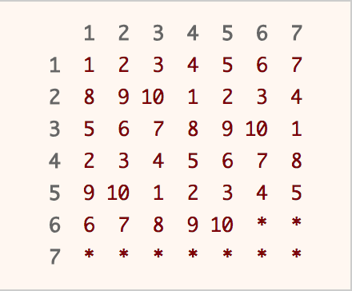

A table is used to illustrate the concept of rejection sampling. Calling rand7() twice will get us row and column index that corresponds to a unique position in the table above. Imagine that you are choosing a number randomly from the table above. If you hit a number, you return that number immediately. If you hit a * , you repeat the process again until you hit a number.

Since 49 is not a multiple of 10, we have to use rejection sampling. Our desired range is integers from 1 to 40, which we can return the answer immediately. If not (the integer falls between 41 to 49), we reject it and repeat the whole process again.

|  |
| --- |
| class Solution extends SolBase {  public int rand10() {  int row, col, idx;  do {  row = rand7();  col = rand7();  idx = col + (row - 1) * 7;  } while (idx > 40);  return 1 + (idx - 1) % 10;  }  } |

**Complexity Analysis**

* Time Complexity: O(1)*O*(1) average, but O(\infty)*O*(∞) worst case.

The [expected value](https://en.wikipedia.org/wiki/Expected_value) for the number of calls to rand7() can be computed as follows:

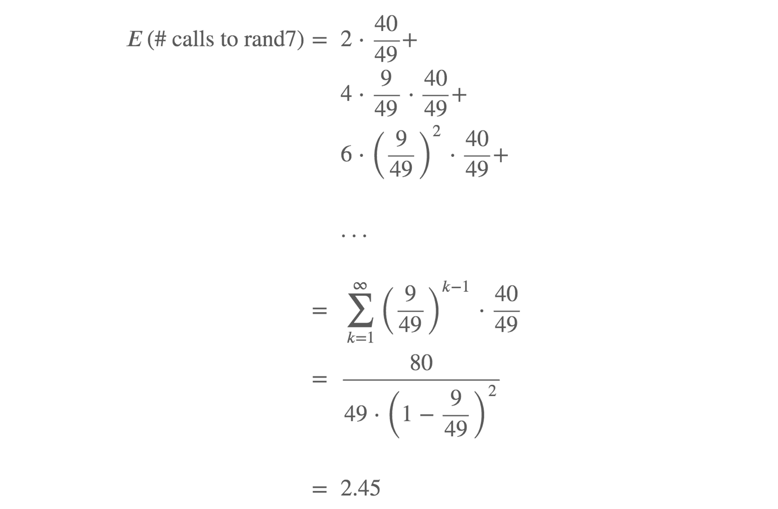

* Space Complexity: O(1)*O*(1).

#### Approach 2: Utilizing out-of-range samples

**Intuition**

There are a total of 2.45 calls to rand7() on average when using approach 1. Can we do better? Glad that you asked. In fact, we are able to improve average number of calls to rand7() by about 10%.

The idea is that we should not throw away the out-of-range samples, but instead use them to increase our chances of finding an in-range sample on the successive call to rand7.

**Algorithm**

Start by generating a random integer in the range 1 to 49 using the aforementioned method. In the event that we could not generate a number in the desired range (1 to 40), it is equally likely that each number of 41 to 49 would be chosen. In other words, we are able to obtain integers in the range of 1 to 9 uniformly. Now, run rand7() again to obtain integers in the range of 1 to 63 uniformly. Apply rejection sampling where the desired range is 1 to 60. If the generated number is in the desired range (1 to 60), we return the number. If it is not (61 to 63), we at least obtain integers of 1 to 3 uniformly. Run rand7() again to obtain integers in the range of 1 to 21 uniformly. The desired range is 1 to 20, and in the unlikely event we get a 21, we reject it and repeat the entire process again.

|  |
| --- |
| class Solution extends SolBase {  public int rand10() {  int a, b, idx;  while (true) {  a = rand7();  b = rand7();  idx = b + (a - 1) * 7;  if (idx <= 40)  return 1 + (idx - 1) % 10;  a = idx - 40;  b = rand7();  // get uniform dist from 1 - 63  idx = b + (a - 1) * 7;  if (idx <= 60)  return 1 + (idx - 1) % 10;  a = idx - 60;  b = rand7();  // get uniform dist from 1 - 21  idx = b + (a - 1) * 7;  if (idx <= 20)  return 1 + (idx - 1) % 10;  }  }  } |

**Complexity Analysis**

* Time Complexity: O(1)*O*(1) average, but O(\infty)*O*(∞) worst case.

The [expected value](https://en.wikipedia.org/wiki/Expected_value) for the number of calls to rand7() can be computed as follows (with some steps omitted due to tediousness):

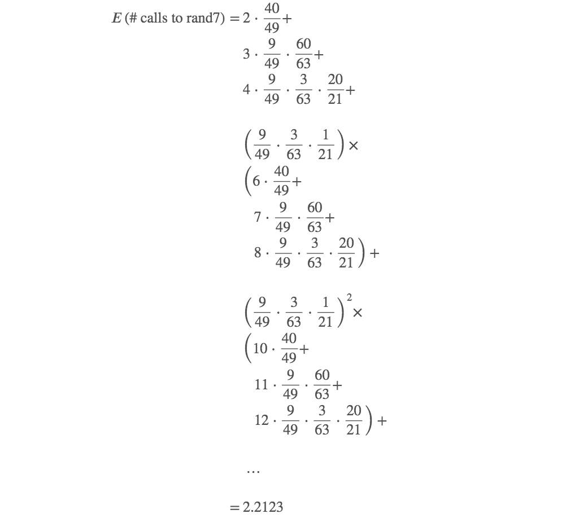

* Space Complexity: O(1)*O*(1).

**Pancake Sorting**

Given an array of integers arr, sort the array by performing a series of **pancake flips**.

In one pancake flip we do the following steps:

* Choose an integer k where 1 <= k <= arr.length.
* Reverse the sub-array arr[0...k-1] (**0-indexed**).

For example, if arr = [3,2,1,4] and we performed a pancake flip choosing k = 3, we reverse the sub-array [3,2,1], so arr = [1,2,3,4] after the pancake flip at k = 3.

Return *an array of the*k*-values corresponding to a sequence of pancake flips that sort*arr. Any valid answer that sorts the array within 10 * arr.length flips will be judged as correct.

**Example 1:**

**Input:** arr = [3,2,4,1]

**Output:** [4,2,4,3]

**Explanation:**

We perform 4 pancake flips, with k values 4, 2, 4, and 3.

Starting state: arr = [3, 2, 4, 1]

After 1st flip (k = 4): arr = [1, 4, 2, 3]

After 2nd flip (k = 2): arr = [4, 1, 2, 3]

After 3rd flip (k = 4): arr = [3, 2, 1, 4]

After 4th flip (k = 3): arr = [1, 2, 3, 4], which is sorted.

**Example 2:**

**Input:** arr = [1,2,3]

**Output:** []

**Explanation:** The input is already sorted, so there is no need to flip anything.

Note that other answers, such as [3, 3], would also be accepted.

**Constraints:**

* 1 <= arr.length <= 100
* 1 <= arr[i] <= arr.length
* All integers in arr are unique (i.e. arr is a permutation of the integers from 1 to arr.length).

## Solution

#### Approach 1: Sort like Bubble-Sort

**Intuition**

One might argue that this is an awkward question to do things. Indeed, it is not the most practical operation that one can have with the pancake flipping, in order to sort a list.

However awkward the problem might be, it is the game that we play with. And in order to win the game, we have to play by the rules. Actually, from this perspective, this problem does share some similarity with the [***Rubik's cube***](https://en.wikipedia.org/wiki/Rubik%27s_Cube), i.e. one cannot move one tile without moving other tiles along with. Let us get on with it, by playing a few rounds ourselves to get the hang of the problem.

Given the input of [3, 2, 4, 1], the desired sorted output would be [1, 2, 3, 4].

As a reminder, the only operation that we could perform in order to move the elements in the list, is the so-called pancake flip, which is to reverse a prefix of the list.

Starting from the largest value in the list, i.e. 4 in the example, its desired position would be the tail of the list. While in the input, it is located at the third of the list, if we look at the list from left to right.

In order to move the value of 4 to its desired position, we could perform the following two steps:

* Firstly, we do the pancake flip on the prefix of [3, 2, 4]. With this operation, we then move the value 4 to the ***head*** of the updated list as [4, 2, 3, 1].

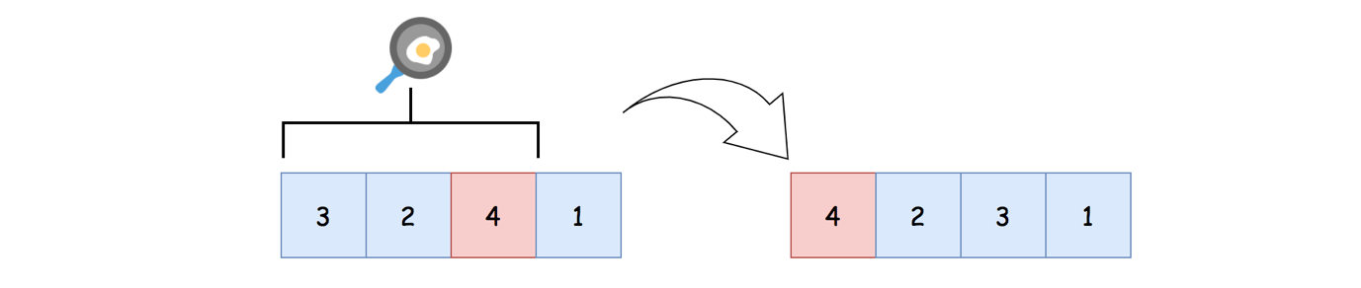

* Now that, the value 4 is located at the head of the list, we could now perform another pancake flip on the entire list, which would get us the list of [1, 3, 2, 4].

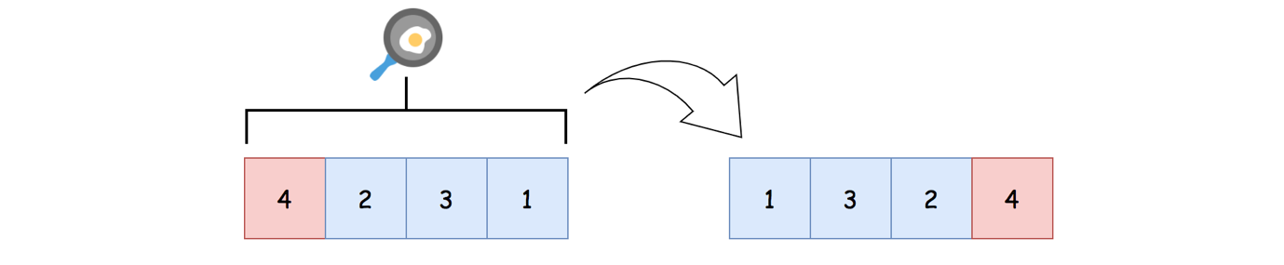

Voila. With the obtained list of [1, 3, 2, 4], we are now one step closer to our final goal, with the value 4 now at its proper place. For the following steps, we only need to focus on the sublist of [1, 3, 2].

If one looks over the above steps again, it might ring a bell to a well-known algorithm called [***bubble sort***](https://en.wikipedia.org/wiki/Bubble_sort).



Indeed, we share the same strategy as the bubble sort, by sinking the numbers to the bottom one by one.

Here we can make a statement that for any given number, in order to move it to any desired position, it takes **at most** two pancake flips to do so.

The idea is simple. First we move the number to the head of the list, then we can switch it with any other element by performing another pancake flip.

**Algorithm**

One can inspire from the bubble sort to implement the algorithm.

* First of all, we implement a function called flip(list, k), which performs the pancake flip on the prefix of list[0:k] (in Python).
* The main algorithm runs a loop over the values of the list, starting from the largest one.
  + At each round, we identify the value to sort (named as value_to_sort), which is the number we would put in place at this round.
  + We then locate the index of the value_to_sort.
  + If the value_to_sort is not at its place already, we can then perform at most two pancake flips as we explained in the intuition.
  + At the end of the round, the value_to_sort would be put in place.

|  |
| --- |
| class Solution {  /**  * sort like bubble-sort i.e. sink the largest number to the bottom at each round.  */  public List<Integer> pancakeSort(int[] A) {  List<Integer> ans = new ArrayList<>();  for (int valueToSort = A.length; valueToSort > 0; valueToSort--) {  // locate the position for the value to sort in this round  int index = this.find(A, valueToSort);  // sink the value_to_sort to the bottom,  // with at most two steps of pancake flipping.  if (index == valueToSort - 1)  continue;  // 1). flip the value to the head if necessary  if (index != 0) {  ans.add(index + 1);  this.flip(A, index + 1);  }  // 2). now that the value is at the head, flip it to the bottom  ans.add(valueToSort);  this.flip(A, valueToSort);  }  return ans;  }  protected void flip(int[] sublist, int k) {  int i = 0;  while (i < k / 2) {  int temp = sublist[i];  sublist[i] = sublist[k - i - 1];  sublist[k - i - 1] = temp;  i += 1;  }  }  protected int find(int[] a, int target) {  for (int i = 0; i < a.length; i++)  if (a[i] == target)  return i;  return -1;  }  } |

**Complexity Analysis**

Let N*N* be the length of the input list.

* Time Complexity: \mathcal{O}(N^2)O(*N*2)
  + In the algorithm, we run a loop with N*N* iterations.
  + Within each iteration, we are dealing with the corresponding prefix of the list. Here we denote the length of the prefix as k*k*, *e.g.* in the first iteration, the length of the prefix is N*N*. While in the second iteration, the length of the prefix is N-1*N*−1.
  + Within each iteration, we have operations whose time complexity is linear to the length of the prefix, such as iterating through the prefix to find the index, or flipping the entire prefix *etc.* Hence, for each iteration, its time complexity would be \mathcal{O}(k)O(*k*)
  + To sum up all iterations, we have the overall time complexity of the algorithm as \sum_{k=1}^{N} \mathcal{O}(k) = \mathcal{O}(N^2)∑*k*=1*N*​O(*k*)=O(*N*2).
* Space Complexity: \mathcal{O}(N)O(*N*)
  + Within the algorithm, we use a list to maintain the final results, which is proportional to the number of pancake flips.
  + For each round of iteration, at most we would add two pancake flips. Therefore, the maximal number of pancake flips needed would be 2\cdot N2⋅*N*.
  + As a result, the space complexity of the algorithm is \mathcal{O}(N)O(*N*). If one does not take into account the space required to hold the result of the function, then one could consider the above algorithm as a constant space solution.

**Largest Component Size by Common Factor**

Given a non-empty array of unique positive integers A, consider the following graph:

* There are A.length nodes, labelled A[0] to A[A.length - 1];
* There is an edge between A[i] and A[j] if and only if A[i] and A[j] share a common factor greater than 1.

Return the size of the largest connected component in the graph.

**Example 1:**

**Input:** [4,6,15,35]

**Output:** 4

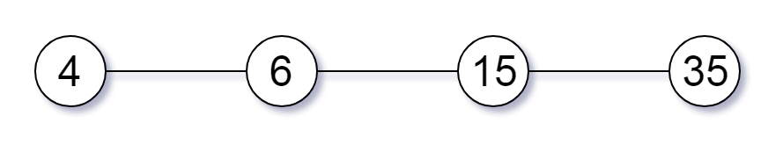

**Example 2:**

**Input:** [20,50,9,63]

**Output:** 2

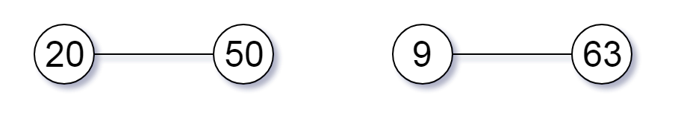

**Example 3:**

**Input:** [2,3,6,7,4,12,21,39]

**Output:** 8

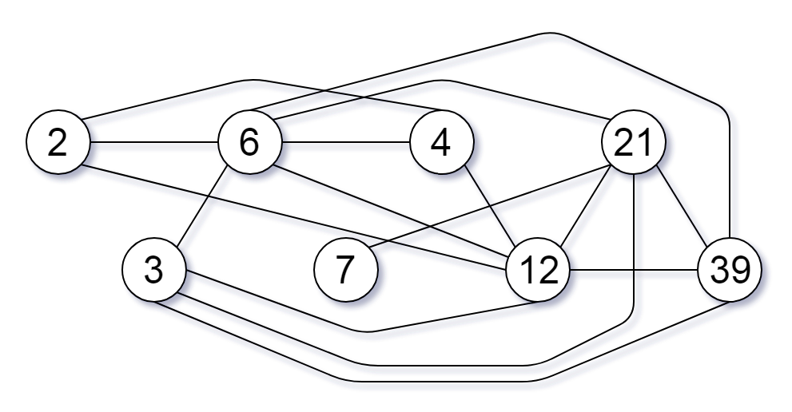

**Note:**

1. 1 <= A.length <= 20000
2. 1 <= A[i] <= 100000

## Solution

#### Overview

We could consider this problem as a graph partition problem.

Each number represents a node in a graph. We are asked to partition the nodes into several groups and find the largest one.

Suppose that we have a means to determine and assign each node to a proper group, then we could easily solve the problem with a single iteration.

We could summarize the algorithm with the following Python pseudo code, where literally we count the appearance of each group.

group_count = {}

for num in number_list:

group_id = group(num)

group_count[group_id] += 1

return max(group_count.values())

The key to the above algorithm lies in the questions on how we define a group and how we assign an element to a group.

Given the above intuition, it might remind you one of the most well-known data structures in computer science called [Disjoint Set](https://en.wikipedia.org/wiki/Disjoint-set_data_structure), which tracks a set of elements partitioned into a number of disjoint (non-overlapping) subsets.

**Union-Find Algorithm**

Indeed, the Disjoint-Set data structure would be the essential building block to solve this problem.

The Disjoint-Set data structure is also known as the Union-Find data structure. Because it mainly consists of two operations: Union() and Find() defined as follows:

* Find(x): get the identity of the group that the element x belongs to.
* Union(x, y): merge the two groups that the two elements belong to respectively.

Here are the sample implementation of the Union-Find data structure, following the [pseudo-code](https://en.wikipedia.org/wiki/Disjoint-set_data_structure) presented on the wiki page.

|  |
| --- |
| class DisjointSetUnion {  private int[] parent;  private int[] size;  public DisjointSetUnion(int size) {  this.parent = new int[size + 1];  this.size = new int[size + 1];  for (int i = 0; i < size + 1; ++i) {  this.parent[i] = i;  this.size[i] = 1;  }  }  /** return the component id that the element x belongs to. */  public int find(int x) {  if (this.parent[x] != x)  this.parent[x] = this.find(this.parent[x]);  return this.parent[x];  }  /**  * merge the two components that x, y belongs to respectively,  * and return the merged component id as the result.  */  public int union(int x, int y) {  int px = this.find(x);  int py = this.find(y);  // the two nodes share the same group  if (px == py)  return px;  // otherwise, connect the two sets (components)  if (this.size[px] > this.size[py]) {  // add the node to the union with less members.  // keeping px as the index of the smaller component  int temp = px;  px = py;  py = temp;  }  // add the smaller component to the larger one  this.parent[px] = py;  this.size[py] += this.size[px];  return py;  }  } |

As one can see, the code is actually surprisingly concise, yet powerful. It could be even more concise, if we did not care about the load balancing during the merge of groups in the Union() function.

We would use the implementation of this Union-Find data structure in the following approaches.

#### Approach 1: Union-Find via Factors

**Intuition**

Now that we are equipped with the Union-Find structure, which greatly facilitates the group identification and group merge operations, we can now reformulate the problem with the help of Union-Find.

As we stated before, the problem can be considered as a graph partition problem where we group nodes into a list of subsets.

Each number in the input list is represented as a node in the graph. The connection between the nodes (i.e. edge) can happen, if and only if the two nodes share a **common factor** greater than one.

One naive idea would be that we enumerate all pairs of nodes, in order to partition the nodes into groups, with the help of Union-Find data structure as we implemented. This could pass some test cases, though it would exceed the time limit for tougher cases, since the algorithm has a quadratic time complexity.

A more efficient idea would be that we build groups led by each of the common factors of the numbers. This can be done in a single iteration over each of the number.

For each number, we enumerate all factors that can divide the number, and then we **attribute** the number to each group led by the factor, i.e. Union(num, factor).

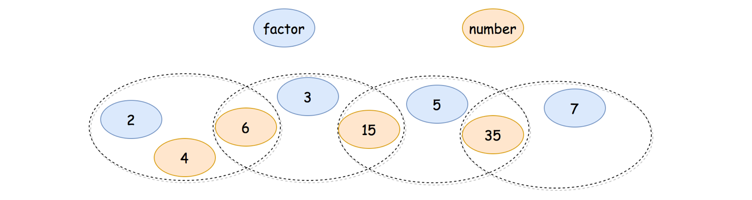

As one can see in the above example, essentially we build a [Venn diagram](https://en.wikipedia.org/wiki/Venn_diagram), where each subset contains a series of numbers as well as factors. Take the input number 6 as an example, it can be divided both by the factors of 2 and 3. As a result, it can be attributed to both groups that has the factors respectively. And thanks to the number 6, eventually the groups led by 2 and 3 respectively can be merged together. At the end, all the input numbers can be attributed to a single big group, thanks to all the joints among the subgroups.

**Algorithm**

With the above intuition, we could implement the algorithm in two general steps:

* Step 1). Attribute each number to a series of groups that are led by each of its factors.
  + We iterate through each number, denoted as num. For each number, we iterate from 2 to sqrt(num) to find out all the factors.
  + For each factor of num, we merge the groups of that possess the element num and factor respectively, i.e. Union(num, factor).
  + In addition, we perform the same union operation on the complement factor as well, i.e. Union(num, num / factor).
* Step 2). Iterate through each number a second time, to find out the final group that the number belongs to.
  + With the mapping between the number and its group ID, i.e. {num -> group_id}, it is intuitive to find out the group that has the most elements.

|  |
| --- |
| class Solution {  public int largestComponentSize(int[] A) {  int maxValue = Arrays.stream(A).reduce(A[0], (x, y) -> x > y ? x : y);  DisjointSetUnion dsu = new DisjointSetUnion(maxValue);  // attribute each element to all the groups that lead by its factors.  for (int num : A) {  for (int factor=2; factor < (int)(Math.sqrt(num))+1; ++ factor)  if (num % factor == 0) {  dsu.union(num, factor);  dsu.union(num, num / factor);  }  }  // count the size of group one by one  int maxGroupSize = 0;  HashMap<Integer, Integer> groupCount = new HashMap<>();  for (int num : A) {  Integer groupId = dsu.find(num);  Integer count = groupCount.getOrDefault(groupId, 0);  groupCount.put(groupId, count+1);  maxGroupSize = Math.max(maxGroupSize, count+1);  }  return maxGroupSize;  }  }  class DisjointSetUnion {  private int[] parent;  private int[] size;  public DisjointSetUnion(int size) {  this.parent = new int[size + 1];  this.size = new int[size + 1];  for (int i = 0; i < size + 1; ++i) {  this.parent[i] = i;  this.size[i] = 1;  }  }  /** return the component id that the element x belongs to. */  public int find(int x) {  if (this.parent[x] != x)  this.parent[x] = this.find(this.parent[x]);  return this.parent[x];  }  /**  * merge the two components that x, y belongs to respectively,  * and return the merged component id as the result.  */  public int union(int x, int y) {  int px = this.find(x);  int py = this.find(y);  // the two nodes share the same group  if (px == py)  return px;  // otherwise, connect the two sets (components)  if (this.size[px] > this.size[py]) {  // add the node to the union with less members.  // keeping px as the index of the smaller component  int temp = px;  px = py;  py = temp;  }  // add the smaller component to the larger one  this.parent[px] = py;  this.size[py] += this.size[px];  return py;  }  } |

**Note:** One might encounter TLE (Time Limit Exceeded) exception with the above solution (especially in Python), when the online judge is under load. But under the normal circumstance, the solution would be accepted, which is even faster than 30% of submissions.

**Complexity Analysis**

Since we applied the Union-Find data structure in our algorithm, we would like to start with a statement on the time complexity of the data structure, as follows:

**Statement**: If M*M* operations, either Union or Find, are applied to N*N* elements, the total run time is \mathcal{O}(M \cdot \log^{*}{N})O(*M*⋅log∗*N*), where \log^{*}log∗ is the [iterated logarithm](https://en.wikipedia.org/wiki/Iterated_logarithm).

One can refer to the [proof of Union-Find complexity](https://en.wikipedia.org/wiki/Proof_of_O(log*n)_time_complexity_of_union%E2%80%93find) for more details.

In our case, the number of elements in the Union-Find data structure is equal to the maximum number of the input list, i.e. max(A).

Let N*N* be the number of elements in the input list, and M*M* be the maximum value of the input list.

* Time Complexity: \mathcal{O}(N \cdot \sqrt{M} \cdot \log^{*}{M})O(*N*⋅*M*​⋅log∗*M*)
  + The number of factors for a given number is bounded by \mathcal{O}(\sqrt{M})O(*M*​). Assuming that any number that is less than \sqrt{M}*M*​ can be divided by M*M*, we would then have 2 \cdot \sqrt{M}2⋅*M*​ pairs of factors.
  + In the first step, we iterate through each number (i.e. N*N* iterations), and for each number, we iterate through all its factors (i.e. up to 2 \cdot \sqrt{M}2⋅*M*​ iterations). As a result, the time complexity of this step would be \mathcal{O}(N \cdot \sqrt{M} \cdot \log^{*}{M})O(*N*⋅*M*​⋅log∗*M*).
  + In the second step, we iterate through each number again. But this time, for each iteration we perform only once the Union-Find operation. Hence, the time complexity for this step would be \mathcal{O}(N \cdot \log^{*}{M})O(*N*⋅log∗*M*).
  + To sum up, the overall complexity of the algorithm would be \mathcal{O}(N \cdot \sqrt{M} \cdot \log^{*}{M}) + \mathcal{O}(N \cdot \log^{*}{M}) = \mathcal{O}(N \cdot \sqrt{M} \cdot \log^{*}{M})O(*N*⋅*M*​⋅log∗*M*)+O(*N*⋅log∗*M*)=O(*N*⋅*M*​⋅log∗*M*).
* Space Complexity: \mathcal{O}(M + N)O(*M*+*N*)
  + The space complexity of the Union-Find data structure is \mathcal{O}(M)O(*M*).
  + In the main algorithm, we use a hash table to keep track of the account for each group. In the worst case, each number forms an individual group. Therefore, the space complexity of this hash table is \mathcal{O}(N)O(*N*).
  + To sum up, the overall space complexity of the algorithm is \mathcal{O}(M) + \mathcal{O}(N) = \mathcal{O}(M + N)O(*M*)+O(*N*)=O(*M*+*N*).

#### Approach 2: Union-Find on Prime Factors

**Intuition**

One might notice that in the above algorithm, we would enumerate through a series of **non-essential** factors for a number.

For instance, for the number 12, we have a number of factors as [2, 3, 4, 6]. In this case, the factors of [4, 6] are not essential, since they have been covered by the prime factors of [2, 3]. If there is another number (say 30) that has a common factor with the number 12, then this common factor is either one of the prime factors of [2, 3] or it can be further divided by these prime factors.

The intuition is that the prime factors of a number can represent all of its factors, i.e. the integer can be characterized by a series of prime factors.

Indeed, "By the fundamental theorem of arithmetic, every positive integer has a unique [*prime factorization*](https://en.wikipedia.org/wiki/Prime_number#Unique_factorization)", as we quote from [wikipedia](https://en.wikipedia.org/wiki/Integer_factorization).

Each positive integer (except 1) can be decomposed into a series of prime numbers, e.g. 12 = 2 * 2 * 312=2∗2∗3.

With the above theories, rather than enumerating all the factors of a number, we just need to enumerate the **prime factors** of a number, in our Union-Find data structure.

**Sieve Method**

Before proceeding to the main algorithm for this problem, let us briefly list the algorithm to decompose a number into a series of prime factors, which itself is not an easy problem.

Here we apply the [sieve of Eratosthenes](https://en.wikipedia.org/wiki/Sieve_of_Eratosthenes) (let's call it sieve method for short), an ancient algorithm to calculate all prime factors up to any given limit.

|  |
| --- |
| List<Integer> primeDecompose(int num) {  List<Integer> primeFactors = new ArrayList<Integer>();  int factor = 2;  while (num >= factor * factor) {  if (num % factor == 0) {  primeFactors.add(factor);  num = num / factor;  } else {  factor += 1;  }  }  primeFactors.add(num);  return primeFactors;  } |

**Algorithm**

Now that we know how to decompose a number into a series of prime factors, we can simply replace common factors in the previous approach with the prime factors. This could work.

However, there is another arguably more efficient method, which is that rather than Union-Find on all numbers together with its prime factors, we do the Union-Find **solely** on the prime factors, excluding the numbers.

We could therefore have much smaller set of elements for the Union-Find operations. We illustrate how it could work on the same example before in the following graph.

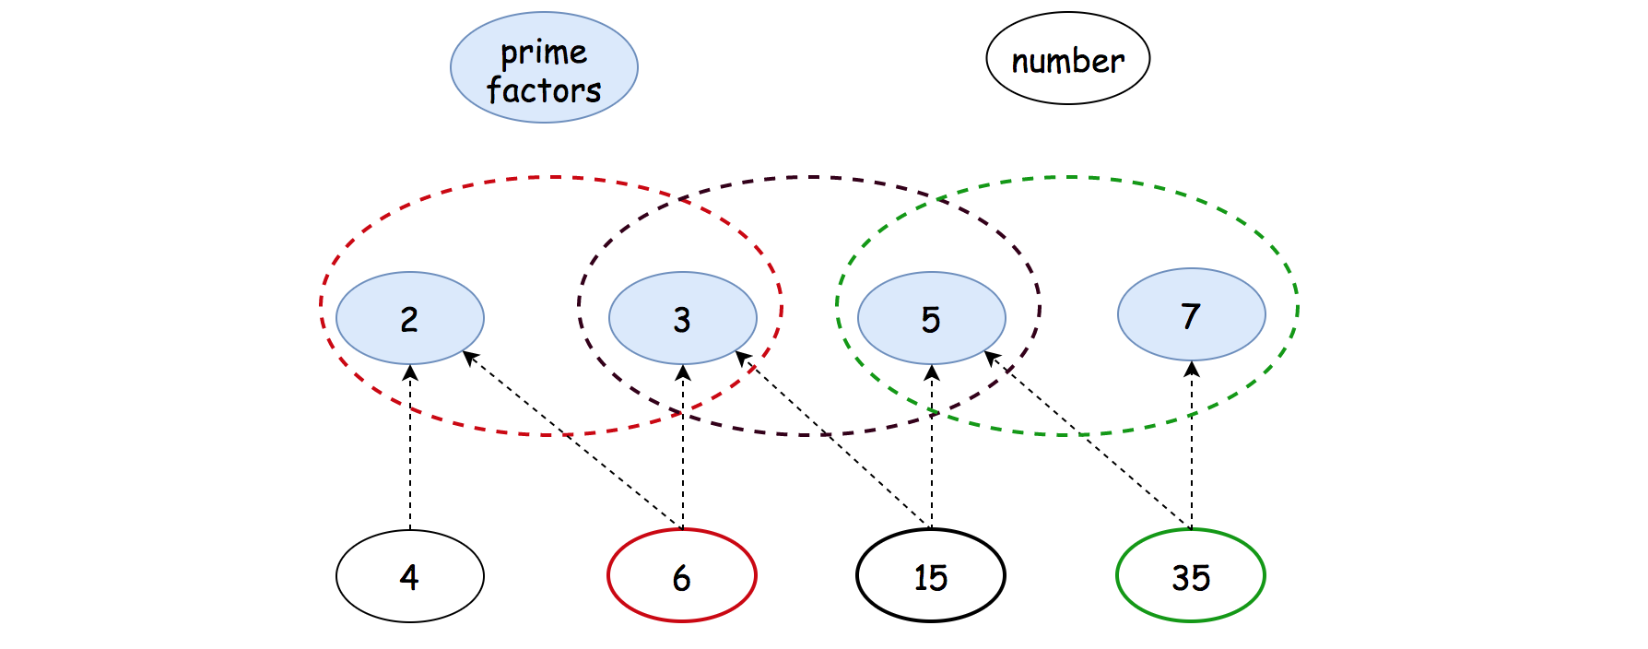

Similar with the previous approach, we could implement the algorithm in two general steps:

* Step 1). Decompose each number into its prime factors and apply Union() operations on the series of prime factors.
  + We iterate through each number, denoted as num. For each number, we decompose it into prime factors.
  + We join all groups that possess these prime factors, by applying Union() operation on each adjacent pair of prime factors.
  + In addition, we use a hash table to keep the mapping between each number and its any of prime factors. Later, we would use this table to find out which group that each number belongs to.
* Step 2). Iterate through each number a second time, to find out the final group that the number belongs to.
  + Since we build Union-Find sets solely on the prime factors, we could find out which group that each prime factor belongs to, *i.e.* prime_factor -> group_id.
  + Thanks to the mapping between the number and its prime factor, *i.e.* {num -> prime_factor}, we could now find out which group that each number belongs with the above Union-Find sets, *i.e.* num -> prime_factor -> group_id.

|  |
| --- |
| class Solution {  public int largestComponentSize(int[] A) {  int maxValue = Arrays.stream(A).reduce(A[0], (x, y) -> x > y ? x : y);  DisjointSetUnion dsu = new DisjointSetUnion(maxValue);  HashMap<Integer, Integer> numFactorMap = new HashMap<>();  // Union-Find on the prime factors.  for (int num : A) {  // find all the unique prime factors.  List<Integer> primeFactors = new ArrayList<>(  new HashSet<>(this.primeDecompose(num)));  // map a number to its first prime factor  numFactorMap.put(num, primeFactors.get(0));  // Merge all the groups that contain the prime factors.  for(int i=0; i<primeFactors.size()-1; ++i)  dsu.union(primeFactors.get(i), primeFactors.get(i+1));  }  // count the size of group one by one  int maxGroupSize = 0;  HashMap<Integer, Integer> groupCount = new HashMap<>();  for (int num : A) {  Integer groupId = dsu.find(numFactorMap.get(num));  Integer count = groupCount.getOrDefault(groupId, 0);  groupCount.put(groupId, count+1);  maxGroupSize = Math.max(maxGroupSize, count+1);  }  return maxGroupSize;  }  protected List<Integer> primeDecompose(int num) {  List<Integer> primeFactors = new ArrayList<Integer>();  int factor = 2;  while (num >= factor * factor) {  if (num % factor == 0) {  primeFactors.add(factor);  num = num / factor;  } else {  factor += 1;  }  }  primeFactors.add(num);  return primeFactors;  }  }  class DisjointSetUnion {  private int[] parent;  private int[] size;  public DisjointSetUnion(int size) {  this.parent = new int[size + 1];  this.size = new int[size + 1];  for (int i = 0; i < size + 1; ++i) {  this.parent[i] = i;  this.size[i] = 1;  }  }  /** return the component id that the element x belongs to. */  public int find(int x) {  if (this.parent[x] != x)  this.parent[x] = this.find(this.parent[x]);  return this.parent[x];  }  /**  * merge the two components that x, y belongs to respectively,  * and return the merged component id as the result.  */  public int union(int x, int y) {  int px = this.find(x);  int py = this.find(y);  // the two nodes share the same group  if (px == py)  return px;  // otherwise, connect the two sets (components)  if (this.size[px] > this.size[py]) {  // add the node to the union with less members.  // keeping px as the index of the smaller component  int temp = px;  px = py;  py = temp;  }  // add the smaller component to the larger one  this.parent[px] = py;  this.size[py] += this.size[px];  return py;  }  } |

**Complexity Analysis**

Let N*N* be the number of elements in the input list, and M*M* be the maximum value of the input list.

* Time Complexity: \mathcal{O}\big(N \cdot (\log_{2}{M} \cdot \log^{*}{M} + \sqrt{M}) \big)O(*N*⋅(log2​*M*⋅log∗*M*+*M*​))
  + First of all, the time complexity of the sieve method to calculate the prime factors of is \mathcal{O}(\sqrt{M})O(*M*​).
  + It is hard to estimate the number of prime factors for a given number. Since the smallest prime number is 2, a coarse upper bound for the number of the prime factors is \log_{2}{M}log2​*M*, *e.g.* 8 = 2 * 2 * 28=2∗2∗2.
  + In the first step, we iterate through each number (*i.e.* N*N* iterations), and for each number, we iterate through all its factors (*i.e.* up to \log_{2}{M}log2​*M* iterations). As a result, together with the calculation of prime factors, the time complexity of this step would be \mathcal{O}(N \cdot \log_{2}{M} \cdot \log^{*}{M}) + \mathcal{O}(N \cdot \sqrt{M}) = \mathcal{O}\big(N \cdot (\log_{2}{M} \cdot \log^{*}{M} + \sqrt{M}) \big)O(*N*⋅log2​*M*⋅log∗*M*)+O(*N*⋅*M*​)=O(*N*⋅(log2​*M*⋅log∗*M*+*M*​)).
  + In the second step, we iterate through each number again. But this time, for each iteration we perform only once the Union-Find operation, *i.e.* \mathcal{O}(N \cdot \log^{*}{M})O(*N*⋅log∗*M*).
  + To sum up, the overall complexity of the algorithm would be \mathcal{O}\big(N \cdot (\log_{2}{M} \cdot \log^{*}{M} + \sqrt{M}) \big)O(*N*⋅(log2​*M*⋅log∗*M*+*M*​)).
  + As one might notice that, the asymptotic complexity of this approach seems to be inferior than the previous approach, due to the calculation of prime factors. However, in reality, the saving we gain on the Union-Find operations could outweigh the cost of prime factor calculation.
* Space Complexity: \mathcal{O}(M + N)O(*M*+*N*)
  + The space complexity of the Union-Find data structure is \mathcal{O}(M)O(*M*).
  + In the main algorithm, we use a hash table to keep track of the count for each group. In the worst case, each number forms an individual group. Therefore, the space complexity of this hash table is \mathcal{O}(N)O(*N*).
  + In addition, we keep a map between each number and one of its prime factors. Hence the space complexity of this map is \mathcal{O}(N)O(*N*).
  + To sum up, the overall space complexity of the algorithm is \mathcal{O}(M) + \mathcal{O}(N) + \mathcal{O}(N) = \mathcal{O}(M + N)O(*M*)+O(*N*)+O(*N*)=O(*M*+*N*).